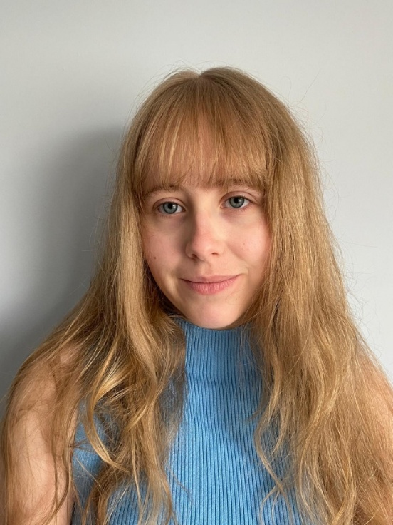
Angel Georgiana Gillam
She/her
07778983910
Angelgillam@icloud.com
Playing age: 14-18
Height: 5’2”
Appearance: White British
Location: Hampshire
Production | Role | Company | Director
Film
The Lion King | Director | Short Film | Angel Gillam
You can’t Eat a Princess | Soul performance | Short Film | Jonah
Back2School | Contestant | Student Film | Ruby Hatcliff
Haunted From Within | Extra as a school girl | Student Film | Aryna
Reeducation of Brianca Brixton | Prisoner | Shepton Mallet Prison | Verona Rose
Riot | Racist, Tik Tok lady | Bournemouth University | Domica
Project Eggman | Student | UCA Farnham | Harry Butcher

TV
‘With You’ charity advert | Sophie who is young person with drug and alcohol problem | Bournemouth University and ‘With You’ charity | Charlie Walker

Stage
Madagascar | Dacer as a Ballerina, penguin | SJ Academy of dance | Director of dance
Dance show | Clown, Mouse, Flower | SJ Academy of dance | Director of dance
Nativity | Snowflake, Angel | School Show | Drama teacher
Wizard of Oz | Munchkin | School Show | Jo Lee
Singing show case | A singer | School Show | Music teacher
Wind in the Willows | Chief Weasel | School Show | Jo Lee
Dracula Spectacular | The lead school child | School Show | Jo Lee
Dairy of the Wimpy Kid | Patty | School Show | Jo Lee
Dracula | Priest | School Show | Drama teacher
Acting up | Multiple Characters | Riding Lights Theatre | Director of RLT
Seconded person Narrative | Multiple Characters | Youth Theatre | Director of HYT
Labyrinth | Ludo | House Drama | Ash
Romeo and Juliet | Nurse | School Show | Mrs Mullender
Elf at Christmas | Elf | Salvation Army | Lou Davis
Who Wrote This? | Improvisation | Who Wrote This? At Brighton, Chichester, Royal Tunbridge Wells and Arundel Fringe | Summer and Fillipe

Audiobook
Christmas Carol | Ghost of Christmas past | School | Mrs Mullender

Skills:
Dialects: Queen’s English
Music/Dance: Jazz, Modern
Qualifications: Passed grade 1 singing, Bronze Arts award by Trinity College London, OCR Cambridge Technical level 3 (equivalent to 3 A levels)
Training: SJ Academy of dance, Stagecoach (summer show 5 day intensive course), A mask workshop, project and performance, Riding Lights Theatre, Online NYT theatre classes, Harrogate Youth Theare, NYT workshop and OCR Cambridge Technical level 3 (equivalent to 3 A levels). Mask performance, Stage combat, devising, formal training improvisation, puppetry, historical techniques.
Sport: Cricket, hockey, netball, tennis, running, athletics, football, horse riding,
Other: I can drive an automatic car, ride a bike, roller skate, ice skate, swim, ski, do yoga and bake. I have worked in a bakery, toy shop, barista for a well-known coffee brand and also work as a sales assistant. Improvisation (personal strength and high level of skill).

