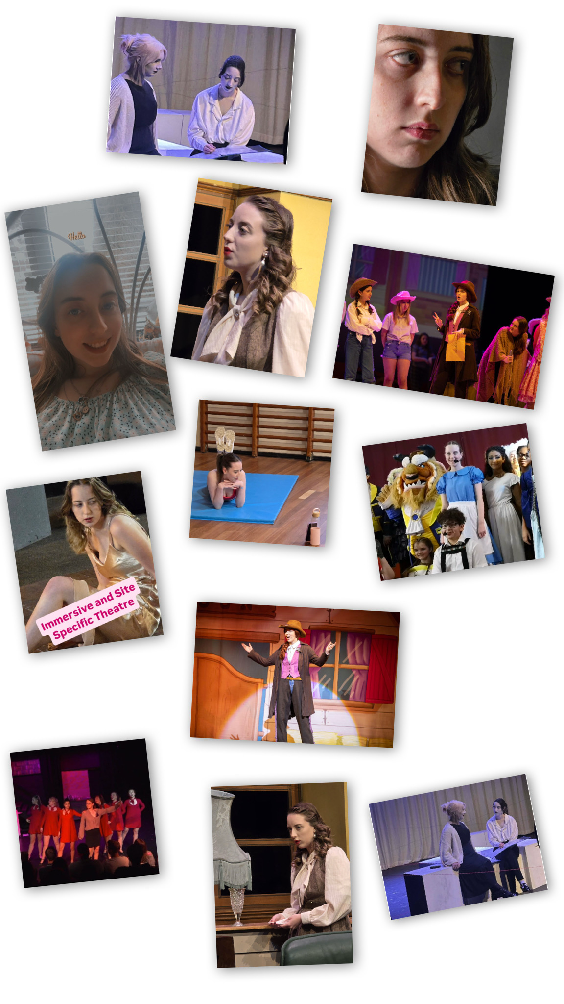

First Name: Amelia

Middle Name: Rose

Last Name: Patrick

Preferred Name: Amelia Rose

Date of Birth: 08/01/2004

Age: 21

Address: Highbury Corngreaves Road B64 7EA

Telephone Number: 07473253135

Email Address: a_rose@icloud.com

Town/City: Birmingham

Eye Colour: Blue

Hair Colour: Light Brown

Skin Tone: White

Height: 5ft 6in

Weight: 110 pounds

Acting Age: 16 - 21

Education: Castle Bromwich Infant School, Castle Bromwich Junior School, Bleakhouse Junior School, Bristnall Hall Academy, Halesowen College, The University of Worcester

Show: Dance 2011

Date: 20th July - 21st July 2011

Location: Birmingham Hippodrome

Show: Matilda Jr

Character: Gubbinsworth

Date: 31st January - 1st February 2018

Location: Bristnall Hall Academy

Show: Beauty and the Beast Jr

Character: Cast A Narrator & Cast B Belle

Date: 29th January - 30th January 2019

Location: Bristnall Hall Academy

Show: G4 Concert

Date: 10th December 2019

Location: Birmingham Town Hall

Show: Footloose

Character: Boy 2/Ensemble

Date: 28th June - 1st July 2021

Location: Halesowen College

Show: October Showcase

Songs: Serious - Legally Blonde, The Song of Purple Summer - The Colour Purple, Buenos Aires - Evita

Date: 19th October - 20th October 2021

Location: Halesowen College

Show: December Showcase

Songs: Buenos Aires - Evita, I Hate Men - Kiss Me Kate, 1650s Medley - Beautiful: The Carol King Musical, My New Philosophy - You're a Good Man Charlie Brown, It's Too Darn Hot - Kiss Me Kate

Date: 30th November - 2nd December 2021

Location: Halesowen College

Show: March Showcase

Songs: Naughty - Matilda, Get Down - Six, It's A Musical - Something Rotten

Date: 19th March 2022

Location: Halesowen College

Show: 9 to 5

Character: Cast A Ensemble & Cast B Roz Keith

Date: 27th June - 30th June 2022

Location: Halesowen College

Show: Is My Microphone On?

Character: E

Date: 15th March & 1st April 2023

Location: The University of Worcester & The Swan Theatre

Show: Trouble's A Brewin'

Character: Sheriff Trifle

Date: 21st May 2023

Location: His Majesty's Theatre

Show: Café Misère

Character: Various

Date: 16th January 2024

Location: The University of Worcester

Show: SCREAM the Musical

Character: Gale Weathers

Date: 14th May 2024

Location: The University of Worcester

Show: Yours Faithfully;

Character: Lili Barham

Date: 13th & 15th May 2025

Location: The University of Worcester

Show: In The Dark

Character: Eleanor Sladen

Date: 30th May 2025

Location: The University of Worcester