ALPHA BOURNE

Rob Winkworth, Wink Talent Agency

[alphabournebookings@gmail.com](mailto:alphabournebookings@gmail.com)

313-739-9470

Non-Union

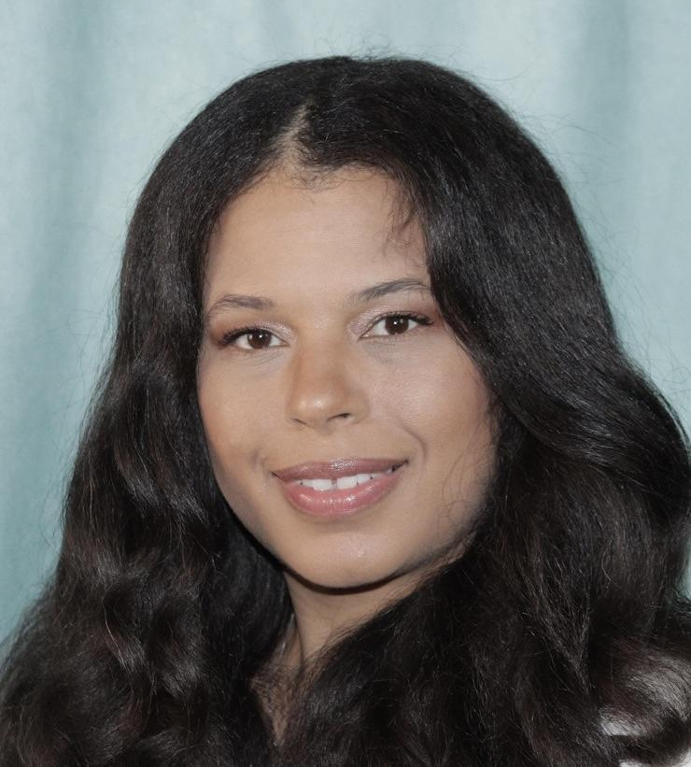

HT: 5’4”

WT: 160lbs

Eyes: Brown

Hair: Brown

FILM

Unknown Supporting Michael

Policy Supporting Antonio Ward

Crash Out Supporting Kaamel Hasaun

Mr. Tomorrow Supporting Darren Brown

Return Of The Mack Supporting Dejuan Ford/ Kamal Smith

The Port Season 2 Bar Patron GhaniVision

McGraw Ave Ep5 S 2 Funeral attendee ep.5 Mula Films

Blackbird Missing Lead Josephine American Girls Productions

The Darkside of Beautiful EMT/ supporting J.M Pozon Productions

Crush Background Big Willow ENT

8 Mile Stand in/Background Curtis Hanson

TELEVISION

Real Entertainment Host Real Entertainment

PODCAST

The Suede Covington Show Co-Host Suede Covington LLC

COMMERCIAL

The Wedding Shoppe Aunt of Bride

Smart Bus Passenger

Gardner White Shopper

Hanes Airplane passenger

THEATER

Perilous Times Dancer TJ Hemphill Ent

Perilous Times Supporting TJ Hemphil ENT

Love Won't Let Me Wait Understudy/Michelle TJ Hemphill ENT

4 Daughters Minus one 2000 A.D. supporting Timberly Robinson

MODELING

Titanium Fashion Show Fashion The M Agency/ Mikk Lynch

The Haute Couture Fashion A&B Fashionistas

TRAINING

Wayne State University Theatre

Acting & Voice Studio Voice acting Barry Shapiro

SPECIAL SKILLS

Singing Soprano, Roller Skating, Baking, Cosmetology, Cosmetic formulator