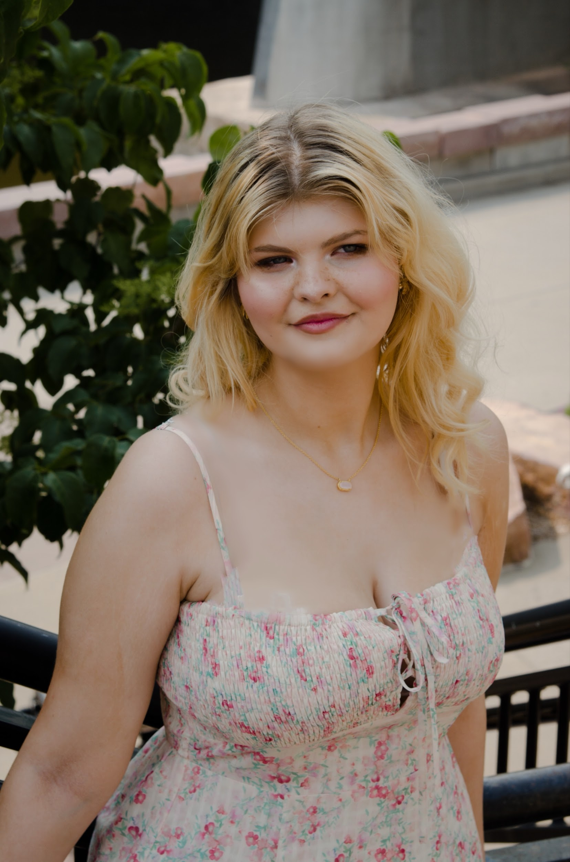Adelaide Humphrey

(Non-Union)

[Adelaide.Humphrey333@gmail.com](mailto:Adelaide.Humphrey333@gmail.com)

Height: 5’8

Eye Color: Blue

Hair Color: Blonde

____________________________________________________________________________________

**THEATER**

Legally blonde Chutney W/Law student/ensemble Spotlight. ‘25

Much Ado About Nothing (abv) Beatrice spotlight. ‘25

Shrek Bishop/Guard/Little Bunny/Tinkerbell Fa4Fa‘25

Alice in Wonderland Featured singer/ dance captain/card Spotlight ‘25

Monster in the Mirror Narrator/Prof. Merlin/Prof. Strange Spotlight ‘25

Mean Girls Junior Dawn/ pre-show announcer /ensemble Spotlight ‘24

Musical Theatre Cabaret Maria/ensemble Fa4Fa ‘24

Into the Woods Tree/ Tap Dancing Bean/ensemble Spotlight ‘24

Rock of Ages DJ/ ensemble Fa4Fa ‘24

Romeo & Juliet (abv) Lady Montague/Friar John/ Gregory Spotlight ‘24

Mary Poppins Ms lark/kite ensemble Spotlight ‘24

*What’s the difference* Max/Mrs teal/ Mr rose/June Spotlight ‘22/23

*Lightning Thief the musical* Oracle of Delphi/ensemble spotlight ‘23

*Once Upon a Mattress pantomime princess/ensemble* spotlight ‘23

*SpongeBob the Musical Sardine #3/ ensemble* Spotlight ‘23

*Sound of Music Ursula/Nun/ensemble* spotlight ‘22

*Wizard of Oz Emerald Ensemble* Spotlight ‘22

**EDUCATION & TRAINING**

Dance: Ballet (8 years), Jazz (3 years), Tap ( 7 years), Hip hop (1 year), Acting ( 1 year) Unity Dance studio TN

Current classes: Dance gallery SD

Voice: Effervescent, Mo

Other classes: Musical theatre Tap (2 years), Tech training, Improv. Spotlight SD

Tech training: Lights (Camp Rock jr), Run Crew (Frozen Jr), Sound (Willy Wonka) all Spotlight SD

____________________________________________________________________________________

**SPECIAL SKILLS**

Singing (Voice: Mezzo-soprano/ Soprano 2), Lift trained, Stage fighting (especially with swords),