Isabel Sanchez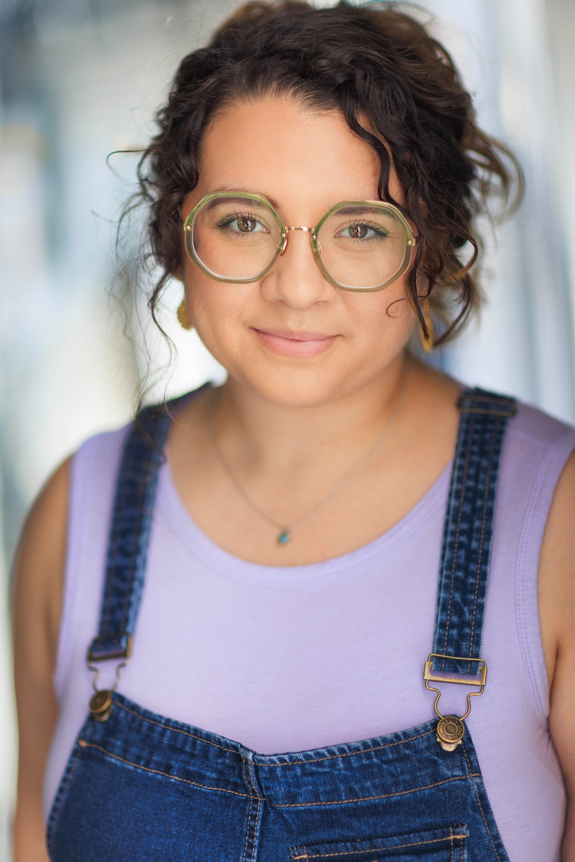

**Tel:** +1925962557

**E-mail:** izzyas@yahoo.com

|  |  | **Height:** 5’ 3” |  |
| --- | --- | --- | --- |
|  |  | **Hair Colour:** Light Brown |  |
| **Playing Age:**  **19-30** |  | **Eye Colour:**  Brown/Hazel |  |
| **Location: London** |  | **Weight:** 170 lbs |  |
|  |  |  |  |

| **Training:** | **Undergraduate**  BFA Acting for the Stage and Screen-Azusa Pacific University 2017-2021  **Postgraduate**  MFA Acting-University of East London 2021-2023 |
| --- | --- |

**Credits:**

| **Year** | **Type** | **Role** | **Production** | **Company** | **Director** |
| --- | --- | --- | --- | --- | --- |
|  |  |  |  |  |  |
|  | Stage |  |  |  |  |
| 2024-25 |  | Multiple | TIE tour | The Phoenix Theatre |  |
|  |  |  |  |  |  |
| 2023 |  | Stella | Soeur Dubois | ELTC | Kevin Murphy |
|  |  |  |  |  |  |
| 2023 |  | Assistant Director | All You Need is LSD | UEL | Majid Mehdizadeh |
|  |  |  |  |  |  |
| 2022 |  | Hermia | A Midsummer Night’s Dream | UEL | Ben Archer |
|  |  |  |  |  |  |
| 2020 |  | Julie Pender | The Penders | APU | Nanci Carole Rubi |
|  |  |  |  |  |  |
| 2019 |  | Middletown | Doctor | APU | Nanci Carole Rubi |
|  | Web Series |  |  |  |  |  |
| 2021 |  | Sydney | The Clash Pad | WAF Productions | Hannah Martinez |  |
| 2021 |  | Featured Actor | Remotely Yours | APU | Alex Hluch |  |
|  | Stage Crew |  |  |  |  |  |
| 2023 |  | Stage Manager | Let Your Hands Sing in the Silence | Projekt Europa | Maria Aberg |  |
| 2023 |  | Sound Design | All You Need is LSD | UEL | Majid Mehdizadeh |  |
| 2023 |  | Stage Manager | Emmaline | Theatre Lab Company | Anastasia Revi |  |
| 2022 |  | Stage Manager | Heartbreak Hotel | TLC | Lydia Vie |  |

| University of East London | *The Meisner Technique* | ​Robyn Paterson  University of East London | *Acting Technique Post- Stanislavsky* | Pavlos Christodoulou​  University of East London | *Building a Successful Career as an Actor* | Radhika Aggarwal​ | |
| --- | --- |
| **Skills**  Basic Guitar  Knitting  Sewing  Piano  Alto (E3)  Belt (B4-C5)  Bartending |  |
| **Vehicle Licenses:** | CA Driver’s License |
| **Accents & Dialects:** California Accent*  American Accent*  Southern US Accent  Northern Irish Accent  British Accent (RP)  East London Accent  *(* = native)* |  |
| **Sports**:  Swimming  Tennis  Basic Horseback Riding  Dance (Tap, ballet) |  |