Ben Avila

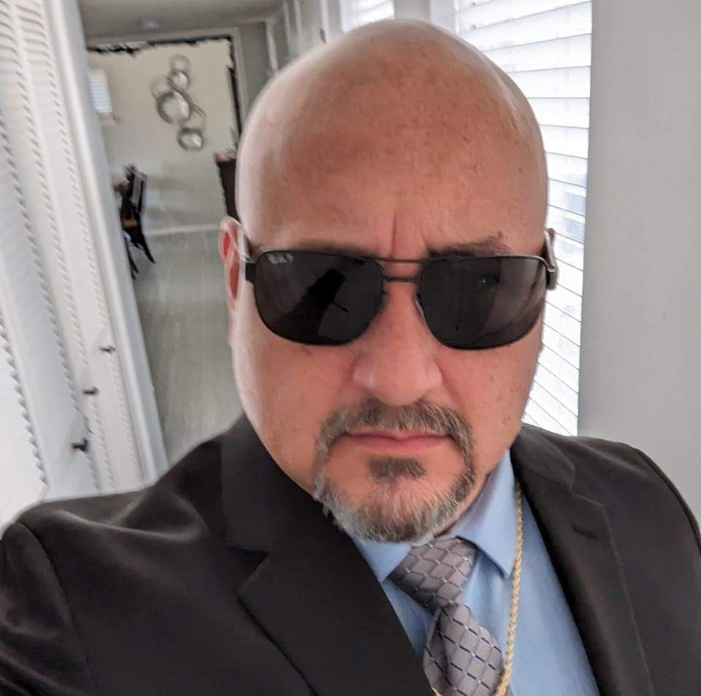

Age: 52

Height: 5’-7”

Weight: 250 Lbs.

Eye Color: Brown

Hair: Bald

Facial Hair Color: Black and White

Contact: [bavila@providentscs.com](mailto:bavila@providentscs.com)

915-222-4187

Languages: English and Spanish

Acting School:

Debbie Reynolds Performing Arts Studio

Films:

Border Lords 1 Supporting Actor – Mob Boss Shades Productions

Muertas Supporting Actor – Factory Boss Ryan Williams

Cascarrabias Main Supporting Actor – Dying Father Ignacio Ramos

Series:

Aim for the Heart Supporting Actor – Mob Boss Shades Productions

Cassie Captures a Criminal Supporting Actor – Philanthropist ATM Productions

Brother’s Revenge Actor – Mob Hitman Ray Crawley

Profession:

President of Provident Safety Consulting Services, Inc. As a professional trainer, I am always speaking in front of crowds of up to 400 people. The safety industry is serious, but with my comic relief of certain subjects, my students are able to absorb more information. As a speaker, changing your message according to the group of people you are speaking in front of is normal. Quick and sometimes improvisational thinking is an important part of being a speaker. I also am a motivational speaker for business owners and leaders in the construction and general industry businesses. Being bi-lingual assist me in getting the message across and sometimes, being able to speak “cholo” (Hispanic thug) during my trainings brings big laughs and connection with all students.