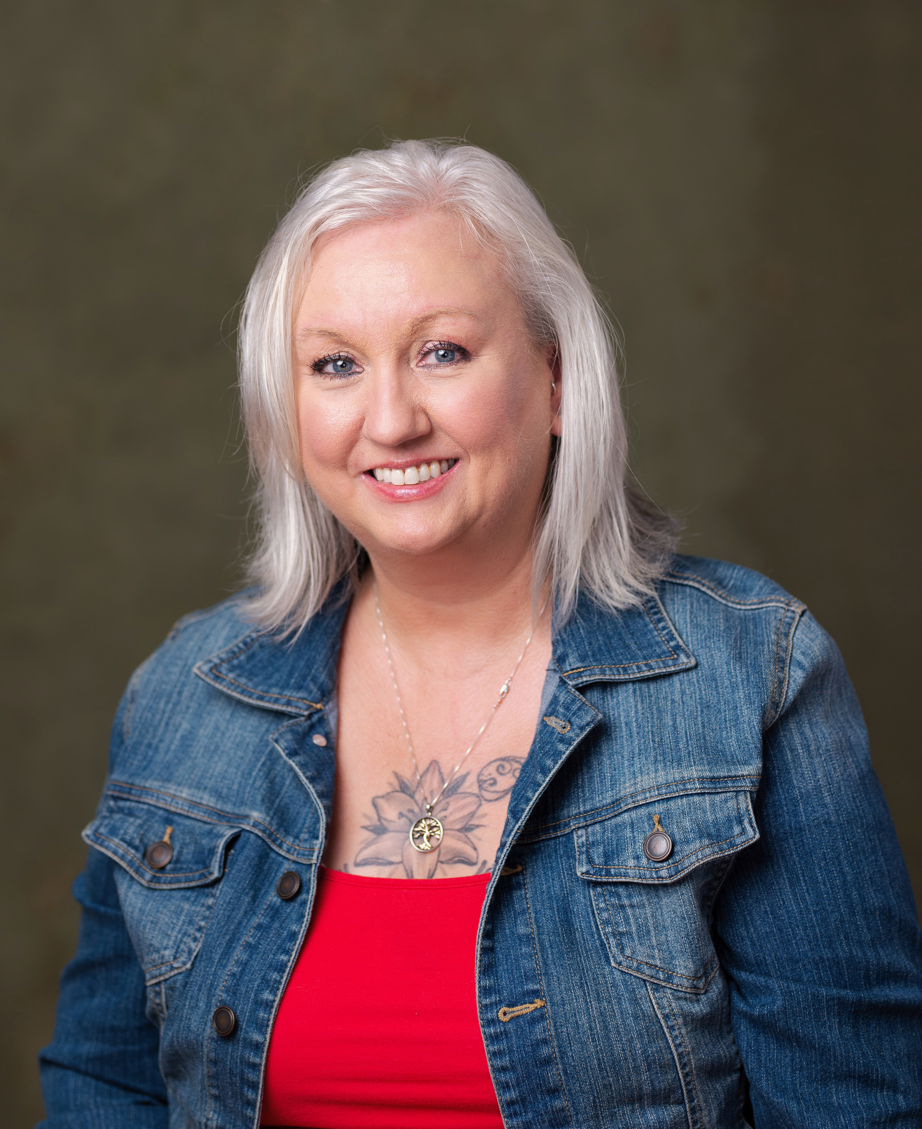
Naydean Walker
828-808-3949
walkernaydean@gmail.com

Personal Details:
Height: 5’5
Eye Color: Blue
Hair: White
Weight 150

Objective:
To pursue a career in acting, utilizing strong dedication and eagerness to learn, seeking opportunities to showcase versatility in diverse roles across Film, Television, and Theater.

Training and Education:
- “Acting Made Easy: Bringing Text to Life” (Monologues), by Dave Lovatt. Udemy Online Course.
- “The Complete Acting Course”, by Galadriel Stineman. Udemy Online Course.
- “Commercial Acting 101”, by Lisa Phillips and Colleen Hannon. Udemy Online Course.
- “Actors: Learn How to Audition for Film and Television”, by Marci Liroff. Udemy Online Course.
- “Get More Acting Auditions with Effective Headshots”, by Aaron Ramos. Udemy Online Course.
- “The Actor’s Bootcamp”, by Calvin McWilliams. Udemy Online Course.
- “Improv from Zero: Off -the-Street to On-The-Stage”, by Philip Geurin. Udemy Online Course.
Workshops/Classes
- “Acting for Beginners” class- Asheville Community Theater. November 2024. Asheville NC.
- “Improv for Beginners” class- Asheville Community Theater. November 2024. Asheville NC.
- The Acting Labs: Laa Joshua; The Joshua Groupe August 2025.
Skills:
- Strong Improvisation Skills
- Excellent ability to analyze and Interpret Character
- Physical Presence and movement awareness
- Competent Public Speaking and Presentation Skills

- Accomplishments:
  - I completed an Online Audition for Global Image Talent August 27th, 2024, and was selected to compete at IPOP (International Presentation of Performers) in Los Angeles in January 2025. I trained for this competition with Ms. Maria Whatley over Zoom for several weeks. I received 14 call backs.

