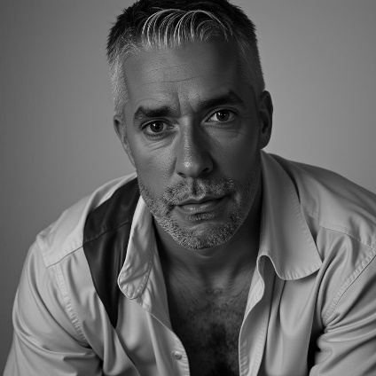
Nick Smith
Fort Worth, Texas
📞 817-709-8589
✉️ nscider@gmail.com

Physical Attributes
Height: 6'2"
Weight: 205 lbs.
Hair: Salt and Pepper
Eyes: Hazel
Facial Hair: Typically stubbled; clean shaven to full beard in ~2 weeks — willing to match production needs

Experience
Avondale Dealerships – Red Creative Productions – Lead Actor
- 7/1/25
Landman (Paramount+) – Background Actor
- 5/30/25, 6/10/25, 6/11/25, 6/26/25, 7/18/25
- Hand double for Billy Bob Thornton for Season 2 Promo Images
- Featured in four scenes as a background actor
- Pulled forward and positioned in featured areas with lead actors in all four scenes
- Non-speaking role with direct on-camera engagement with leads

Atonement – Independent Film – Background Actor
- 6/22/25
- Driving vehicles

Psychica – Commercial – Think Branded Media
- 7/11/25
- Dancing in Club

Training
Currently seeking formal training opportunities

Special Skills
- Physically fit and athletic – horseback to any sport
- Comfortable with any range of roles and environments – roughneck to mansions
- Reliable, takes direction well, and adapts quickly on set
- Available for travel

