**ABIGAIL MCKEE**

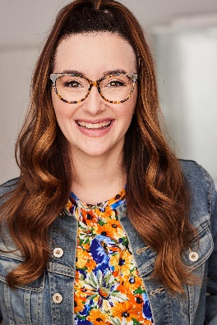 SAG-AFTRA

|  |  |  |
| --- | --- | --- |
| **TELEVISION** |  |  |
| ATYPICAL  Greys Anatomy | Costar  Featured | Netflix  ABC |

|  |  |  |
| --- | --- | --- |
| **FILM** |  |  |
| Knights of Swing | Supporting | Apple TV/Dir: Emilio Palame |

|  |  |  |
| --- | --- | --- |
| **THEATER** |  |  |
| Who Will Carry the Word | Supporting | Dir: Judith Pallidino |
|  |  |  |
| The Crucible | Supporting | Dir: D. Lance Marsh |
|  |  |  |
| Radiance | Lead | Dir: Gianna Blasquez |

|  |  |  |
| --- | --- | --- |
| **TRAINING** |  |  |
| Improv | Eric Price | The Second City |
|  |  |  |
| Basics of Booking/Commercial | Kelli Daniels and Cyd Strittmatter | ASG Casting |
|  |  |  |
| On Camera Audition Workshop | Marci Liroff | The Acting Factory |
|  |  |  |
| Commercial Workshop | Killian McHugh | Killian’s Acting Studio |
|  |  |  |
| Bachelor Arts in Theatre Performance | Various Professors | Oklahoma City University |

**SKILLS**

Singing (Alto) Voiceover, Improv, and Beginner Jazz.