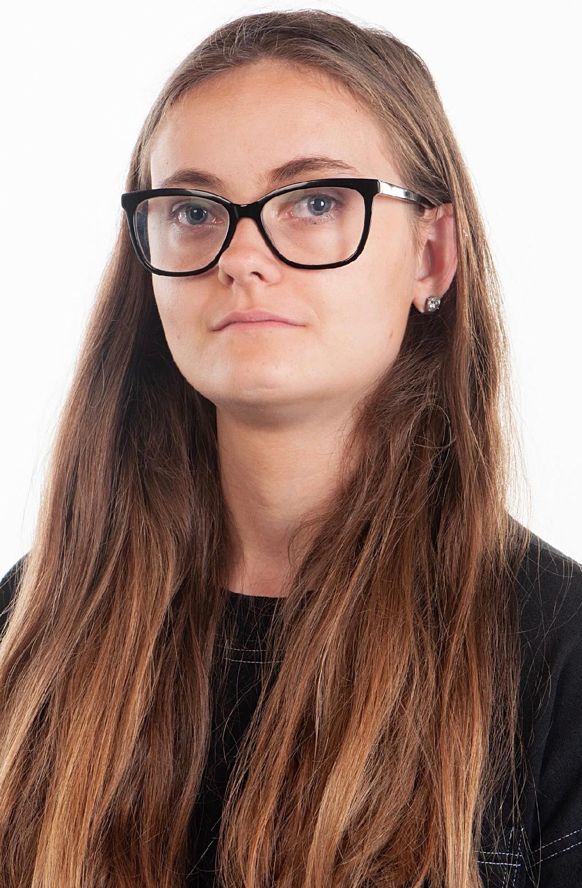**Nicola Baker**

**07956561001**

[Bakernicola09@gmail.com](mailto:Bakernicola09@gmail.com)

Playing age 16-28

Appearance: White British

Location: Essex

**Bio**

Eye colour: Grey

Height :5’5

Hair Colour: light brown

**Education**

University of Greenwich- BA in acting

University of East London- MA Acting for Stage and screen

City and Islington College- higher National Certificate performance acting

**Credits**

**Theatre Role Location Year**

**\* Macbeth - Witch, N7 Theatre, 2023**

**Film Role Director Year**

**\* The Offering Doctor, Katie Hicks, 2025**

**Skills**

Improviation

Physical theatre

Movement

**Showreel link**

<https://www.dropbox.com/scl/fi/ip6jg8rb43ydveinhhzh4/Showreel.mp4?rlkey=0c522hvuor5u9u3oamklt1t2e&st=uzze7gyi&dl=0>