CHE ROBERTS (404) 587-4424
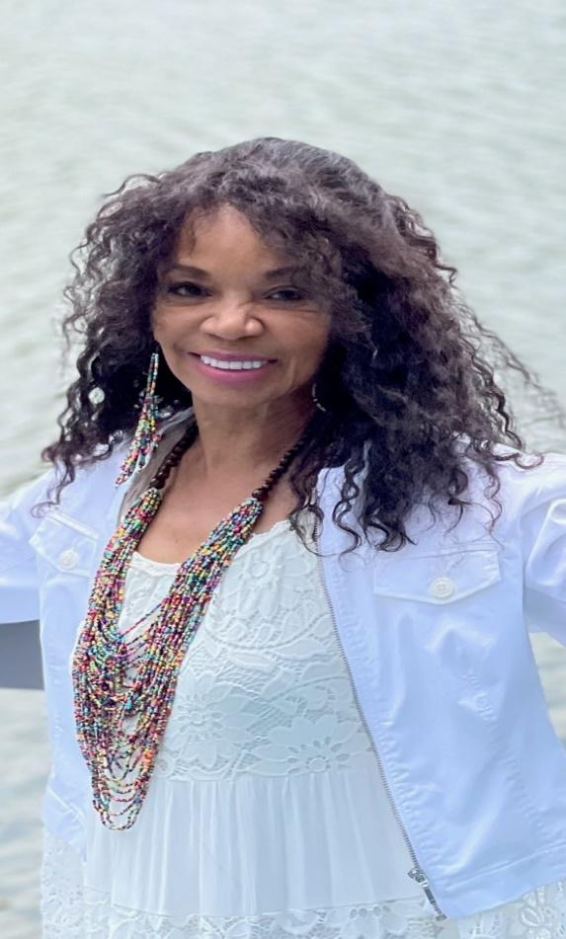
Height: 5’2” Weight: 110 Hair: Black: Eyes: Brown

Title | Role | Director | Production Company
THE WEDDING CRUISE | Daughter | BD Porter | Darnell  Players
A DIFFERENT TWIST OF GOD’S TROMBONES | Church lady,  Street Walker, Freedom Speaker | Faye Adams Taylor | S.T.A.R. Ensemble

Training- Currently Taking Acting Classes at SW Art Center and the Darnell Center
TV and Film – Evolve at Paul Robeson Theatre
Member of STAR Ensemble (Senior Thespians Are Ready)
Retired Real Estate Agent
robertscheryl11@gmail.com
1500 New Hope Rd.
Atlanta, GA 30331k

