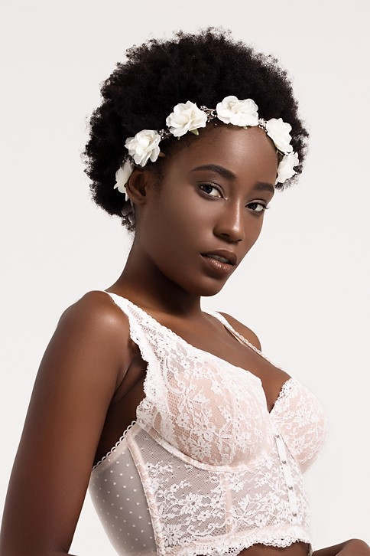

RUTH LALANNE

323-648-9945

[Ruthlalanne96@gmail.com](mailto:Ruthlalanne96@gmail.com)

**Height**: 5’7” **Weight**: 120lbs **Hair**: Black **Eyes**: Brown **Measurements:** 38C-26-33

EXPERIENCE

**FASHION SHOWS**

**The Model Experience**

L.A. Live Fashion Show Runway Feb. 2018

* Walked the runway for three unique designers, including fitness wear by ETP (@embracethaprocess), formal wear by LA based designer Yvonne (@styledbyyvonne), and abstract high fashion by Oseas Villatoro (@studiobyoseasvillatoro)
* Arrived early for call time to begin hair and makeup
* Changed quickly backstage between sets

**FashionBar Chicago**

Fashion Fights for H.E.R Show Runway July 2018

* Walked for four amazing designers: House of Flayva (@yolabaker), Jane X (@jane.x.pearl), Pertra Poorova Fashion Studio (@petrapoorova), and a last minute elegant gown designer named Abraham.
* Arrived early for call time to begin hair and makeup
* Changed quickly backstage between sets

**Masaki Matsuka**

Fall Collection Fashion Show Runway October 2018

* Walked in 2 outfits for couture Japanese designer Masaki Matsuka displaying their fall collection at their boutique in Santa Monica
* Arrived early for hair & makeup
* Changed quickly between sets

**Masaki Matsuka**

Fall Collection Fashion Show Runway October 2018

* Walked for couture Japanese designer Masaki Matsuka displaying their fall collection at the San Gabriel Hilton Hotel
* Arrived early for hair & makeup

**Luxe Brand International Fashion Show** Runway March 2019

The Karen Elle Project

* Arrived early hair and makeup ready
* Walked for two designers in Luxe Brand runway show
* Changed quickly between sets

**BEAUTY**

**Narina Beauty** Beauty September 2020

* Arrived early with hair appropriately styled and requested wardrobe items
* Shot content for Narina Beauty makeup brand.

**Snapchat Beauty** Beauty July 2023

* Arrived to set at scheduled 11:45AM call time for makeup and interviewed with Snapchat on beauty.
* Shot b-roll

**MUSIC VIDEOS**

**New Dance – XG** Background August 2023

* Arrived early for call time to set of XG’s new music video for the song New Dance.
* Served as one of four principal background extras for a scene in the video.

**No Brainer – DJ Khaled, Chance the Rapper, Justin Bieber, Quavo** Background June 2018

* Arrived early when call time changed for hair, makeup, and styling
* Did changes quickly between sets.
* Served as background and promo girl for Luc Bellaire and Ciroc in video

**MOVIES**

**Feature Film** Background (Concert Goer) May 2023

**Sande Alessi Casting**

* Arrived early to set in Anaheim, CA hair and makeup ready with proper documentation.
* Filmed 12 hours on set of movie with The Weeknd and Jenna Ortega on 5/11/23.

**S.O.S (State of Solitude)** Actress (Lola) June-Oct 2023

**Director: A.T. White**

* Filming as supporting character Lola in feature film set to release November 2023.
* Was off book before first day of filming and participated in rehearsals and table read with cast before filming.

**Vicious Affair** Clubgoer July 2023

* Played a clubgoer on set of Blac Chyna’s new Tubi movie with Robert Richard. Filmed overnight in Hollywood.

**Prepare to Die** Kidnapped Girl August-September 2023

* Worked 4 days on set on action movie Prepare to Die (featured on Tubi) as one of the featured kidnapped women who are saved by the leads.

**Starstruck** Icon Employee / Fan October 2023

* Filmed two days on set of movie Starstruck starring Brett Gray of Netflix’s “On My Block” and other actors. Played as an Icon record label employee and a fan outside in a separate scene.

**TELEVISION/STREAMING**

**Let’s Make A Deal** Contestant January 2023

* Arrived early for call time
* Filmed two episodes of Let’s Make A Deal ep. 14147, 14157. Air date: 4/20/23
* Served as featured contestant in one episode and background in the other.

**Amazon Music: Bars & Nuggets** Featured Audience Member May 2023

* Arrived early for call time in West Hollywood at Quixote Studies
* Filmed an episode of Bars & Nuggets with rapper The Game on 5/16/23

**The Verdict with Judge Hatchett** Plaintiff/Actress May 2023

Episode: That’s A Stretch

* Arrived early for 9AM call time & onsite COVID test with all necessary documents in hand.
* Filmed an episode of The Verdict with Judge Hatchett acting as the Plaintiff on 5/19/23.

**Person, Place, or Thing** Contestant September 2023

* Played as a contestant on the game show and won a $200 Lobstergram for my participation.

**America’s Funniest Home Videos** Audience October 2023

* Arrived hair and makeup ready and served as audience member on AFV.

**America’s Got Talent** Audience/Voter Oct/Nov 2023

* Arrived hair and makeup ready and served as audience member on AGT and voted both days worked in the Fantasy League choosing which performer would go on to the finals.

**Tribunal Justice** Audience November 2023

* Worked two full days on set as an audience member of 10 separate court cases shown across the two days. Arrived hair and makeup ready with appropriate wardrobe.

**House of Villians** Stand In February 2024

* Worked as a stand in on this hit reality show featuring Tiffany Pollard.

**PARTS MODELING**

**YouTube Shorts Music Discovery & Creation** Hand Model May 2023

* Served as a hand model on set of Youtube Shorts on 5/23/23. Arrived early for nail technician to do the required manicure and maintained moisturized hands throughout the shoot.

**Olive & June** Hand Model May 2023

* Served as a hand model for Olive & June. Arrived with clean, bare nails as instructed. Filmed video content and stills, using Olive and June products to do my own manicure on set.

**COMMERCIALS**

**MallForAfrica.com** Commercial August 2018

* Arrived to the shoot the same time videographer arrived to set up, already in hair and makeup.
* Filmed four scenes for marketing commercial for MallForAfrica.com

**Burger King** Commercial November 2018

* Arrived early to set
* Participated in their $1 Nuggets campaign as a featured actor

**Del Taco** TikTok Ad June 2023

* Arrived on time to set in Costa Mesa
* Participated in their “My bestie and I 10 years later” TikTok commercial

**Peloton** Commercial August 2023

* Worked two days on set as a stand in for Nike athlete and Peloton instructor Tunde Oyeneyin in this Peloton commercial.

**Dolby Music** “Love More” Commercial September 2023

* Worked two days as a background actress on different sets: one in a rave scene in Santa Clarita, the other at an AMC theatre near Burbank/Glendale in the Dolby Music Love More commercial.

**Top Ramen** Social Media Commercials November 2023

* Arrived on time with multiple wardrobe options and shot 3 different holiday themed videos using Top Ramen to make different recipes like gingerbread cookies and showing how Top Ramen can be elevated in the traditional sense.

**White Claw** Commercial November 2023

* Arrived on time with multiple wardrobe options and served as a background actress in different scenes for the White Claw commercial.

**T. Rowe Price Financial** NU Extra January 2024

* Served as a nu extra in this commercial. Casted by Idell James Casting.

**OTHER VIDEOS**

**Calpak** UGC video November 2023

* In exchange for product, I provided content that the brand ultimately really liked and subsequently they asked to work with me again.

**Ryze Mushroom Coffee** UGC deal August 2022- current

* Remotely create brand specified UGC content for platforms like Tiktok to be used in advertising.
* Film, edit, revise, and upload the final assigned videos to Google Drive within 1 week.

**Burning Trees Media** Campaign March 2019

* Arrived early for call time hair + makeup ready
* Shot photo and video for their new company’s campaign that teaches medical marijuana users to grow their own cannabis at home

**Pollution LLC**

UGC Makeup Fails Video Video September 2018

* Filmed and sent in makeup fail tutorial video in a timely manner for use in advertising for Google.

**PROMOTIONAL/BRAND AMBASSADOR**

Nexxus March 2024

Forever21 x Rolling Loud March 2024

Disney Marathon January 2024

Dove VitaminCare+ February 2024

Rizo’s Curls January 2024

Tequila & Tacos Festival (Bartender) August 11 & 12th 2023

Tequila & Tacos Festival (Bartender) July 15 & 16th 2023

Ryze Mushroom Coffee August 2022- current

J’RIS Accessory Depot October 2018- Jan 2020

Masaki Matsuka Couture July 2018- Dec 2019

Oakley Jun 2018- July 2018

Ray Ban Nov 2017- Mar 2018

SwimClassy Dec 2016- Jan 2019

Smiley Miley Apr 2017 – Nov 2018

**PAID & GIFTED COLLABORATIONS**

Just Water -remote

PiperWai - remote

Love Beauty Planet – remote

One Size Beauty - remote

Revlon Colorstay – remote

Mele Skincare – remote

**TRAINING**

Rio Summers -ANTM Model/Runway Jan-Feb 2018

**SPECIAL SKILLS**

* Acting
* Longboarding
* Cooking/Baking