Kelly Brown
Hair: Brown
Eyes: Brown
Age: 12
Contact: Yvonne Brown ybrown2109@gmail.com

Tel: (469) 430-3575

Kelly has participated in theatre productions since the age of six, gaining experience in both musicals and series performances. She is passionate about all facets of performance and was selected for a lead role in a film adaptation of Annie produced by a North Texas Theater Company.  Theatre Experience | 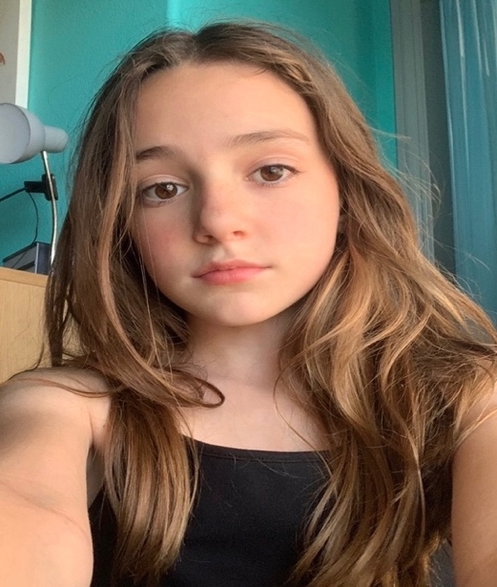
The Curious Savage  Shrek  Annie (Movie Studio)  The Little Mermaid  Seussical Junior  The Lion, Witch & Wardrobe  Annie Kids  The Sound of Music | Lily  Dragon  Miss Hannigan  Flounder  Jo Jo  Lucy  Annie  Gretl | FISD  FISD  NTPA  FISD  NTPA  NTPA  NTPA  NTPA | 2025  2024  2024  2023  2023  2023  2023  2022
Little Red Riding Hood | Sgt. Sue | NTPA | 2021
The Enchanted Bookshop | Heidi | NTPA | 2021
Frozen Kids | Hans | NTPA | 2021
101 Dalmatians Kids | Penny | NTPA | 2020
Annie Jr. | Molly/Maid/Apple Seller | NTPA | 2020
Elf Jr. | E. Von Brocklin/Elf | NTPA | 2019
James and the Giant Peach | Buzz | NTPA | 2019
Training
Audition Prep & Vocals |  | NTPA | 2022-24
Dance  Special Skills – British Dialect |  | NTPA | 2019-20
Awards
AMPS Award - Runner-Up
Rising Star Division – Supporting Actress in a Musical
AMPs Award – Runner Up
Junior Division – Physical Acting in a Play

