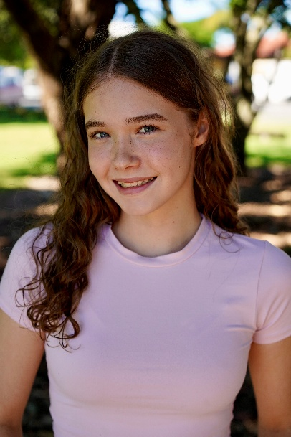Josie Kirk

Phone: 0480408458

Email: [nataliehankinson@yahoo.com.au](mailto:nataliehankinson@yahoo.com.au)

Age: 14

DOB: 18th March 2010

Height: 162

Hair colour: Honey Brown

Eye colour: Blue

Ethnicity: Australian Caucasian

I am a passionate actor, singer and dancer and enjoy every opportunity I get to perform. I have been performing since the age of 4. I am a committed hard-working person and work well with a team.

**Training**

2025 – Musical Theatre – National Academy Of Performing Arts

2014 – 2024: Musical Theatre, singing, dancing, acting - Hyped Performing Arts (Courtney Monsma, Emily Monsma, Tiahni Wilton, Chiara Lagana)

2016 – 2022: Jazz, Lyrical, Hip-hop – Hyped Performing Arts

2020 – Present: Tap (Alana Andrews)

**Workshops**

2024: Musical Theatre workshops (2) – Emily Monsma

2021: Acting workshop – Emily Monsma and Timothy Carrol

2022: Musical theatre workshop – Courntey Monsma and Justine Anderson

**Shows and Experiences**

|  |  |  |  |
| --- | --- | --- | --- |
| **Show** | **Role** | **Where** | **Year** |
| **Curtains** | **Niki Harris (Lead)** | **NAPA (National Academy of Performing Arts)** | **2025** |
| **Alice In Wonderland**  **The Pantomime** | **Cheshire Cat (Lead)** | **Spotlight Theatre** | **2025** |
| **Newsies** | **Featured Newsie** | **All Saints** | **2025** |
| **Crossbones** | **Engineer (Lead)** | **All Saints** | **2024** |
| **Peter Pan the Pantomime** | **John Darling (Lead)** | **Spotlight Theatre** | **2024** |
| **Hairspray (adaptation)** | **Corny Collins (Lead)** | **Hyped Performing Arts** | **2024** |
| **Greatest Showman (adaptation)** | **P.T. Barnum (Lead)** | **Hyped Performing Arts** | **2023** |
| **High School Musical (adaptation)** | **Sharpay Evans (Lead)** | **Hyped Performing Arts** | **2022** |
| **Annie (adaptation)** | **Annie (Lead)** | **Hyped Performing Arts** | **2020** |

Skills:

American Accent, British Accent, piano player, guitar player, singing, dancing, acting, public speaking, horse riding, roller/ice skating,