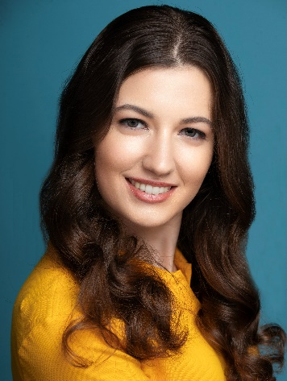
Erin Ziccarelli
Height: 5’6 571-565-4481
Weight: 120 lbs erineziccarelli@gmail.com
Hair/Eye color: brown/hazel Union affiliation: None

TV
Lady in the Lake Extra Apple TV

COMMERCIAL
Square Payment System Extra Windy Films
Level All Content Videos Lead Green Screen Films
Museum of the Bible; Jesse Low, Director Extra DropDrop Productions

TRAINING
MDM Artists Group DC, Michael McDavitt, T.V. and Film Techniques, Cold Copy, Improv
Uptight Citizens Brigade, Doug Moe, Improv 101 (Basics), Improv 201 (Game of the Scene)
Comedy Cellar, Veronica Mosey, Standup Writing and Performance Techniques

SKILLS
Athletics: yoga, cycling, table tennis, weightlifting (<15 lbs), snow skiing, aerobics, bowling, running, volleyball
Comedy: improvisation (short form and long form), sketch, stand-up
Instruments: piano (10 years of experience)
Languages: English (native), German (proficient), Latin (beginner)

