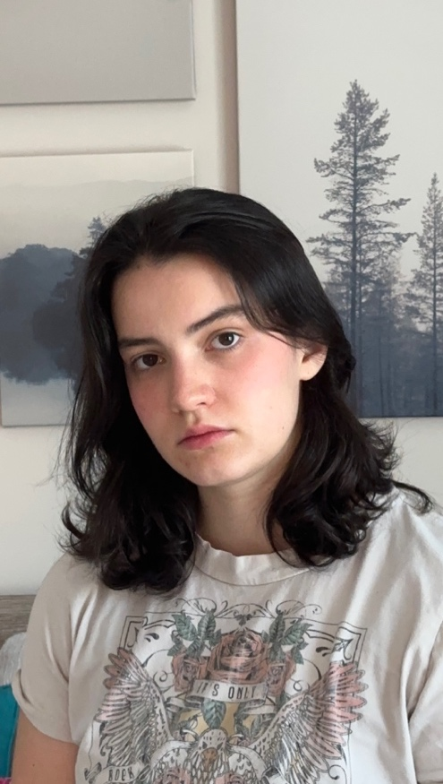

Alana Nyers
Wilmington, North Carolina
Cell: 910-398-2013
Email: alana.nyers@icloud.com

Height: 5’7”
Weight: 140 lbs
Eye Color: Brown
Hair Color: Dark Brown
Union Status: Non-Union | Seeking Representation

Work Experience | Theatre/Stage
Role(s) | Production | Director/Company
Lady Bird 2 | Frog and Toad | Act for Youth
Mouse 3 | Rodgers & Hammerstein’s Cinderella | Dir. Martha Nida, Act for Youth
Tech Crew | School House Rock Live | Dir. Brian Wingrove, Act for Youth
Wedding/Funeral Attendee | Our Town | Dir. Martha Hale, Act for Youth
Main Child in Party Scene | Nutcracker (Ballet) | Moscow Ballet
Flower/Snowflake/Arabian Dancer (en pointe) | Nutcracker (Ballet) | Wilmington Dance Theatre
Fairy Court Dancer (en pointe) | Sleeping Beauty (Ballet) | Wilmington Dance Theatre
Training
Class/workshop | Instructor | Institution
On-Camera Audition Technique | Megan Peterson | Actor’s Arsenal, Wilmington
Ballet Apprenticeship Program | - | Wilmington Conservatory of Fine Arts
Cecchetti Ballet Intensive | Walter & Ines Angelini | U.S. International Ballet
Vaganova Ballet Intensive | Nina Danilova | Wilmington Conservatory of Fine Arts
Private Vocal Coaching | - | Independent Study
Special Skills
Performance: Ballet (en pointe), Contemporary, Improv, Singing, Spoken Word
Physical: Swimming, Running, Weightlifting, Horseback Riding, Motorcycle Riding, Jujitsu, Volleyball
Languages: Fluent in English, Basic German
Technical: Computer Analysis, Crime Analysis, Case-Building, Pistol Shooting
Creative: Drawing, Writing, Photography
Driving: Manual & Automatic Transmission
Tattoos: Artistic waterline piece (leg/side of body), Butterfly and Moth (lower back)

Passports: United States of America, Switzerland, United Kingdom
Drivers Licenses: Class C, Motorcycle Endorsement

