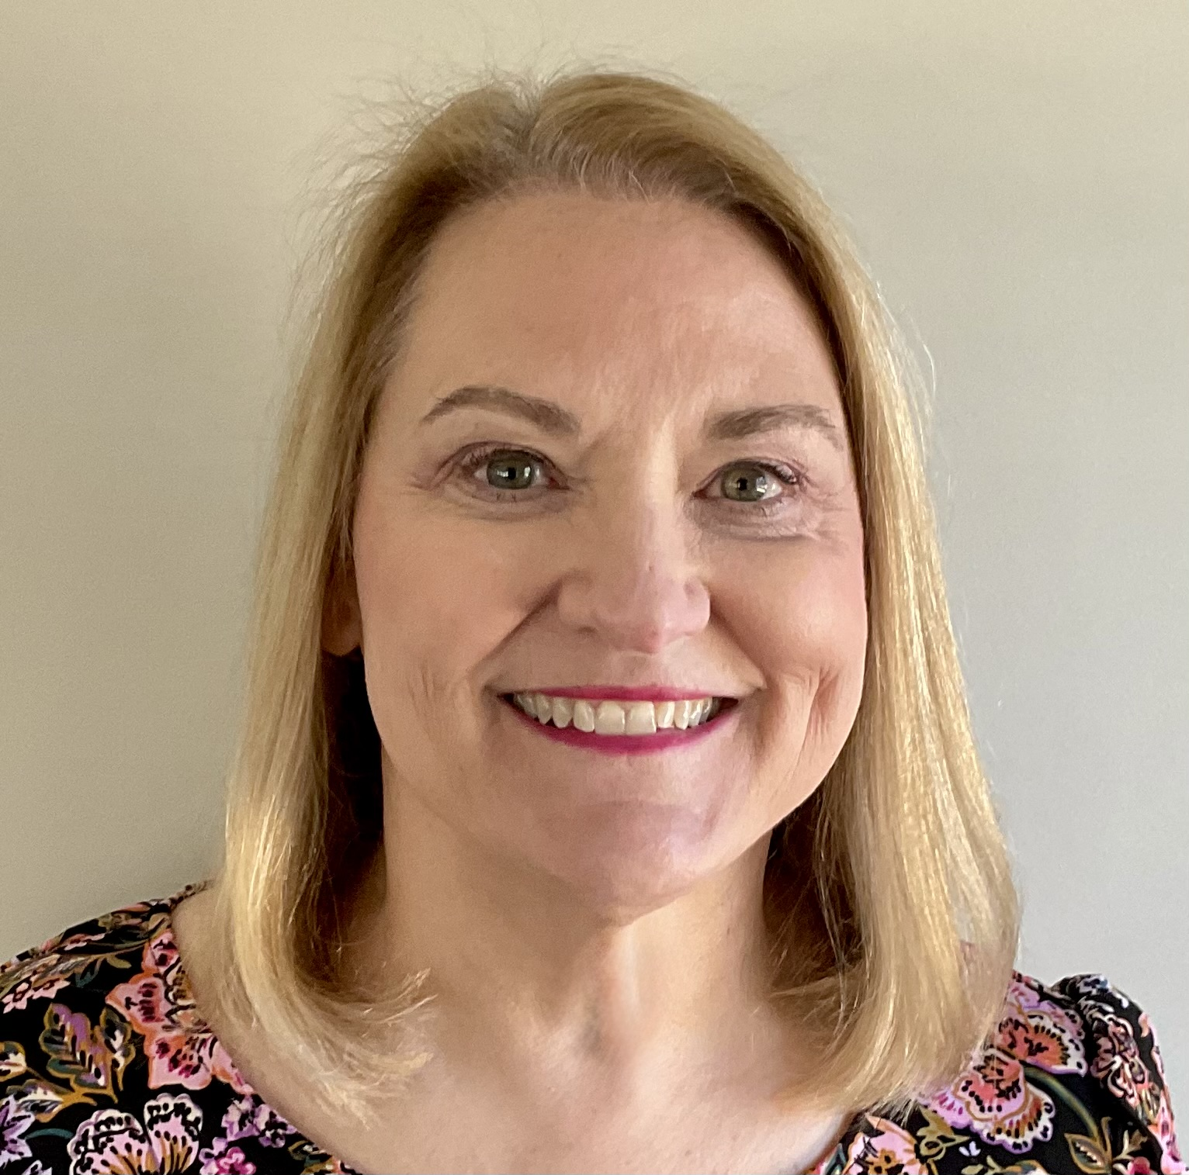 |  |  | Pamela Smulders  404-384-6410  pamelasmulders@gmail.com  Non-Union  objective  Fresh face seeking roles as actor or background actor. Desire to gain on-set experience and be part of an impactful and professional production.  To serve as a photo double for a lead actress in select scenes  personal details  Natural, organic features: No facial fillers or lip enhancements, no tattoos or piercing (other than ear lobes), no breast implants.  Clean, professional appearance  Hair: Golden blond with chestnut undertones  Eyes: Hazel  Height: 5’ 4 1/2”  Weight: 158  Ethnicity: Caucasian  Dress: 12  Shirt: Large  Pants: 14  Shoes: Women’s 9  Bra Size: 38DD  experience  May, 2025: Murdaugh Murders (Currently filming)  Role: Court House bystander – Friend of Alex Murdaugh  May, 2025: Sistas Season 10 (Tyler Perry Productions)  Role: Lawyer in upscale law firm  May, 2025: Crooked Suits – In Production)  Role: Governor Harper (speaking role)  April, 2025: By Any Means – Mark Wahlburg Feature Film  Role: Pedestrian set in 1960’s reacting to scene  April, 2025: DTF ST. Louis – Jason Bateman HBO Project  Role: Restaurant Patron  abilities  With my past experience as a commercial contract negotiator, I have an extraordinary ability to use my facial expressions and body language to evoke a desired response. I have a natural charm, a quick wit, and an authenticity that makes me instantly relatable to audiences.  Able to follow on-set direction with professionalism and consistency  Willing to use automobile for scenes.  Available for a late-day call time and extended night shoot
 | Atlanta Area
 | 404-384-6410
 | pamelasmulders@gmail.com
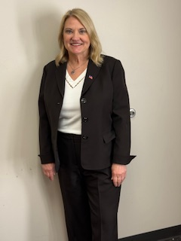
Governor Harper in Crooked Suits

