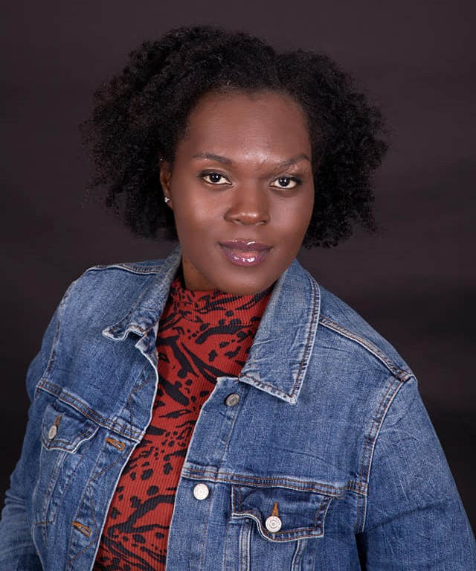
Jenise Albritton, Terika
Actress/Model/Writer/Singer
Email: jenloassassin@gmail.com
FB/IG/Twitter: JenLoAssassin
Location: Kinston, NC / Atlanta, GA
Phone: 470-377-3134
Height: 5’7” Hair: Brown Eyes: Brown
Vocal Range: Alto/Soprano

Film/Plays
Sistah, Oh My Sistahs Nefer, Shades of Black Dir. Carmen Davis
Black On Both Sides Protester Dir. Alonge Hawes
Blue Collar Hustle S1, S2 Best Friend Dir. Alonge Hawes
XXI O’Day Student, Party Goer Dir. Brandon Holland
Who’s Spreading The Word Aubrey Davis-Daughter Dir./Prod. Annetta T. Swift
The Last Disciples: JOB Neighbor Dir:/Prod.: Jurian Isabelle
Other
Movies - Star on Fox , Uncle Drew and Dumpling
100 Voices Choir performance at Atlanta State Capital
Radio Host on Real Talk: Second Chance
Lil Zane music video – Broken Pieces
Training
Acting class at ActHer Studios
Acting classes with LS Acting Studios – Louis Stancil and Shon Middlebrooks
Behind the scenes: Boom mic, Social Media (film, pictures and posting)
Training with Creative Veins. Certificate of completion for Intro To Acting.
Online training with director Janet Urban through Friends In Film.
Acting classes with Dewayne Boyd and Todd Manaigo at Porter Sanford III Performing Arts Community Center
Class at ActHer Studios

Skills/Talents
Singing, writing music and poetry. Making Custom Wigs
Author, motivational speaker.

