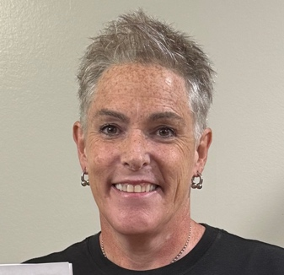
MILLER RAE
170 Huntcliff Court · Fayetteville, GA 30214
📞 404-399-8223 📧 millerraevo@gmail.com
📸 Headshot available upon request

ABOUT ME
Over 35 years of experience in theater. Professionally trained character actor and voice talent with 26 original character voices in my repertoire. Skilled singer with a charismatic presence, confident delivery, and unwavering integrity. Passionate, creative, and imaginative performer dedicated to bringing stories and characters to life. FILM & TELEVISION
DTF St. Louis – Detective | HBO
Naked Gun: Laws of Toughness – Book Club Member | Paramount Pictures
Cape Fear – AA Member / Bar Patron | Apple TV+
Murdaugh Murders – Paramedic | Universal Content Productions
Breadwinner – Pedestrian | Trips Star Pictures
The Surgeon – Restaurant Patron | SCAD Student Film
Flip Side – Audience Member | SyndicateTHEATER
Hamlet – Horatio | Georgia State University
Taming of the Shrew – Katherine | Production Players
Magic – Bag Lady | Production Players
Arms and the Man – Catherine Petkoff | Production PlayersSKILLS & ADDITIONAL INFORMATION
- Improvisation, character work, public speaking, stage combat (basic), dialects (Southern, British RP)
- Singers: trained vocal performance
- Voiceover: 26 original character voices
- Reliable, collaborative, strong presence on stage and camera
- Driver’s license · Owns wardrobe for various character types
EDUCATION
- Agnes Scott College
Master of Art in Education
- Georgia State University
Bachelor of Arts in English and Theater · Minor in Philosophy

