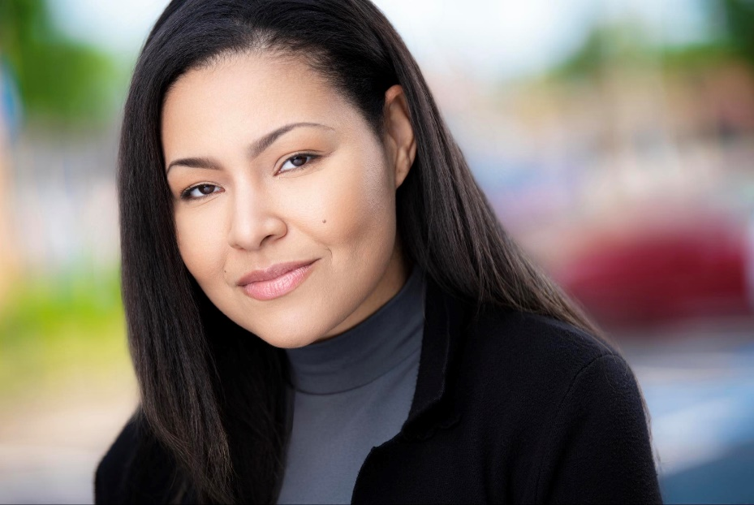
Tiffany Evans
Email: Booktiffanyevans@gmail.com
Phone: +1 407-615-9382
Instagram: tiffanynycole_
Location: Orlando | Atlanta
Talent Agency: Bailey’s Entertainment Group
Playing age: 28 - 43
Height: 5'4“
Hair: Black
Eye: Brown
Gender: Female
Build: Average
Ethnicity: Mixed-race

Experience
Background Actor
Peacock TV // “M.I.A”
06/2025 – Miami, FL
- Efficiently executed complex crowd scenes, ensuring seamless integration with the film's storyline.
- Quickly adapted to last-minute changes and successfully adjusted performances to fit the revised vision.
Training
Studio Conservatory Acting for Stage, Film & TV - The American Musical and Dramatic Academy – 2010-2011
Television Episodic Class – L.A. Actors Institute – 2023
On-Camera Commercial Workshop – Dwayne Boyd’s Premier Actors’ Network – 2025
Improv Development Class – Winter Springs Performing Arts – 2025-Ongoing
Skills
Singing: Mezzo Soprano | Alto
Accents: Standard English (Native) | Southern
Other: Voiceover Work | Memorization | Improvisation | Language Skills | Rollerblading | Method Acting

Passport and Driver’s License available

