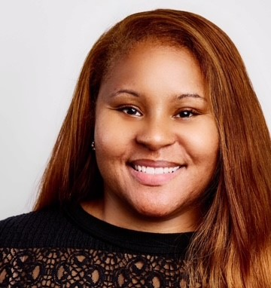^{Ashley Randall}
https://www.linkedin.com/in/ashleycatherinerandall/ | 313.610.7845 | ashleyrandall@hotmail.com | Los Angeles, CA

SUMMARY
Voiceover artist with a background in broadcasting, media production, and performance. Skilled in commercial, narration, corporate, and character voiceover with a versatile vocal range. Ability to interpret scripts and deliver engaging performances tailored to the target audience. Professional recording setup with audio production capabilities.
TRAINING & EDUCATION
Bachelor of Arts in Broadcast and Cable Production – Western Michigan University
Voiceover I & II (Instructor: David Wayne Parker) - Michigan Actors Studio
Stella Adler Academy of Acting (2024 SOVAS Scholarship Recipient)

VOICEOVER EXPERIENCE
News Anchor – 89.1 WIDR-FM (2000-2002)
- Delivered weekly news broadcasts with clear articulation and professional tone.
- Conducted live on-air reporting and scripted news segments.
- Enhanced ability to engage audiences through voice modulation and pacing.
TECHNICAL SKILLS
- Professional voice recording
- Home studio setup with high-quality microphone
- Script interpretation and delivery techniques

