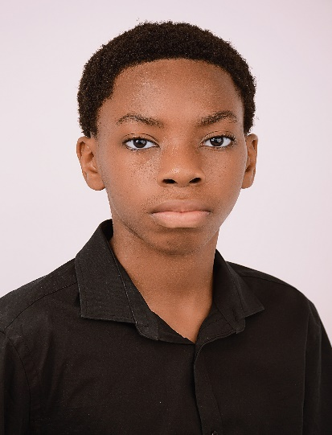
Somto Nwafor Non-Union
Email: somtonwafor76@gmail.com
Contact: +234 808 268 1578

Physical Attributes
Height: 5 “7”
Weight: 51 kg
Eye Color: Brown
Hair Color: Black
Special Skills
Drawing, Singing: Vocal Range: Tenor/High Bass, Video Editing, Playing the piano and electric guitar, Photography, Basketball, Soccer, Swimming, Gymnastics, Improvisation, Accent.
Training
IGCSE Drama Curriculum: September 2023 – May 2025
10 hour Acting Masterclass: Actors Academy

Experience
Lion King Timon Main Character
Moremi Olugbo Main Character
Child International Kotun Lead Role

