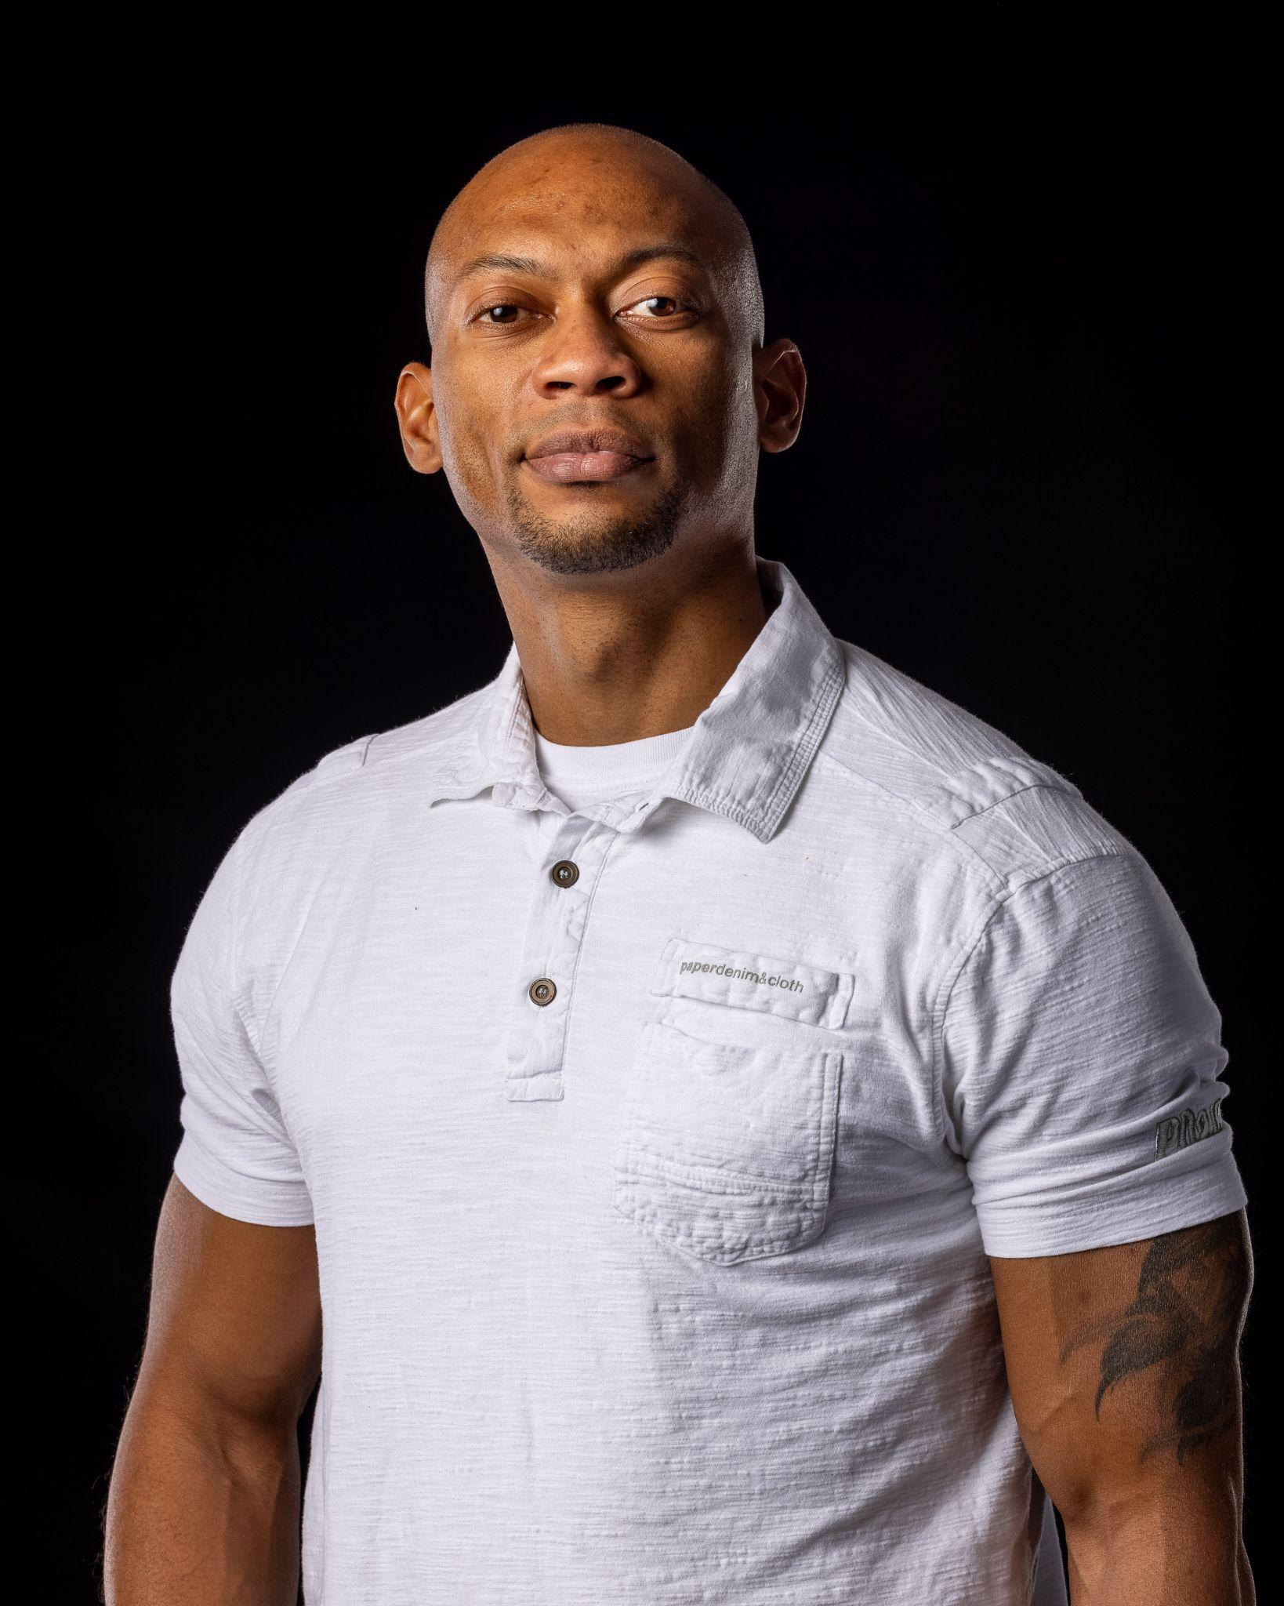RAYLIN SCHANNETTE

***STAGE NAME****:* RAY’LIN FRANCOIS ***AGE RANGE:*** 30 – 45 yrs.

***HEIGHT:*** 6’0 / 72 in ***WEIGHT:*** 175 lbs. ***EYES*:** BROWN

***HAIR:***BLACK ***NON-UNION YEARS ACTIVE:*** *2015-Present*

***PHONE:*** 225-328-1961 ***EMAIL:*** [raylinfrancois@gmail.com](mailto:raylinfrancois@gmail.com)

***ETHNICITY:*** LOUISISANA CREOLE / SICILLIAN

***ETHNIC APPEREANCE:*** Biracial, Multi-racial, Caribbean, Afo-Latino, African American, Ethnically Ambiguous, Indigenous, Hawaiian Pacific Islander, South American, Central American

**FILM**

El Mensaje Supporting Dir. JC Gonzalez

Hunters Supporting Dir Baldemar Garcia

How Far? Lead Dir. Hugo Rodriguez

Halloween Tales of Crow Lead Dir. Hugo Rodriguez

Side Effects Lead Dir. Ray ‘Lin Francois

Monster Supporting Valley Entertainment

The Terror on Halloween Night Supporting Valley Entertainment

I See U.C.I. Supporting Valley Entertainment

I Survived Supporting Dir. Hugo Rodriguez

Foresight Supporting Dir. Hugo Rodriguez

Devil’s Dinner Supporting Dir. Hugo Rodriguez

Project V Supporting Dir. Hugo Rodriguez

Find Me Lead Dir. Hugo Rodriguez

Morals Supporting Dir. Hugo Rodriguez

This is who I was Supporting Dir. Zack Rodriguez

Black Panthers Rescue Squad Supporting Dir. Fernando Arteaga

Secuestro De Karla Parks Supporting Dir. Fernando Arteaga

**TELEVISION**

RGV Borderlines Co-Star Dir. Ray’Lin Francois

Special Ops: Lioness Army Major Doctor Dir. Taylor Sheridan

**MUSIC VIDEOS (8) / COMMERCIALS (6)**

(List Available Upon Request)

**EDUCATION: Baton Rouge Community College Mayjor:** Criminal Justice **Minor:** Fine Arts

**SPECIAL SKILLS**

**Languages:** English, conversational Spanish

**Sports:** Football, Baseball, Softball, Boxing, Kickboxing, Martial Arts (Karate, Muay Thai), Swimming (freestyle, backstroke, doggy paddle, breaststroke)

**Other:** Yoga, Weightlifting, Dancing (Hip-Hop, Salsa, Cumbia, Merengue), Writer, Gardener, Cooking, Boogie Boarding, Hiking, Skydiving, Zip Lining, Snorkeling, Scuba Diving, ***Fight Choreographer***, Print Modeling, Public Speaking, Rapping, Singing (tenor)

**SPECIAL TRAINING**

Border Patrol Agent (2010-present)

United States Navy (2007-2023)

Firearm (handgun & rifle), Self-Defense, Close-Quarter Combat, Ground Defense, CPR, SWAT, Search and Seizures, Arresting Subjects, Undercover Surveillance