Genevieve Newman

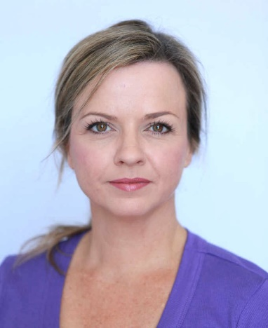  Contact  Ph 0414 522 140 gnewman@bigpond.net.au  45 Lilacdale Rd  INNALOO WA 6018  Key Skills  Acting, Singing,  Voice Over  Dance incl Ballet & Tap  Various Accents  Violin, Piano, Guitar  Agent  Now Actors – Perth  (08) 9201 1822  perth@nowactors.com.au  www.nowactors.com.au  URL:  https://www.nowactors.com.au/perth  /female/actors/genevieve-newman/ | Theatre Experience  YEAR PLAY (character) DIRECTOR VENUE / PRODUCER  2024 Picnic at Hanging Rock – Mrs Appleyard Kathleen DelCasale Old Mill Theatre  2024 Annie the Musical – Mrs Pugh Olivia Collier Regal Theatre - HAMA  2023 Company – Sarah Gillian Binks Limelight Theatre  2022 Wizard of Oz – Aunt Em Olivia Collier Crown Theatre - HAMA  2021 bare A Pop Opera – Claire Olivia Collier Subiaco Arts Centre  2020 High School Musical – Ms Darbus Olivia Collier Regal Theatre – HAMA  2020 Heathers The Musical – Ms Fleming Olivia Collier Regal Theatre – HAMA  2019 Wizard of Oz – Aunt Em Olivia Collier Regal Theatre – HAMA  2019 Ladies in Black – Mrs Miles Kimberley Shaw Playlovers  2018 Side by Side by Sondheim Gillian Binks Limelight Theatre  2017 Ruthless the Musical – Judy/Ginger Kate McIntosh Koorliny Arts Centre  2016 Sound of Music – nun Jeremy Sams Crown Theatre – GFO  2015 Faust – ensemble Bruno Ravella His Maj Theatre - WAO  2015 Oklahoma - ensemble Adam Mitchell Regal Theatre - MUSEO  2014 Anything Goes - Hope Harcourt Terry Pirlo Limelight Theatre  2013 Phantom of the Opera – Mdm Giry Bob Mainwaring Limelight Theatre  2013 Hairspray – Velma Von Tussle Shelley McGinn Limelight Theatre  1992-2012  The Best Little Whorehouse in Texas – Miss Mona  Joseph & His Amazing Technicolor Dreamcoat - Narrator  HMS Pinafore – ensemble  The Wedding Singer – Grandma Rose  Beauty and the Beast – Silly Girl  West Side Story – Anybodys  The Magic Flute – ensemble  City of Angels – Donna/Oolie  Grease – ensemble  The Wiz – ensemble
  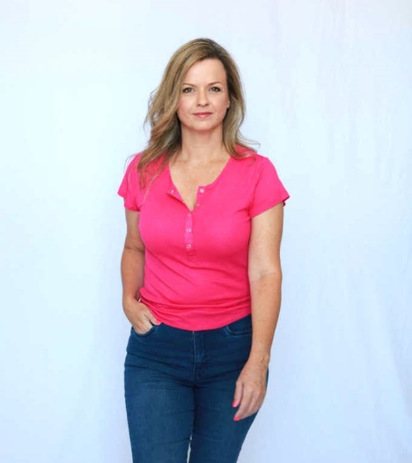 | FILM / TV / COMMERCIALS  2012-current:  Dirt Music / Black Ghost / Sovereign / P & N Bank / WA Museum / Greyhounds WA / Crown Perth / LotteryWest / Cash Converters / Internode Internet / Perth International Airport / RAC WA / HBF / ATCO Gas

EDUCATION
Bachelor of Communications – Media & Photo-media (Edith Cowan University)
Certificate of Musical Theatre – WAAPA (Edith Cowan University)
Showreel & Casting – TAAFTA
Masterclass Audition & Voiceover – Black Swan Theatre Co.
High School Diploma – John XXIII College
AMEB 8th Grade & Suzuki Method – Violin
Advanced RAD Level – Classical Ballet – John & Bernadette Ballet School

AWARDS
Finley Award - Best Lead Actress in a Musical - Ruthless the Musical – Judy/Ginger
Limelight Award - Best Lead Actress in a Musical - Joseph & Technicolor Dreamcoat - Narrator
John XXIII College – Music Award & Service Award
___________________________________________________________________________

