**Melissa Falen Actor & Voice Over Artist**

[**https://www.imdb.com/name/nm14804894/**](https://www.imdb.com/name/nm14804894/)

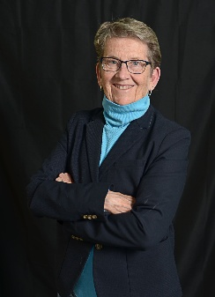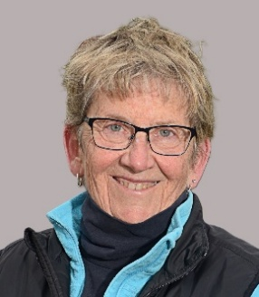 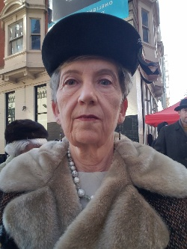 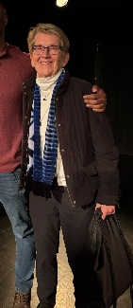

**Introduction**

I am a retired career associate professor and collegiate athletics coach. Shortly after retirement, I had an opportunity for a background role. I had a great experience, loved the diverse community of people I met on set, and decided to pursue more significant acting opportunities. Since then, I have been fortunate to get speaking roles in short and feature films, tv series, podcasts, and commercials, along with more background work. As a former coach, I understand and embrace teamwork. I have strong leadership skills, am organized and have solid computer skills. I am motivated to learn, grow and excel as a film and voice-over actor. My time is flexible, I am willing to travel, and I am a "quick" study. My outside interests include film in general, photography, hiking, pickleball, politics and LBGTQ advocacy.

**Work History**

**ACTING**

**05/2025** Principal Handy in ***Chosen: Reclaiming Her Time***, feature film (in production)

**12/2024** Female lead in 3 social media ***commercials*** for IMCI (in production)

**11/2024** Orchestra Manager**, *The Audition,*** short film (in production), Timothy Parsons film

**10/2024** Miss Helen**, *Fortuitous*,** feature film (in production), Crystal Bass film

**09/2024** Beth, ***Equity (ongoing series),* episode 2,** 4cornerstv

**04/2024** Grandma Margaret**, *Almost an Angel*,** feature film, Shelton R. Johnson film

**03/2024** Cashier, ***Dead Man Walking***, student short film, Stevenson University

**02/2024** Beth**, *Equity (ongoing series),* episode 1,** 4cornerstv

**01/2024**  Female Lead, ***Commercial***, MySquard app

**10/2023** Victim,Connie Ridgeway**, Crime Nation episode 2**

**06/2023** Josephine in ***All Gifted***, student short film, American U.

**04/2023** StrandedWoman (speaking/action role), ***It’s Not True,*** episode 9, Ticfy Prime

**VOICE**

**05/2025** Secretary in ***Room 107***, short film (in production)

**08/2024** Shadow in ***Inner Shadow*,** short film (in production)

**08/2023** Lynette in ***Fireside,*** podcast

**03/2023** Voice in promo reel, ***Stone Fort***, student short film, American U.

**02/2023**  Skrull Dora Milaje in ***Black Panther: Legacy*** (stop-motion film)

**BACKGROUND**

**05/2015** Hospital Staff, ***Neurodivergent***, short film by Graham Sack (in production)

**03/2025** Nobelman’s aide **in *Love and Duty*,** Rowan Brooks short film (in production)

**07/2024 *“Untitled”*** Kathryn Bigelow Netflix Film

**07/2024** Featured extra, **High School Lullaby,** short film

**05/2023** 4cornerstv, ***St. Louis Blues***, short film

**02/2023** Ticfy Prime ***It’s Not True,*** episode 7

10/2022 4 Star Casting ***Lady Of The Lake***

**Education Master of Arts: Education,** Fairfield University

**Bachelor of Science: Health & Physical Education,** West Chester University

**Skills**

Exceptional communicator, can-do attitude, team player, strong Interpersonal skills, professional demeanor, leadership, attention to detail, memorization skills, flexible, quick learner

**Other Attributes**

Height: 5’6”, Weight: 140

Physically Fit/Athletic

**Contact Information**

**Email:** [**mfalen@verizon.net**](mailto:mfalen@verizon.net)

**Phone:** **410-913-2613**