ELLA SANDER  +972542612998  ellasanderella@gmail.com  Haifa, Israel / New York, NY (American citizen) | 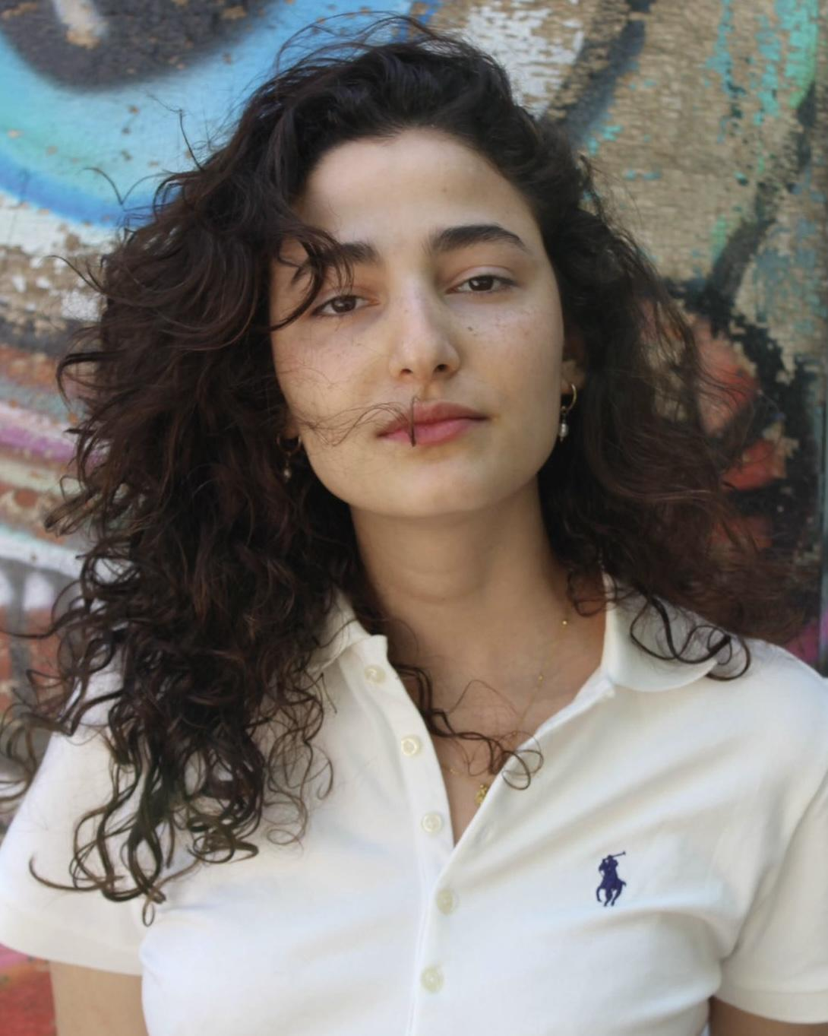Ella Sander
RELEVANT EXPERIENCE
The Troupe | Shula | Re’ut School of the Arts, 2019
The Pearl Color | Zoe | Re’ut School of the Arts, 2018
Spanish Orchard | Ensemble | Re’ut School of the Arts, 2018
EDUCATION & TRAINING
Acting Technique, Movement, Voice, Script Analysis, Theater History | Re’ut School of the Arts (2017–2019) | Haifa, Israel
6 week Summer Intensive | Sandy Faison, Todd Susman, Colleen Smith Wallnau, Mary Beth Donahue, Brad Lemons, Sarah Jenkins | Neighborhood Playhouse School of the Theatre (June-July 2025) | 340 E 54th St, New York
PERSONAL STATS
Height: 5’9”
Hair color: Brown
Weight: 123 lbs
Eye color: Dark Brown
MISCELLANEOUS
Special skills: Fluent Hebrew and English (Hebrew & American accents), Aerial Yoga (6 years), Mountain Trekking (3 years)
Passport status: Valid Israeli and U.S. passports

