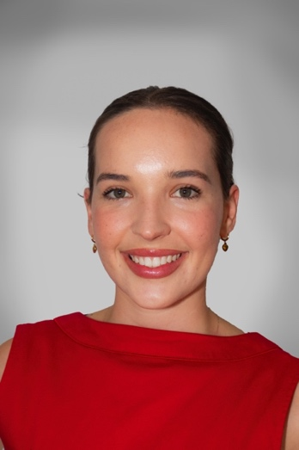

**Brianna Pope Email: Briannapopeacting@gmail.com**

**Phone: (+64) 022 646 7452**

**Overview:**

I have been acting since 14, with experience spanning multiple Kiwi productions and major international projects for Amazon and Netflix. I am very comfortable on set and around the cameras. I am passionate about deeply developing and embodying characters. I strive to connect with audiences by portraying characters in a way that feels both genuine and engaging.

Location: Auckland, NZ (Moving to USA in June)  
Height: 5'10” / 179cm

Age: 21   
Eye Colour: Green  
Hair Colour: Brown  
Playing Age: 16-25

Productions Worked on:

* The Educators
* The Lord Of the Rings
* One Of Us Is Lying
* Broken wood Mysteries
* Power Rangers
* Juniper (2021)
* Shortland Street (Featured)
* Under Her Skin – Short film: Lead Role
* Checkmate – Short film: Lead Role

(These are currently unlisted on YouTube but available via this link as they are being entered elsewhere)

Click here to watch *Under Her Skin* [*(Preview)*](https://www.youtube.com/watch?v=TMX8K3v5vXQ)

Click here to watch [*Checkmate*](https://www.youtube.com/watch?v=AuCofuApn4k&feature=youtu.be)