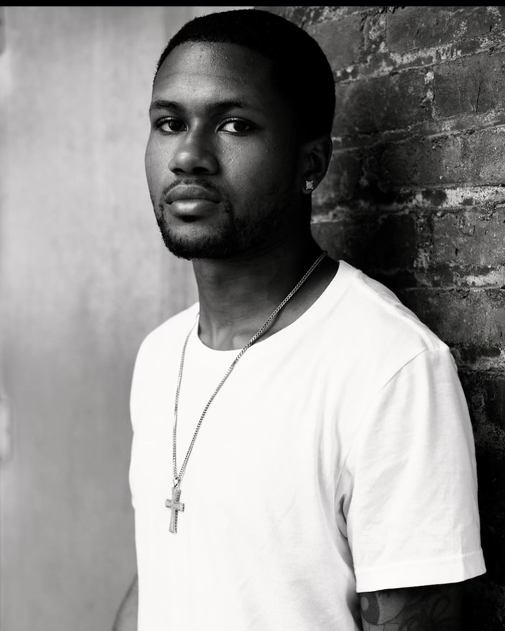 |  | BRANDON PERKINS  ACTOR/MODEL  Stats
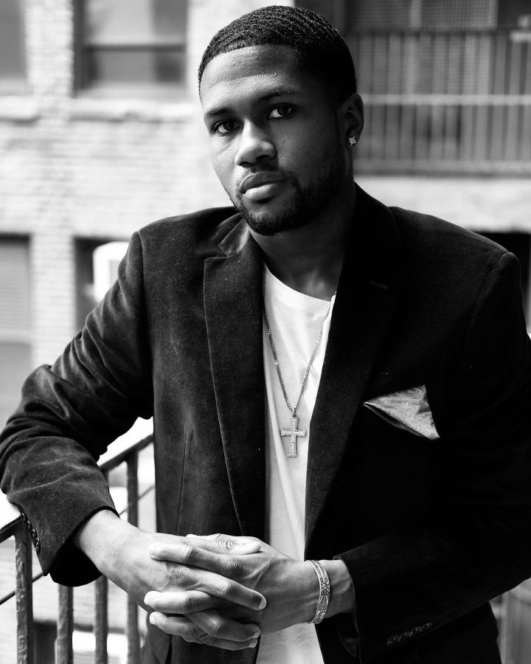    Contact  PHONE:  718-755-4936  EMAIL:  Mr.Perkins830@gmail.com |  | EXPERIENCE  GEP Cencast LLC, General Extra  4/22 – present  Castings: unreleased  - Godfather of Harlem – Season 3  - Power Book III: Raising Kanan – Season 3  - Girls on the Bus – Season 1  - Upgraded  - O Horizon  - Power Book II: Ghost – Season 3  - Saint X – Season 1  - Blank Slate - Pilot  - Law and Order – Season 22  - Law and Order: SVU – Season 24  - Law and Order: Organized Crime - Season 3  - Evers’s Blueberry – Season 1  - The Missing – Season 1  - Fleishman is in Trouble – Season 1  - BAAMAS – pilot  - Diarra from Detroit  - FBI – Season 5  Released:  - Everything's Trash – Season 1  Entertainment Casting Services, LLC, General Extra  6/22 – 12/2022  Castings:  - Gilded Age – Season 2  THE MODEL EXPERIENCE, Model  8/21 – 9/2022  Spring 2022  - LA Fashion Week  MEDIAMAKERS NYC, Production Assistant  08/2018 – 12/2022  2022 Scene Reenactment  - Documentary – Behind the Mic, Fall 2023  2018-2022  - Assist producers with show preparations and video of b-roll content  - Setup/test/breakdown of audio-visual equipment  - Assist in the content development process, generated ideas  - Assist in the video editing process using ProTools  EDUCATION  Morrisville State College, SUNY B.S in Technical Management

