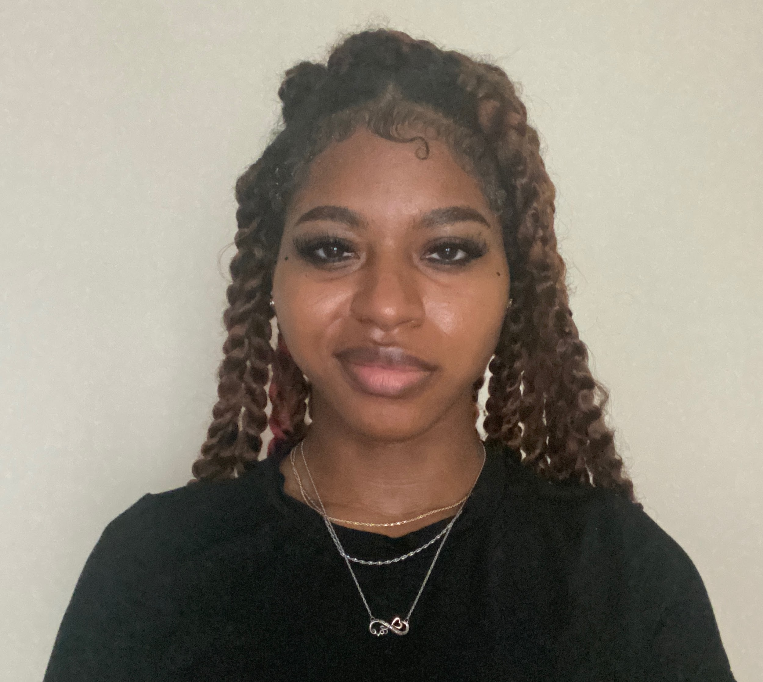

**Physical Attributesiimmmmmmmmmmmmmmmmmmmmmmmmmmmmmmmmm**

**Height:** 5’3’’

**Weight:** 127lbs

**Eye Color:** Dark Brown

**Hair Color:** Dark Brown

**Acting Creditslllmmmmmmmmmmmmmmmmmmmmmmmmmmmmmmmmmmm**

* **Television**

GIGI & NATE Background PN Films (Dir. Nick Hamm)

* **Plays**

School Girls; Or, The Role (u/s) Lisanne Shaffer-Dickerson

African Mean Girls Play

* **Scene Work**

Shakespeare: King Lear Lead ECU

In Love & Warcraft Lead ECU

**Educationmiiilmmmmmmmmmmmmmmmmmmmmmmmmmmmmmmmmmmmm**

* Central Piedmont Community College
  + Associate of Arts
* East Carolina University
  + BFA Theatre Arts: Acting Concentration

**Special Skillslmmmmmmmmmmmmmmmmmmmmmmmmmmmmmmmmmmmm**

Can read IPA, Can Stitch & Sew, Ghana Accent, Cockney Accent, British Accent, Russian Accent, Juggling, Volleyball, Tennis, Running, Swimming, Equestrian (general), Yoga, Cycling, Licensed Driver.

**Trainingllmmlmmmmmmmmmmmmmmmmmmmmmmmmmmmmmmmmmmmm**

Acting 1 (DRA 130-01) James Duke

Acting Studio 1 Austin Jones

Script Analysis Jen-Scott Mobley

Voice and Speech For the Actor Rebecca Simon

Theatre Design Jeni Parker, Reid Parker,

Micheal Shoaf, Delta Childers-Smith