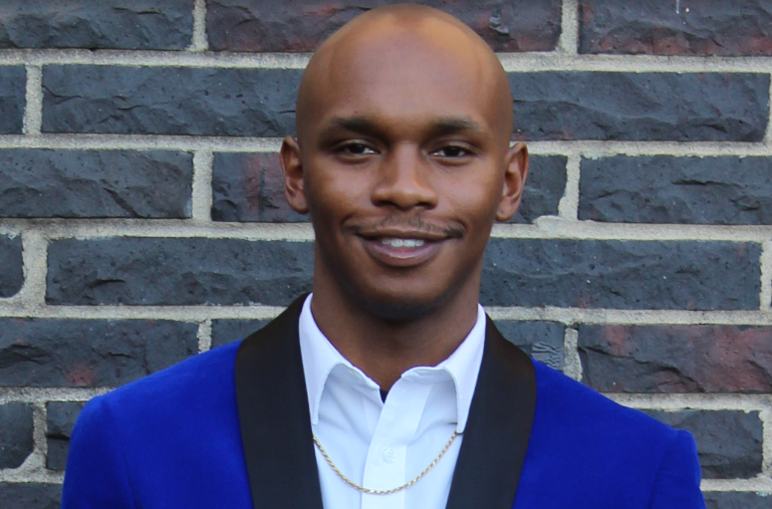 |  | Brennan jamaal francois  Actor
Profile  Height: 5’9  Weight: 155  Hair: Bald/Black  Eyes: Dark Brown  Jacket Size: Medium, 36  Shirt Size: Medium, 15 1/2, 32-33  Pant Size: 32X34  Shoe Size: 10 1/2  Contact  PHONE:  706-469-7122  WEBSITE:  www.Youtube.com/pastorjamaalfrancois  EMAIL:  eyehavethevictory@gmail.com |  | Film  Project Name: The Assistant 2: A Family Affair (On Going)  Role: Detective Briggs  Director: Karlton Clay  Company: Victory Productions Network  Project Name: Sistahood 2 (2024)  Role: Patient  Director: Karlton Clay  Company: Victory Productions Network  Project Name: Pastor Thorne (2022)  Role: Drug Customer  Director: Karlton Clay  Company: Victory Productions Network  Project Name: The Suicide Squad (2021)  Role: Prisoner  Director: James Gunn  Company: DC Entertainment/Warner Bros.  Project Name: Called (2020)  Role: Voice of Mr. Townsend  Director: Brennan Jamaal Francois  Company: PCP Entertainment  Television Commercials  Project name: “We Buy Gold Boy” Christmas Edition, Jazzy Edition, and Flames Edition  Role: Rapper  Director: Devalle Townsend  Company: Flaco’s Productions  Played Locally throughout the CSRA on BET, MTV, VH1, TV One.  Special SKILLS  Voiceovers, Public Speaking, Preaching, Song Writing, Jingles, Rapping.

