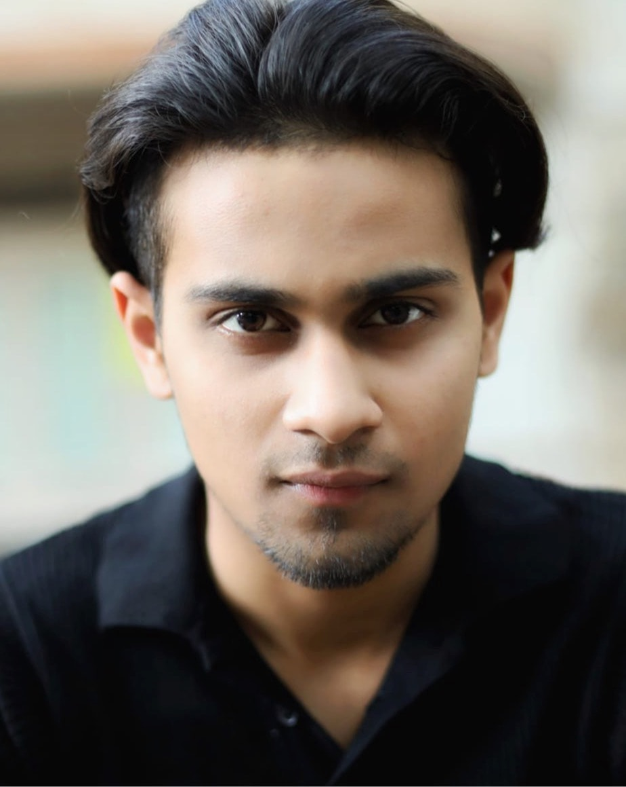 |  | EDUCATION
Ditton Park Academy
September 2021 – August 2023
Opting 3 subjects for my A-Levels out of Drama, Media Studies and English Language, I secured grades of BBC to pass with flying colours and learn new skills to build a secure career for me going forward. I trained under a retired Theatre Artist, George Sotiropoulos who taught me Method Acting of Stanislavski, Grotowski No-Prop Acting and Brecht Comedic Humour.
Royal Holloway University of London
September 2023 – Present
Admitted in the RHUL university, it felt prestigious to take my education forward by learning the Drama and Theatre Studies [Foundation Year] course. While in the first year, I underwent the Foundation Studies relating to Media and English, I have begun learning about Scriptwriting for Plays and Movies. Having written 4 feature-film scripts already as my first steps to forging myself as a professional. I have also submitted myself for the Academy Nicholl Fellowship Screenwriting Competition and the BAFTA Film Festival with little but no success till the final round. But I stand optimistic to learn more and improve in my skills to write a script and act in them becoming the balanced version of both Actor-Screenwriter for n illustrious career ahead.
aradhya sakpal  ACTOR, SCREENWRITER  Profile  A hard-working individual with a strong passion driven towards Performing Arts. I have balanced my studies along with my career by finding numerous work in the Entertainment Industry across 2 nations, UK and India, working not just in Theater but also Cinematic Media, Web-Series and Song.  CONTACT  PHONE NUMBER:  +44 77605 12924  EMAIL ADDRESS:  Aradhya.sakpal@gmail.com |  | WORK EXPERIENCE
RAMAYANA THE MUSICAL - ACTOR
January 2024 – March 2024
Held in London where the Hindus enjoy performing the inauguration of the Iconic Ram Mandir in Ayodhya, India, believed to be the birth city of Lord Rama, a Hindu Deity. A Musical Play recalling his Epic, Ramayana was constructed by the MML Committee for which I auditioned to play the lead role of the Revered Hindu Deity, Rama. Harnessing my skills and lessons taught, I studied the character to its peak, watched many shows regarding him to change myself in my habits and lived as the character to perform the ever-loving Lord Rama, where upon my performance I was showered with love from the audience almost coming to touch my feet. While it sounds magical, I felt it that day on the first show in MML Theatre.

SHEGAVICHA RANA - ACTOR
July 2023 – September 2024
Held in the same Theatre, I made my Stage Debut with this production under the guidance of the Great Dr. Sanjay Pendse who is a legendary Theatre Artist in the Nagpur, Maharashtra [India]. HE taught me voice-modulation, exercises to achieve a deeper voice while performing and how to get rid of stage fear and anxiety while performing. In his play, I performed a Hindu Mystic Saint, Gajanan Maharaj, worshipped by many. I transformed my body physique, stopped gym workout and started eating less food to get myself thin in under one month to achieve Gajanan Maharaj’s physical appearance.

KANNADA - ACTOR
May 2023 – June 2023
Signed up with Spotlight back then with an agent, named LA Management, I found myself a small role in the Bollywood Web-Series, released on Voot, titled Kannada. Performing besides Parmeesh Verma, Punjabi Rapper and Actor, I played the role of his younger brother who motivated him to follow his dreams when he was shown to be degenerate, reminding him of his struggles to reach Canada. I portrayed the emotions of Sorrow, Support, Motivation and emotional moment by even crying on camera given the cues. While, it took me a lot of efforts to debut with might, Parmeesh Sir’s mentoring helped me through. I don’t consider myself a perfect actor, but with the lesson I have got and bright education ahead, I can surely say my acting can impress one at this age.

MAHA GAMANAM - DANCER
October 2024
Dancing next to Telugu Rising star, Shiva Kandukuri was a nail-biting event in my life, not knowing the lyrics of a certain song, a certain language but dancing and lip-synching to them while dancing with full joy to show my screen-presence was something filled with adrenaline. While this is a short, underwhelming experience, I hope to find more as such to build my experience and find myself as a lead one day having my own songs.

ME AND MY LESBIAN FRIEND – ACTOR/ASSISTANT DIRECTOR
December 2024
A Short film filmed at my University by a post-graduate, I auditioned for the role for Mark and secured it to only find myself learning more about the script and asking the Producer/Creator to help me assist him in the Principle Photography for the Short Film. Lasting around 25-30 mins… this Short film was based around college romance where I had to act as the boyfriend for the protagonist’s crush and make him feel overly jealous. As an AD, I enjoyed the first-time experience of Filming someone as per the DOP’s cinematography and capture the essence of the scene. The joy of witnessing the beauty of what I’ve captured brought me goosebumps and satisfaction in knowing I can also include Directing as my potential career option. I seek to gain more experience in it, having made my debut just yet.

MACBETH [2025] – ACTOR/MUSIC COMPOSER
May 2025
Macbeth [2025] is a Short Film released on YouTube, made as a form of coursework from my University to adapt a Shakespearean Scene of our choice and modernise that to a point where it add elements of horror, eeriness of murder mystery and a string of cultural representation to keep it classical and accurate to Shakespeare’s writings. I participated as Lead Actor, Matthew [Modern Macbeth] who contemplates after killing his own and is dealing with hallucinations haunting him, while Lydia [Lady Macbeth] encourages him to stay put. The choice to add a Violin Music Score adds feel to the film and makes the audience intrigued at the 5 min short Film. The intention was to make the audience feel cultural eloped into the world of Macbeth by the help of Classical Venetian Music that fits in the atmosphere of a Chapel where the scene takes place. This was my suggestion to the Director who implanted that gave me credit. I have attached below a link of the Short Film. Do watch.
https://youtu.be/j9i-PPqUl_Q

THE LONG WALK HOME [2025] – ACTOR
February 2025
The Long Walk Home is a 2025 Short Film, which I auditioned for and played the Second Lead role of Will, a romantic boyfriend who loves his girlfriend quite a lot however, after being rejected into a live-in with her, he distances from her and isolates himself during a zombie apocalypse. Will, is horrified to see his girlfriend infected by the disease and resorts to violence in order to protect his life. While his efforts to kill her were fruitless, he loses his own life in the process and dies out of shame and anger. I have attached below a link to the Short Film. Do watch and enjoy.
https://youtu.be/WSbtK_1TqQQ

