GABRIELLE MINERVINO  Model Resume |  |  |  |  |  |  | 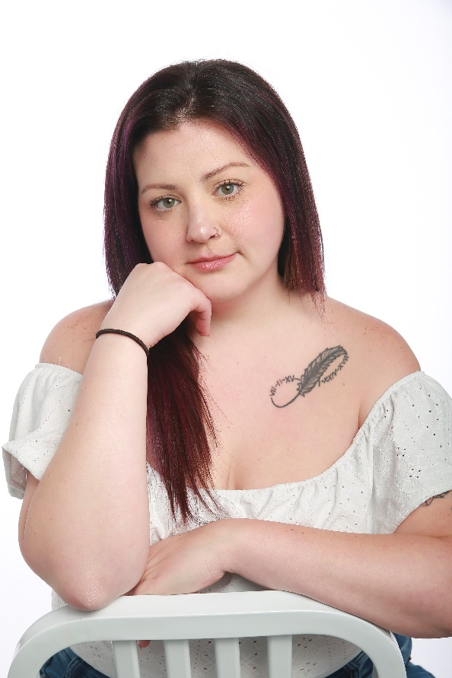
Contact Information
Phone  (706) 707-4484 |  |  | Address  Hartwell, Ga 30643
Email  gabhm24@gmail.com |  |  | Website  www.gabrielleminervino.modelingfolio.com
Personal Statement |  |  |  |  |  |  |  |  |  | Bio
As a dedicated pageant participant, I've cultivated a strong foundation in stage presence, poise, and public engagement. My experience in pageantry has honed my ability to present confidently, adapt to various themes, and connect with diverse audiences. I'm eager to transition these skills into the modeling industry, bringing a unique blend of grace and versatility to every assignment.  Passionate and dedicated aspiring model with a strong interest in fashion, beauty, and creative expression. Eager to bring energy, professionalism, and versatility to every photoshoot and runway opportunity. I am committed to developing my skills, building a strong portfolio, and collaborating with photographers, designers, and brands to create powerful visual content. Known for taking direction well, adapting quickly, and maintaining a positive attitude in fast-paced environments. Ready to grow in the industry and represent brands with confidence and authenticity. |  |  |  |  |  |  |  |  |  | Eye color: Green  Hair color: Brown/Purple  Height: 5’6”  Weight: 200 lbs
Education
National EMS Academy | 2024 – 2024  National Emergency Services Academy- Watkinsville, GA  Course: EMT- B |  |  |  |  |  | High School | 2008–2012  Hart County High School- Hartwell, GA  High School (HS) Diploma
Special Skills
 | - Fluent in English  - Conversationalist  - Excellent posing skills |  |  | - Excellent time management  - Team collaboration  - On stage confidence |  |  |  | - Strong interpersonal skills  - Able to take direction well  - Strong work ethic
Work Experience
 |  | 2024–Present  Tilly’s Tiki Bar and Grill — Lavonia, GA |  |  | Clear verbal communication with guests, upselling items, keeping a smile on my face
 |  | 2024–2025  National EMS — Watkinsville, GA |  |  | Administering basic life support (BSL), rapid patient assessments, quick thinking

