ELEANOR DEMPSEY
0852830576
Elliedempsey1@gmail.com
Playing age: 20-28
Height: 5’8”
Appearance: White
Location: Dundalk
Voice Quality: Clear, bright
Training: BA (hons) Drama and Performance

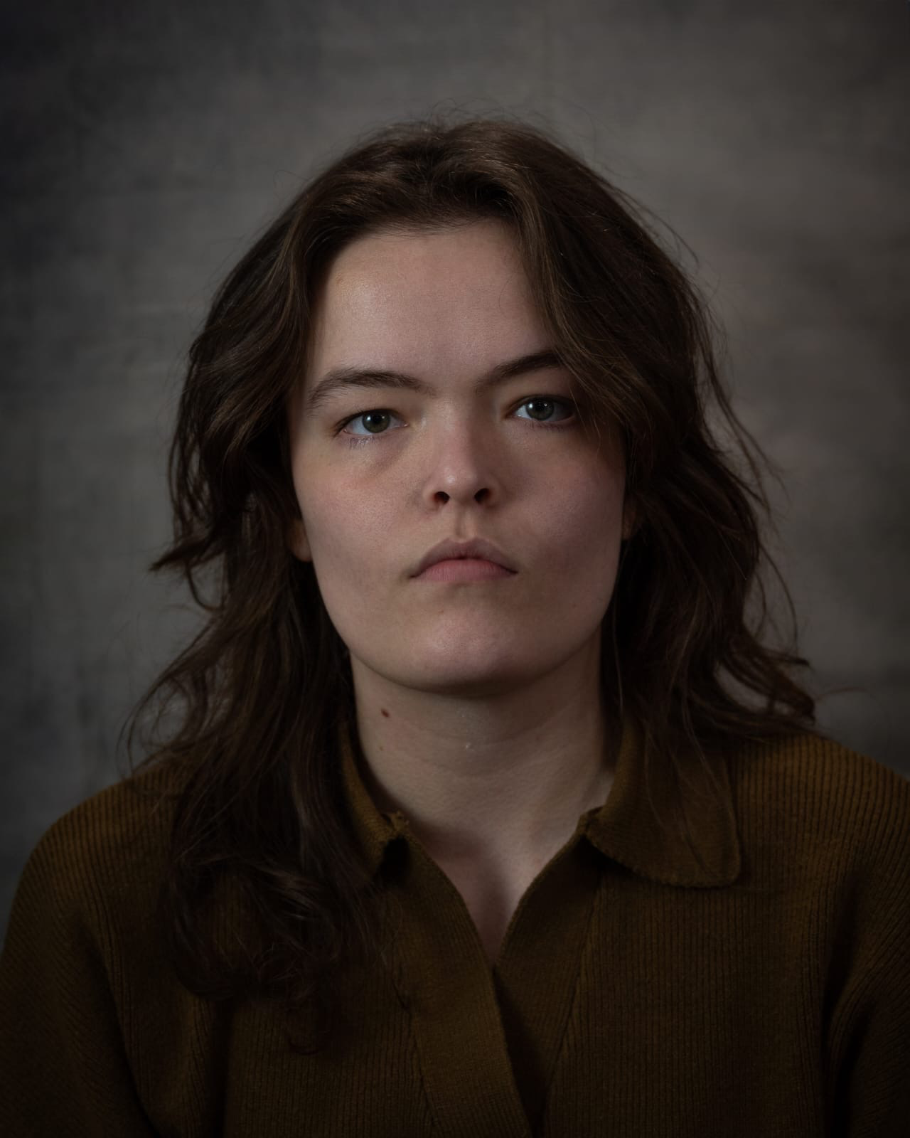
Production  Stage  Macbeth (2025)  The Big House (2024)  King Lear (2024)  Terminus (2023)  Eight (2022)  La Corbiere (2021)  Film  Pull Back the Curtain (2023) | Role  Lady Macbeth  Rose  Edmund  B  Bobby  Marie-claire  River | Venue/Company  An Táin Arts Centre  An Táin Arts Centre  An Táin Arts Centre  An Táin Arts Centre  Macanna Theatre  Macanna Theatre  Dir. Shona Kelly

SKILLS
Accents: Irish*, Northern Ireland, Southern Irish, RP, London, Scottish, General American ,Southern American

