ACTING RESUME
Ca'ron Abrams-Murray
Contact details  Email  Abramscaron@gmail.com  Social Media  Instagram Camtheboss__  Phone  (267) 236-9288  Education  Community College of Philadelphia  Chestnut Hill College  A.A Business Education  B.A Business Management  Acting School and Training  LS Studios  John Casablanca  MTM- Model Talent Management  National Performers Academy | Agent details  Represented by  N/A  Agent  N/A  Agent’s phone  N/A  Agent’s email  N/A  Bio  Eye Color: Brown  Height: 6’0”  Hair Color: Black  Weight: 160 lbs |  | 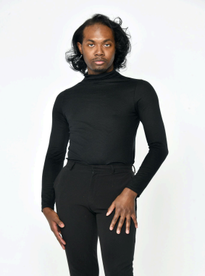
Film & Credits

Dear Momma (2024)- Extra Played (Juror)

The Immortal Life of Henrietta Lack- (2012)- Cousin Cootie (Henry Hector)

Accredited: High school Play made into Film Based on the Book and HS Script play
Recognition: Oprah Winfrey and Rebecca Skloot (Author)

HBO Film 2017
Special Skills
Swimming  Dancing |  | Fashion stylish  Stand up- Comedy |  | Action Stunt work  Cooking
Accents: Spanish, Caribbean, Southern

