**Personal Information**

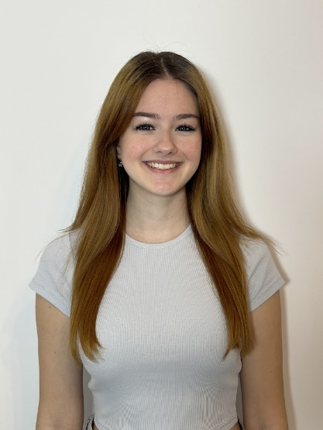Name: Mates Ioana Teodora

Address: 30 Ioan Bianu Street, Sector 1, Bucharest, Romania

Phone: +040724705418

Email: ioana.teodora.mates@gmail.com

Gender: Female

Date of Birth: 19/04/2008

Nationality: Romanian

School: National College of Music George Enescu

**Professional Experience**

Theatre

• 2019-2022 –Part of the cast of the musical ***Madagascar - A Musical Adventure Jr.*** at the Comic Opera for Children, role- lemur

• 2022 – Part of the cast of the musical ***Peter Pan*** at the Comic Opera for Children, role – Fairy

• 2022-2024 –Part of the cast of the musical ***A Christmas Story*** at the Comic Opera for Children, role– reindeer (2022) Maria from The Sound of Music (2023) elf (2024)

• 2023-2024 –Part of the cast of the musical ***The Elixir of Love*** at the Comic Opera for Children, role – Child

• 2023-2025 –Part of the cast of the musical ***School of Rock*** at the Comic Opera for Children, role – Maddison (2023) Teacher, Perent (2025)

• 2023-2025 –Part of the cast of the musical ***Annie Jr***. – Grace Farrell, Ensemble

• 2024-2025 –Part of the cast of the musical ***Matilda*** role – Hortensia

TV shows

• extra in the Netflix series Wednesday

• extra in the Antena 1 series Well done, daddy

Music and festivals

• Participation in various music festivals, including the Musician Brothers Festival, Romanian Music Festival, and Baroque Music Festival (2015-2017)

• Member of Cor cu Dor Choir, performing in Disney concerts, Christmas concerts, and various special events

• Backing vocal for The Voice Romania 2022

• Performances at multiple concerts, including those with Tom Odell, Nikos Vertis and Romanian Artists

**Education & Training (Current)**

• 2025 - Present – Musical theatre courses at Bliss Music Academy

• 2022 - Present – Classical singing lessons

• 2022 - Present – Member of the School of Musical program at Comic Opera for Children

• 2020 - Present – Volunteer at Comic Opera for Children

• 2021 - Present – Member of Cor cu Dor

• 2019 - Present – Acting courses at Comedy Theatre

**Competitions & Awards**

CLASSICAL CANTO

• 1st Place Special Prize at Scherzo 2025 (7th Edition)

• 1st Place Excellence Award at Magic of Carols 2024

• 1st Place Excellence & Sensitivity Award at On the Wings of Sound 2024 (18th Edition)

• 1st Place Excellence Award at Scherzo 2024

• 1st Place & Best Romanian Song Award at On the Wings of Sound 2024 (17th Edition)

• 1st Place at Crai Nou 2024

• 1st Place at Artheo Vocal Contest

• 1st Place Special Prize at Magic of Carols 2023 (11th Edition)

PIANO

• 3rd Prize at Paul Polidor Music Festival 2016

• 1st Prize at Grand Prize of the National Palace of Children 2016

• Honorable Mention at Iosif Sava National Competition 2016

• 2nd Prize at Piano Technique Competition 2016

CHOIR

• 1st Place at Chorus Inside Festival, Croatia (July 2024)

• Romania’s Got Talent 2023-2024

• Ficco Canto Music Group Award 2023 (Group Artharia)

DANCE

• 1st Place at Music and Sea International Choir Festival, Greece (September 2022)

• 1st Place at Bucharest Dance Festival (Lyrical Dance Section)

• 1st Place at Golden Stars Competition 2022

**Previous Education & Training**

•2025- Jazz Dance Workshop at Tempo Loops

•2023-2024 – Dance courses at Independent Arts

• 2024 – Summer Intensive Musical Theatre Programme at Institute of the Arts, Barcelona

• 2024 – Singing courses at Music City

• 2022-2023 – Participation in the European non-formal education program EduClub - Modern Perspectives in Education

• 2020-2022 – Ballet courses at Pas Boutique

• 2020-2022 – Singing courses at Rock School

• 2019-2020 – Contemporary dance courses at Comic Opera for Children

• 2018-2020 – Acting courses at Comic Opera for Children

• 2015 - 2020 – Piano and music theory courses at Iosif Sava School of Arts

• 2014-2019 – Acting courses at Qfeel School

• 2018-2019 – Medieval Art courses at Comic Opera for Children

• 2016-2019 – Ballet at Nadia Comaneci Foundation

• 2011-2014 – Ballet courses at House of Ballet

**Personal Skills**

Languages:

• English – B1 Level

• Italian – A2 Level

Instruments:

• Piano (Intermediate)

• Guitar (Beginner)

Abilities:

• Strong communication, movement, concentration, memorization, and improvisation skills