Tayshawn Walker
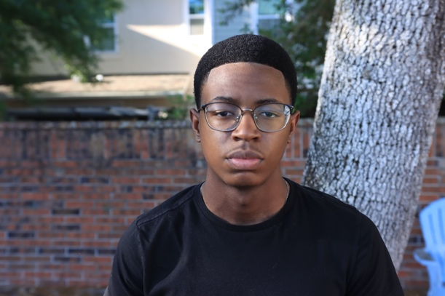

Personal Information
- Height: 5'6"
- Weight: 123lbs.
- Hair: Black
- Eyes: Brown
- DOB: 8/22/07
Theater
- Email: taywalker0822@gmail.com
- Phone Number: 912-322-7514
- Address: 12836 Parkbury Drive, Orlando, FL 32828

Education
Castle Creek Elementary School
Improv Workshop (Legacy Middle School) -2019 and 2020
Thespians (Legacy Middle School) - 2019-2020
University Highschool Theatre Magnet 2021-2025
Thespians (University Highschool)

Special Skill

Acting

Dance (Hip Hop)

Experience/Awards
- Gingerbread Man: Lead role, Castle Creek Elementary School - 2017
- Black History Month: Supporting role, Christ Dominion Church - 2020
- Christmas Blessing: Lead role, Christ Dominion Church - 2020
- 15 Reasons not to be in a play: Supporting role, Legacy Middle School - 2021
- Black History Month: Lead and Supporting role, Christ Dominion Church – 2021
- She kills monsters: Extra/Ensemble role, University Highschool – 2022
- Thespian district competition Pantomime “Bar fight” University Highschool (Excellent) - 2022
- Thespian District Competition: Student Directed Lead role Omari in “Pipeline” by Dominique Morisseau, University Highschool (Superior and Best in show) – 2022
- Thespian State Competition: Student Directed Lead role Omari in “Pipeline” by Dominique Morisseau, University Highschool (Perfect score superior) – 2023
- University Highschool Newsies: Supporting role “Teddy Roosevelt” – 2023
- Thespian District Competition: Pantomime Lead role “The Heist”, University Highschool (Superior) - 2023
- Thespian District Competition: Student Directed Lead Role “Black Stache” in “Peter and the Starcatcher” by Rick Elice, University Highschool (Excellent) – 2023
- Thespian District Competition: Duet Acting Lead Role “Lee” in “True West” by Sam Shepard, University Highschool (Perfect Score Superior and Best in Show) – 2023
- Thespian State Competition: Supporting role “Teddy Roosevelt” in “Newsies” by Harvey Fierstein. - 2024
- Thespian State Competition: Duet Acting Lead Role “Lee” in “True West” by Sam Shepard, University Highschool (Perfect Score Superior) – 2024
- Resurrection Skit: Lead Role at Christ Dominion Church – 2024
- Orlando Shakes TYC: Lead role “King Henry IV” In “King Henry IV Part 1” by William Shakespeare – 2024
- University Highschool: Lead Role “Zach” in “Chorus Line” by James Kirkwood Jr. and Nicholas Dante, University Highschool (Applause Award Nominee) – 2024
- University Highschool One-Act: Supporting Role “Sideshow Barker” in “Unclaimed” by Mandy Conner – 2024
- William Daniel Mills: “Caleb” and “Comparison” in a original piece titled “Me 2 Me” - 2025

