Stephanie Cohen

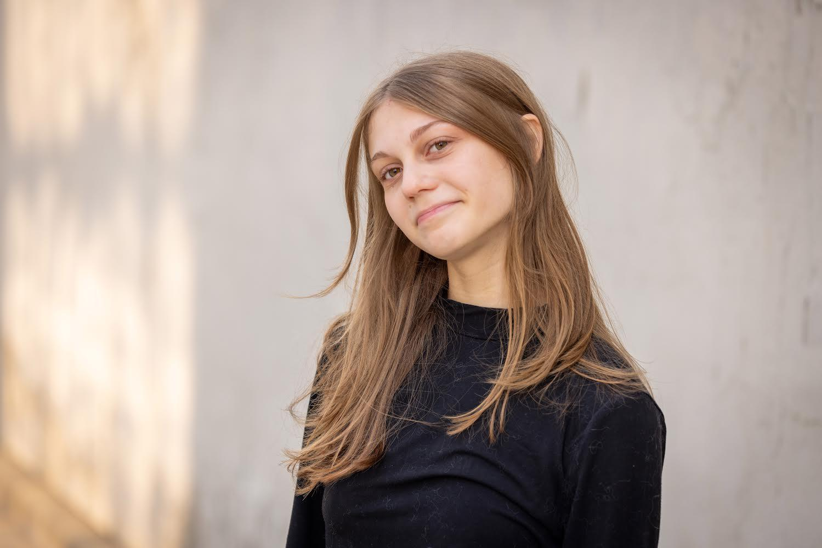**Phone:** 440-823-1760 **Email:**smileycohen@yahoo.com

**Hair Color:** Dark Blonde

**Height:** 5’3

**Eye Color:** Hazel

Acting Credits

**Film**

Stupid Love Story Regina

Academy for The Preforming Arts

**Theater**

*OMG We Ate a Guy!* Chessica Academy for The Performing Arts

Education

Chagrin Falls Academy for the Performing Arts : CTE Certificate of Completion Ex. May 2026

Voice (Linklater/Fitzmaurice): Abraham Adams Theatrical Makeup: April Rock

Stagecraft: Ben Needham Shakespeare: Abraham Adams

Stanislavski: Dan Hendrock Meisner: Abraham Adams

Theater Etiquette: Katherine Swartzbeck Musical Theater: Dan Hendrock

Improv: Ryan Santa

Acting for the Camera: Dan Hendrock Movement (Laban, Neutral Mask, Commedia, Michael Chekhov): Abraham Adams

Special Skills

Singing

Acting

Ukulele

French Accent

2 Masterclasses stage fighting: armed and unarmed with SAFD Bill Gordon