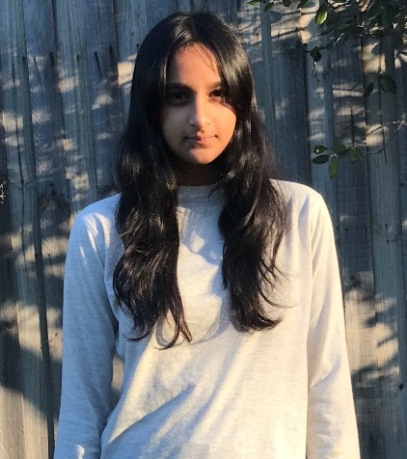
Zara Mehdi
Non-Union

Contact: +61493880235
Email: amehdi.zara@gmail.com

Personal Information .
Date of birth: 1/2/2011
Location: Doncaster, Melbourne, VIC
Physical Attributes .
Height: 162cm
Weight: 48kg
Eye Colour: Dark brown
Hair Colour: Black/dark brown
Training .
Class/Workshop | Instructor/School | Location
Y4 Theatre Arts | Dulwich College/Corin James | Singapore
Y6 Stagecraft & Performance | Dulwich College/Laura Rodgers | Singapore
Y7 Acting Technique & Theory | Dulwich College/Catherine Howe | Singapore
Y8 Production & Performance Studies | East Doncaster Secondary/Guilia Downes | Doncaster, VIC
Y9 Performing Arts (on going) | East Doncaster Secondary/Megan Thompson | Doncaster, VIC
GormanWorks On- Camera Holiday Workshop | Katie & Charmaine Gorman | Melbourne
Acting Experience .
Production | Role | Company/School | Director
The Séance | Alex Larson | East Doncaster Secondary | Megan Thompson
Special Skills .
Special Skills
Soccer/Football | Jump Rope
Netball | Roller Skating
Badminton | Sewing
Hula Hooping | Baking
Basic Gymnastics | Swimming
About Me .
Hi, I’m Zara a 14-year-old actor from based in Doncaster, Melbourne. I love acting because it lets me step into someone else’s world and tell meaningful stories. I really enjoy comedic and action roles . Outside of acting, I’m into football and baking. I’m excited to keep growing and to work on awesome projects!

