Doris “Dee” Gilliam
803-730-7986
dmg06c@my.fsu.edu
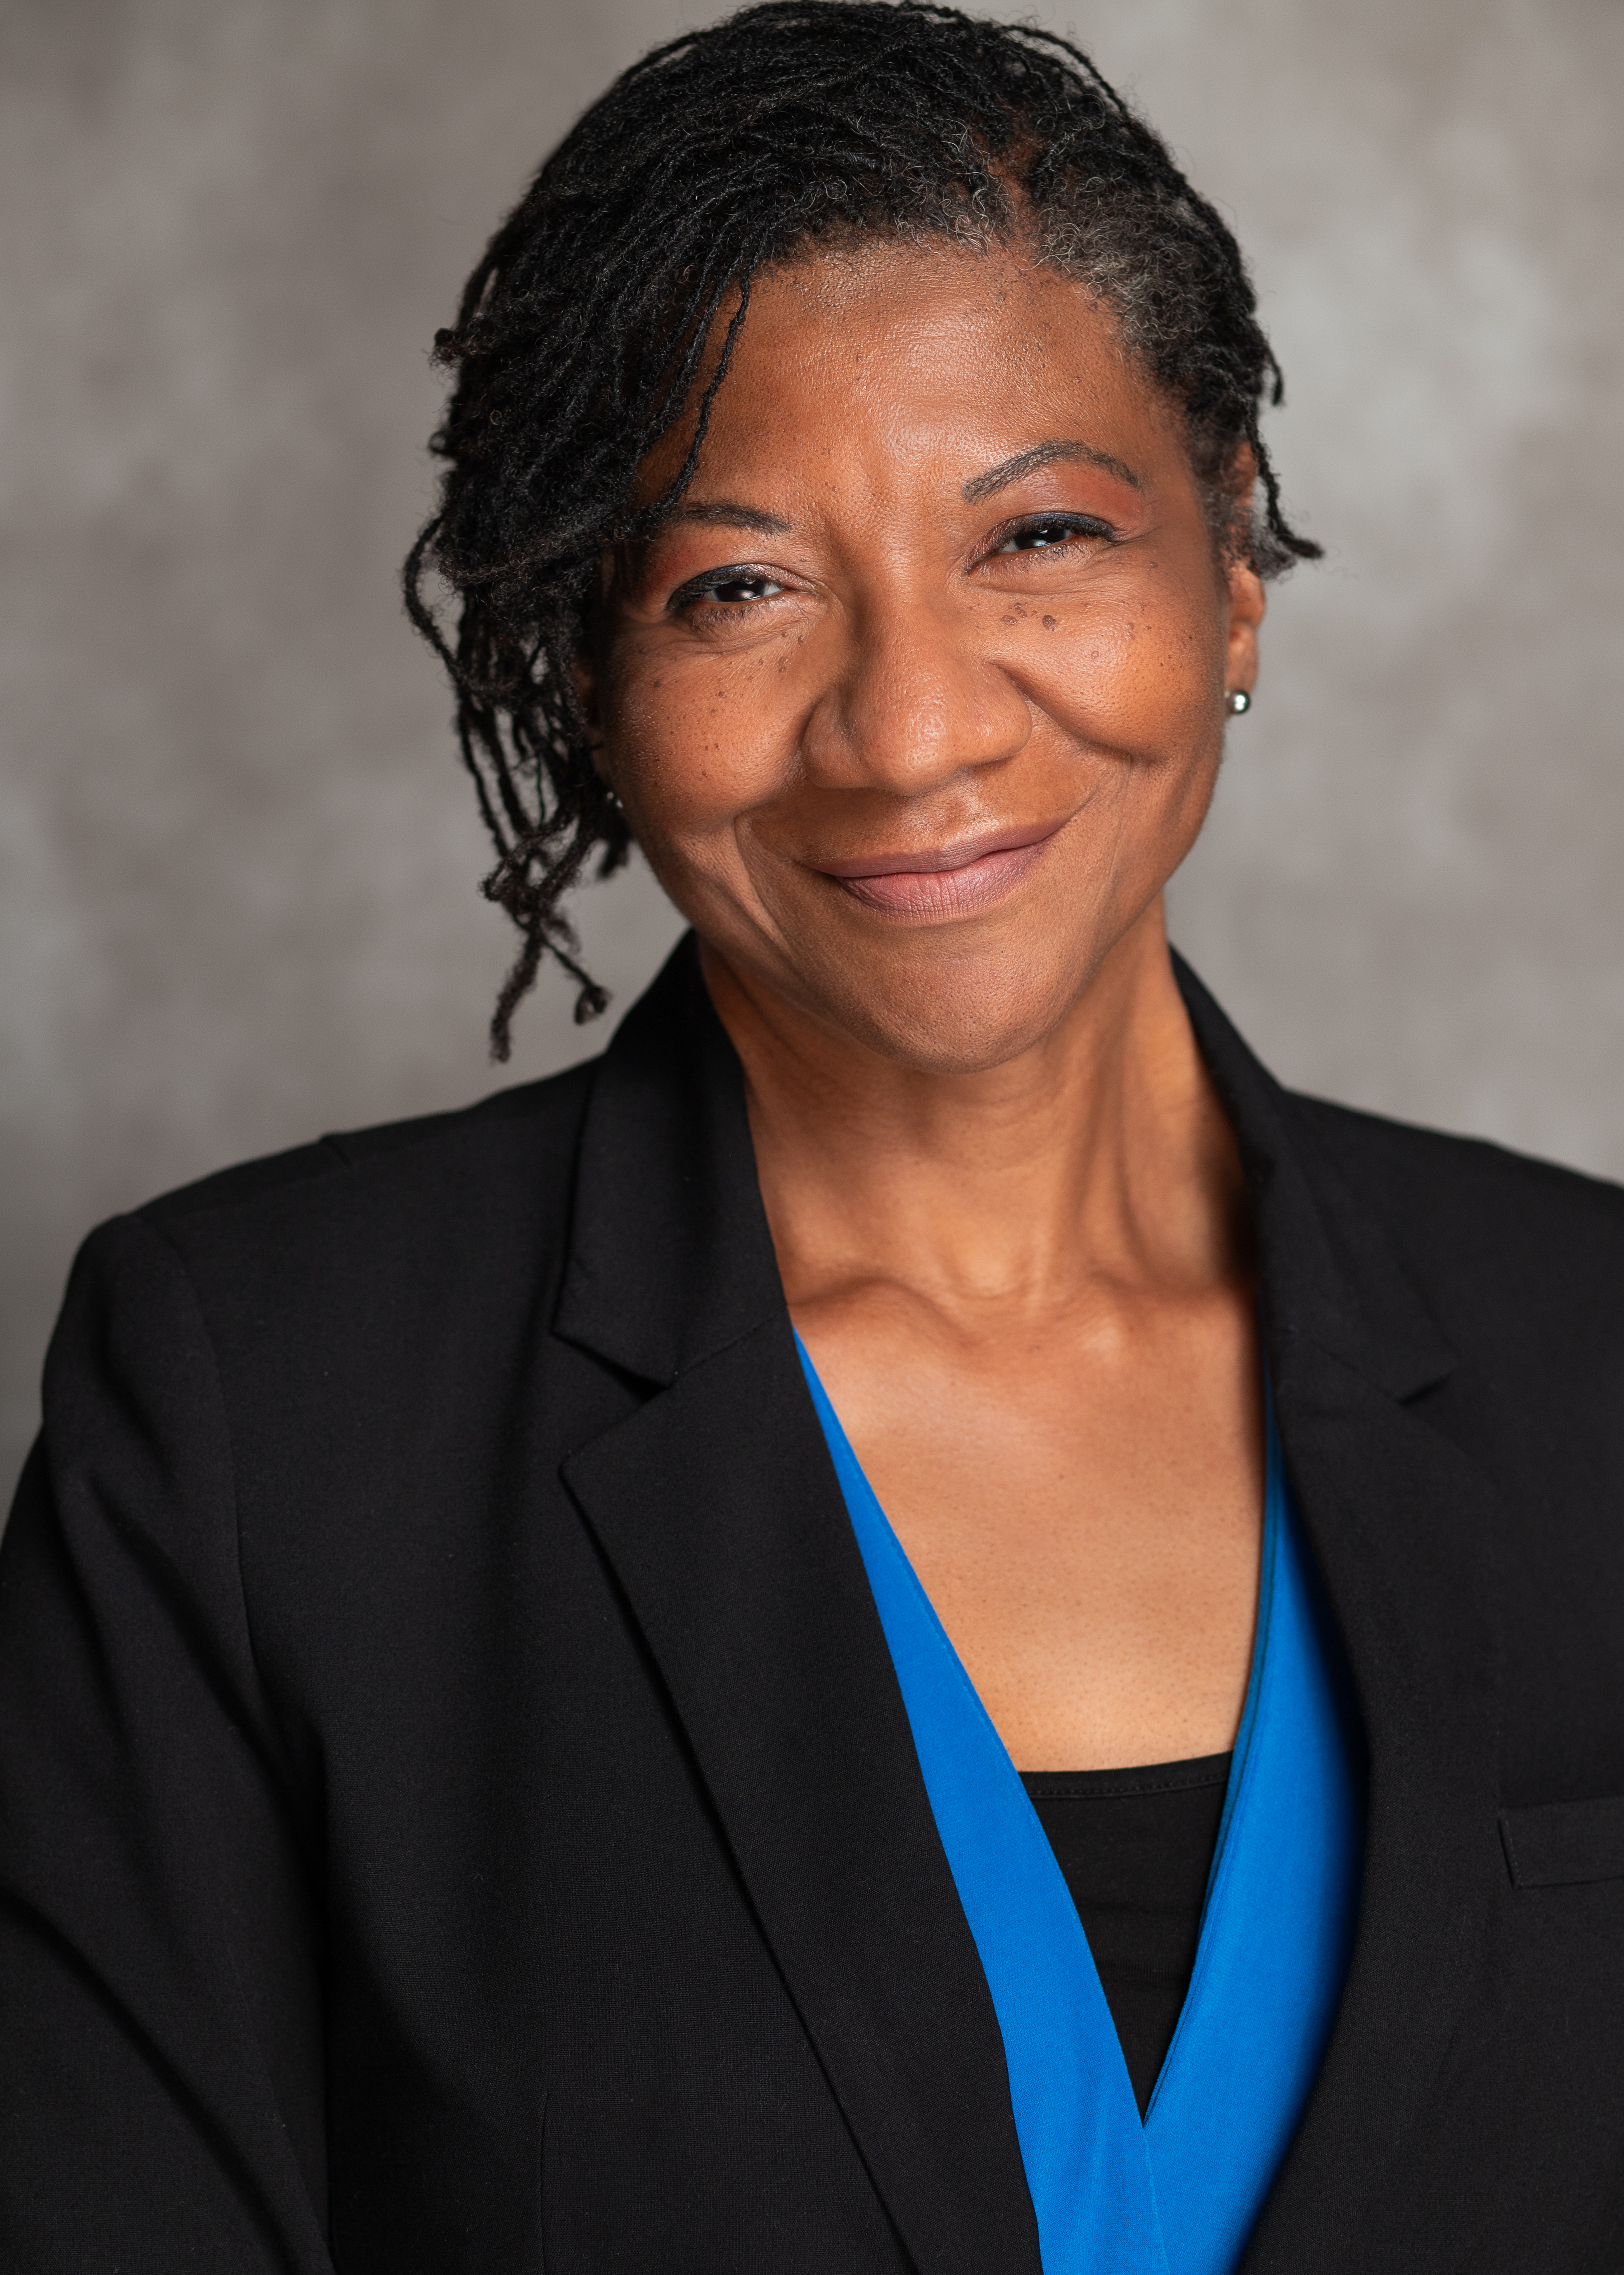

Statistics:
- Height: 5'3"
- Weight: 145 lbs
- Wardrobe sizes:8/10
- Build: Curvy
- Eyes: Black
- Hair: Black

Relevant Skills:
- Excellent communication skills in English
- Experienced public speaker
- Comfortable in front of the camera
- Vocalist
- Spanish speaker

Educational Qualifications:
2013. Ph. D. Interdisciplinary Humanities. Florida State University
1987. M.A. Spanish Language. University of Florida
Recent Work Summary:
Midlands Technical College, Foreign language Instructor/ Coordinator. 2017-present.
Responsibilities:
- Develop and deliver in-person and online Spanish classes
- Create and maintain Spanish classes using D2L and Vista Higher Learning Management systems
- Schedule Spanish and French academic classes
- Train Adjunct Instructors

Acting Experience
Commercials:
Commercial, “Grandmother”, Riverbanks Photoshoot, Flock and Rally: Integrated Communications & Marketing
Commercial, “Advisor”, National EMS Association. 2022
Commercial, “Employee”, Corporate commercial. 2018
Theater:
“Wit”, Lab Technician, Student, Trustus Theater. 2000

Related experience
Emcee/Host. Midlands Technical College Hispanic Heritage Day at MTC event, 2022
Emcee. Allen University Graduation, 2016
Emcee. Saint Paul’s College Gala and Fundraiser, 2006
Emcee. Mr. And Miss Saint Paul’s College pageant, 2004-2005

Training
Trustus Theater African American Actor’s Workshop, 1999/2000
Other Skills
Languages: Spanish, fluent; Portuguese, conversational
Music: Djembe; Vocals, Soprano; B-flat clarinet, Intermediate

