Milos Otasevic
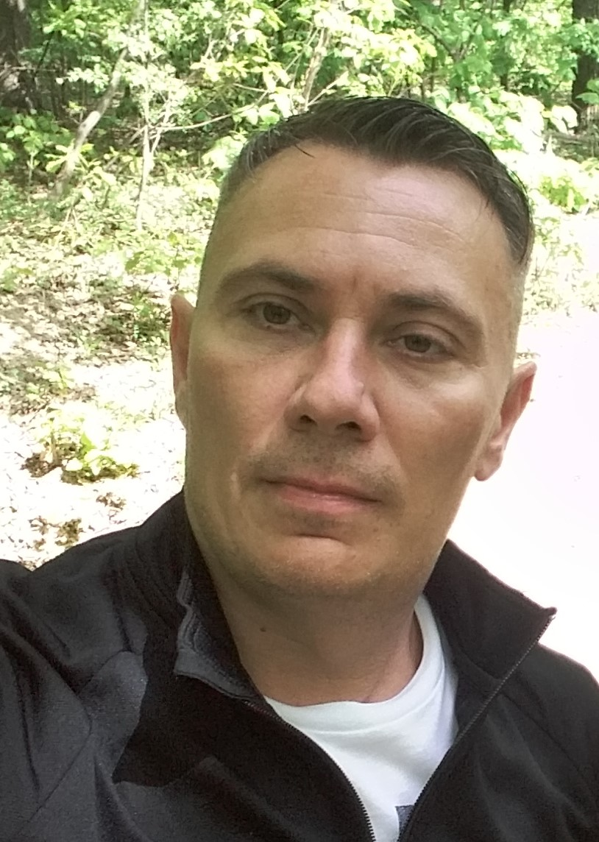  CONTACT  Address:  Bloor ST 1055, Mississauga, Ontario, Canada, L4Y2N5  Seljackih buna 65, Novi Sad, 21000, Serbia  Phone:  WhatsApp  +1 416 728 9864  Viber  +381 63 641 788  Based:  Canada, Toronto  Serbia, Novi Sad  Email:  motasevic13@gmail.com  Skype:  milos.otasevic3  Date of birth:  13.08.1980  LANGUAGES  English:  - Listening  - Speaking  - Writing  - Reading |  | Experienced operations and executive leader with a proven track record in the betting, iGaming, and retail industries. Adept at driving organizational growth, strategic planning, and operational excellence. Expert in business development, customer-centric strategies, marketing, and CRM systems. Strong leadership skills with a commitment to fostering positive work cultures and achieving key performance indicators (KPIs).  WORK EXPERIENCE  Self-Employed – M Consulting  Canada, Toronto 02/2024 – Present  Experienced consultant specializing in Retail, Online Business, iGaming, and CRM Strategy, with over 25 years of industry experience in renowned companies. I provide strategic insights and hands-on expertise to optimize performance, increase customer engagement, and drive revenue growth.  Retail & Online Business: Business development, growth strategies, omnichannel optimisation, and brand positioning.  iGaming Industry: CRM strategy, acquisition & retention campaigns, and player engagement, with a strong focus on P&L accountability and BP budgeting.  CRM: Loyalty programs, data-driven marketing, automation, and lifetime value optimisation.  Operational Excellence: Process improvement, team leadership, OPEX/CAPEX planning, and strategic planning.  Expertise in ATL/BTL/TTL marketing, CSR initiatives, financial analysis, and overall budget control.  CEO – Brobet1  Serbia & Guinea Bissau 09/2022 – 01/2024  Founded and managed a startup across online, retail, and POS terminals in collaboration with DIGITAIN.  Implemented brand expansion.  Launched operations in July 2023, securing 12% market share in two months.  Directed daily operations with a workforce of 550+ and trained 45 HQ employees with full retention.  Led all marketing strategies (ATL, BTL, TTL), executed brand-building campaigns, and oversaw procurement and import logistics.  Drove business growth by 300% in under three months.  Built CRM and retention programs with a strong focus on ROI, P&L, and data-driven segmentation.  Created and controlled BP budget, CAPEX/OPEX planning, CSR activities, and competitor analysis.  Maintained comprehensive financial oversight through KPI tracking, financial analysis, and NGR/GGR monitoring.  Group CEO – Bwinners  Gambia, Senegal, Sierra Leone, G. Bissau 12/2020 – 06/2022  Formulated and executed business strategies, achieving $8.7M EBITDA growth in Year 1.  Developed CRM, retention/acquisition funnels, FTD strategies, and loyalty initiatives.  Implemented brand expansion, land base & POS.  New design for the land base and website.  New bonuses for all 3 LOB.  CMR strategy implementation, new tools, and customer call centre. Utilised Google Analytics to monitor and analyse user behaviour across digital platforms, identifying high-performing campaigns and underperforming funnels in sports betting environments.  Tracked customer journey from ad impression to bet placement, optimising conversion rates and user acquisition strategies.  Monitored traffic sources, bounce rates, session duration, and goal completions to guide marketing and UX decisions.  Created custom dashboards and reports for performance tracking of promotions, online betting events, and user engagement.  Integrated Google Tag Manager for enhanced tracking of custom events (e.g. bet slip submission, odds selection, login/signup flow).  Collaborated with the product and marketing teams to A/B test landing pages, improve retention campaigns, and drive user reactivation.  Used data insights to increase the ROI of digital campaigns and lower CAC (customer acquisition cost).  Leveraged Google Analytics data to inform real-time campaign optimisations during major sports events (e.g. Champions League, Euro, NBA Finals).  Analysed cross-channel performance (SEO, Paid Search, Display, Social, Email) to allocate marketing budgets more efficiently.  Implemented full scope of P&L, CAPEX, OPEX, BP budgeting, and CSR projects.  Managed omnichannel marketing across ATL, BTL, and TTL, and performed Google Analytics-based performance measurement.  Oversaw API integrations (MNO, MoMo), market expansion, and sales programs with measurable KPIs.  Provided strategic board-level insights and controlled financial direction and brand integrity across 4 countries.  Executive Director – MaxBet  Bosnia & Herzegovina 03/2020 – 11/2020  Directed land-based, online, and terminal operations (25 shops + 29 WLTS).  Managed online business with €5.2M monthly GGR and full P&L responsibility.  Supervised 118 staff, ensured operational excellence, and implemented performance metrics.  Spearheaded brand strategies, BP budgeting, and CAPEX/OPEX planning.  Improved sales/profit by 51%, launched CRM strategies, and elevated employee performance through targeted training.  Running and setup of the marketing campaign: ATL, BTL, TTL.  Directly managed and developed online sports betting and casino platforms, ensuring optimal UX, UI, and engagement for players across desktop and mobile.  Coordinated with product, IT, and marketing teams to implement new betting features, casino game providers, and promotional tools (Free Bets, Bonuses, Jackpot systems).  Oversaw CRM campaigns and personalised player journeys to increase retention and lifetime value (LTV).  Analysed player behaviour and KPIs (GGR, NGR, ARPU, session duration) to optimise acquisition and retention strategies.  Worked closely with platform providers (e.g. EveryMatrix, Playtech, BetConstruct, SBTech...) to enhance site functionality and compliance.  Responsible for content and odds management on sportsbook, as well as casino game portfolio curation (slots, live games, tables).  Implemented real-time dashboards and reporting (Google Analytics, Power BI) to monitor campaign performance and conversion rates.  Launched and managed cross-channel marketing campaigns (email, push, SMS, paid search, affiliates) targeting both sportsbook and casino players.  Ensured full regulatory compliance with local and international gaming laws (AML).  Led initiatives to increase player acquisition through SEO/SEM, affiliate partnerships, and social media strategies.  Commercial Manager – EDITEC  London, Kenya, Ghana 03/2019 – 02/2020  Responsibility for the performance and strategic growth of 257 retail betting shops operating under COCO, COMO, and DODO across two countries.  Led a team of 30 professionals at HQ and over 800 retail staff, including shop managers, cashiers, traders, and administrative staff, focusing on recruitment, onboarding, continuous training, and professional development.  Designed and implemented business plan KPIs and tracked daily, monthly, and annual sales performance across the entire retail network.  Accountable for full P&L management, including preparation, execution, and optimisation of OPEX and CAPEX budgets, with a strong focus on cost reduction and ROI improvement.  Oversaw procurement and purchasing processes, ensuring timely delivery of all operational needs, including IT equipment, marketing materials, uniforms, and shop supplies.  Developed and led an Active Sales Program for shop employees, introducing retail activation strategies, product bundles, and sales challenges to boost engagement and revenue.  Introduced and executed a Train the Trainer program, ensuring consistency in service quality, betting practices, and operational compliance.  Played a key role in network expansion, including the launch of new retail shops, the rebranding of white-label partners, and the optimisation of underperforming locations.  Conducted regular field visits and market scans, benchmarking competition and identifying opportunities for improvement in customer service, pricing, and product offering.  Set up and monitored sales targets for regional and shop-level teams, linking performance to tailored incentive programs.  Introduced and managed packaged betting offers and combo products, enhancing cross-sell rates and increasing average ticket size.  Worked hand-in-hand with the Marketing Department on promotional strategy, ATL & BTL campaigns, brand activations, and seasonal betting events (World Cup, Euro, Olympics, etc.).  Identified operational issues and implemented quick-turnaround solutions to improve customer satisfaction and internal workflow.  Conducted competitor analysis and market trend reviews, making data-driven decisions to adjust shop layout, odds display, and retail pricing.  Successfully launched a marketing strategy in international markets (Kenya, Ghana), resulting in 19% year-on-year retail sales growth.  Provided day-to-day support to the Chief Operating Officer (COO) in executing key operational directives and cross-departmental projects.  Created executive-level presentations and reports, using market insights and performance analytics to guide strategic decisions.  Managed CRM and loyalty data, tracking customer behaviour and developing retention offers and loyalty campaigns that led to a 21% improvement in customer satisfaction (MM project).  Led operational transformation initiatives, including digital ticketing rollout, in-shop screen integration, and bet slip automation.  Responsible for daily reporting, sales analytics, and preparation of executive dashboards for HQ and stakeholders.  Retail Manager – Hellenic Petroleum EKO Serbia  Serbia, Belgrade 04/2015 – 01/2018  Responsibility for the retail network of 54 petrol stations (COMO, COCO, DODO systems), including mini markets, car washes, and cafés.  Management of franchise projects (DODO & COMO), including contract negotiations, market estimation, network expansion, and competition analysis.  Leadership of the entire retail team:  3 Area Managers  2 Area Trainers  39 Site Managers  Over 600 front-line employees (cashiers, pump attendants, administrators)  Development and implementation of performance KPIs, annual targets, and performance appraisals for all team levels.  Annual budget planning and control, including cost optimisation and profitability tracking.  Increased yearly EBITDA from €9 million to €12.5 million through strategic initiatives and operational improvements.  Collaborated with category managers and marketing teams on product selection, promotions (ATL/BTL), and customer engagement campaigns.  Led projects for differentiated fuels, exchange offices, active sales programs, and new service concepts.  Conducted market research, competition monitoring, and implemented dynamic pricing strategies.  Supervised training programs ("Train the Trainer"), designed educational materials for promotions and services (fuel, loyalty programs, CW, café).  Coordinated mystery shopper programs, set up criteria, analysed reports, and acted on customer feedback.  Ensured safety and security across all PS locations, in cooperation with CIT companies and local partners.  Oversaw procurement, inventory management, visual merchandising, and service standards across all locations.  Daily communication with Headquarters in Athens on strategy alignment and operational reporting.  Supported the implementation of SAP, internal sales tracking tools, and SOP across the network.  Played a central role in the development and execution of the SMILE loyalty program and other customer engagement tools.  Area Manager – Hellenic Petroleum EKO Serbia Serbia, Novi Sad 03/2005 – 04/2015  Developed and implemented Standard Operating Procedures (SOPs) for all petrol stations, covering safety protocols, fuel and LPG reception, cashier operations, forecourt procedures, office administration, technical reporting, secure cash handling, PRISMA system usage, and GS handover processes.  Led the transition from COCO to COMO business model, including the creation of COMO contracts, selection and training of COMO managers, and full operational setup.  Opened and launched operations at 39 petrol stations, overseeing recruitment and complete onboarding of new staff and station managers.  Collaborated with the Development Department to secure all required licenses and permits for newly established petrol stations, including FD approvals and fuel supply certifications.  Designed and launched a taxi loyalty program, acquiring 2,000 taxi drivers and securing over 720,000 litres of annual fuel sales while providing wide-reaching, cost-free brand visibility through vehicle branding.  Initiated a targeted discount card system to attract agricultural clients and expand the customer base.  Worked closely with the commercial division to secure large-scale fleet contracts and participated in public tenders for major clients (e.g., Subotica Medical Centre, Loznica Electric, Zrenjanin City Administration).  Partnered with the Marketing Department on high-impact campaigns such as “Everyone Wins” and collaborated with the Football Association of Serbia on joint promotional activities.  Organised brand activations during summer travel seasons at key border crossings and toll booths.  Maintained rigorous oversight of gas station operations, emphasising a balance of training (50%) and supervision (50%) to ensure excellence in customer service.  Increased Mystery Shopper (Mystery Motorist) satisfaction scores from 88% to 96.3% through training initiatives and performance monitoring.  Collaborated with the NFR team to track sales, introduce new products, and optimise mini-market layouts for enhanced revenue.  Proactively monitored and reduced OPEX through efficient planning and implementation of cost-saving measures.  Maintained control of all fuel deliveries and non-fuel stock, ensuring procedural compliance and minimizing losses.  Delivered all KPIs and business plan objectives defined by company leadership.  Led a team of 15 Gas Station Managers and approximately 280 employees, ensuring high operational standards and team engagement.  Conducted regular competitive analysis and provided actionable insights to boost sales performance.  Drove sales through team-building initiatives, including contests and motivation strategies.  Resolved customer and internal conflicts swiftly, fostering a positive and productive work environment.  Reduced training time for new hires by 50% via a streamlined onboarding program.  Introduced an enhanced performance evaluation framework, resulting in notable improvement in employee output.  Led a charity sales campaign that contributed to a 9% annual increase in sales.  Reduced shrinkage by 19% through daily inventory checks and precise stock control.  Petrol Station Manager – Hellenic Petroleum EKO Serbia Serbia, Novi Sad 01/2004 – 02/2005  Supervised all daily operations, cash handling, and fuel inventory.  Executed CRM and sales initiatives, improved service quality and safety protocols.  Contributed to customer acquisition through fleet programs and retail experience enhancement.  Maintained full control of P&L and supported CSR-focused customer engagement strategies.  Commercial customers, fleet contracts for fuel supply.  ADDITIONAL SKILLS  - Time management skills  - Retail and Franchise expert  - Strong leadership skills  - Persistence & self-motivation  - Continuous learning skills  - Ability to take initiative  - Knowledge of buyers' psychology  - Coaching skills  - Product knowledge  - Perfect communication and negotiation skills.  - Ability to work well under pressure  - Sales Operations  - Business Planning  - Business Strategy  - Planograms  - New Store Openings  - Operations Management  - Strategic Planning  - Retail Sales  - Store Management  - Sales  - Market Research  - Business Development  - Project Management  - SAP  - CRM  - ONLINE  - Team Leadership  - Customer Service  - Negotiation  - Retail Category Management  - Commercial supervision  - Commercial site supervision  Certifications  - OPQ Report  - NAVAK Academy (Driver Academy)  - HACCP Food Controlling and Certification  - English Proficiency Level 3  - Finance and Casino Expert Certification  - ALPIS Training  Awards  - Best Area Manager, IMA (2012, 2014, 2015)  - Leader in Active Sales Results (2014)  - Best Manager for Customer Care and Loyalty Program (2013)  - Best Customer Service in Network, IMA (2011, 2012)

