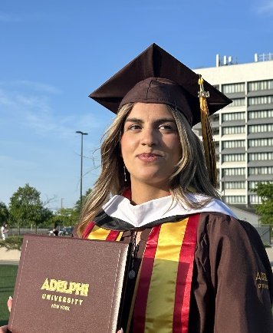
Lydia Fraga Córdoba

Phone: +1 (516)-513-2866

Email: Lylanzarote@gmail.com

Education

Long Island University, Brookville, NY August 2019- Graduation May 2022

- Major: Bachelor’s in Health Sciences with a concentration in Spanish for Health Professions
- Soccer, Athletic and Academic Scholarship
- GPA 3.3

Adelphi University, Garden City, NY August 2022- May 2024 Graduation
- Master’s Degree: M.A in physical activities coaching and teaching
- Soccer, Athletic and Academic Scholarship
- GPA 3.4

Experience

Evergreen Charter School, Hempstead, NY July 2024- Present

Spanish Teacher
- Spanish third grade teacher
- In charge of athletics at the middle school girls’ soccer team
- Designed engaging bilingual lessons
- Interactive learning with games
- Maintained a positive and structured classroom environment
- Adapted teaching methods to meet the diverse learning needs of students

Soccer Camps Pro, Summer Camps, USA June 2024- August 2024

Camp Coordinator- Traveling through the East Coast in the United States
- Developed and executed structured weekly and daily schedules
- In charge of camp registrations, transportation, Venue setup and equipment management
- Led and supervised a team of coaches
- Ensure safety, managing weather and first aid protocols depending n the State we where at
- Served as primary point of contact for parents, addressing inquiries and providing updates
- Managed camp budgets
- Monitored camp performance, gathering feedback from both participants and parents

Kaptiva Sports – Real Madrid World Challenge March 2025 – April 2025
Field Responsible Staff
- Coordinated matches and ensured smooth field operations during the tournament
- Managed team check-ins and verified compliance with tournament rules and schedules
- Supervised field logistics and resolved operational issues to maintain game punctuality
- Acted as the primary point of contact for teams, referees, and organizers on-site

Tilles Center for Performing Arts, Brookville, NY September 2021- May 2022

Event Staff
- Responsible for opening house and check tickets
- Helping people find their seats
- Able to undergo problems and/or confrontations between people of the audience

Cáritas Diocesana, Residencia de mayores, Madrid, Spain June 2016-July 2016

Nursing home volunteer
- I helped taking care of the patients
- Spent time with them and making them feel better
- Activities and Exercises

Waitress, The Boulevard, North Bergen, NJ February 2020-November 2021

Waitress and Event attendant
- Waitress for events
- Bringing bottles, drinks and food to the public
- Concerts, weddings, birthday parties

Kaptiva Sports, East and West coast, US July 2022-August 2022 June 2023-August 2023

Traveling Soccer Coach for Camps
- Travel around the US coaching at different soccer camps
- Implemented and enforced safety measures, handled minor injuries
- Provided experience to help the players with their technical and tactical soccer skills
- Created and led a variety of dynamic soccer drills
- Promoted a supportive and inclusive team culture

Coaching June 2020- Currently
- Soccer coach
- Coached kids between 5-16 years old
- Teaching them how to behave in a sport environment
- Teach them not only soccer skills but also real life situations to know how to sometimes manage their temper and emotions
- Helping them with athletic skills

Skills

- Microsoft Office
- Teamwork
- Communication
- Problem-Solving
- Bilingual; Spanish and English
- Leadership
- Creativity

Certifications

Project Management Coursework (Coursera)
- Foundations of Project Management
- Project Initiation: Starting a Successful Project
- Project Planning: Putting It All Together
- Project Execution: Running the Project
- Agile Project Management

