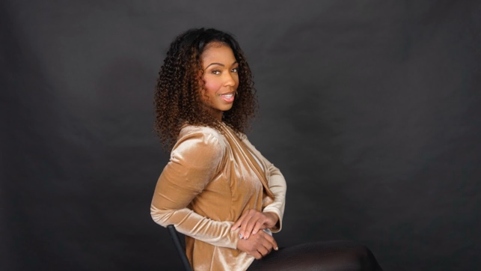

**Jimille Figaro**

I.T.S. Models and Talent

313 West Liberty Street Ste.356 Lancaster, PA 17603

C: 717.380.3851 O:717.509.3890

[Info@itstalent.net](mailto:Info@itstalent.net) itstalent.net

**SAG ELIGIBLE/ NON- UNION**

**Hair:** Black **Clothing Size:** Medium

**Eye Color:** Hazel/ Light Brown **Shoe Size:** 9

**Age Range:** 28-38 **Vocal Range:** Soprano to Alto

**Height:** 5’6”

**Weight:** 155

**FILM**

Five minutes with Jesus Peggy Johnson Pattie Rice Production

Lady in the Lake+ Apple TV Multiple Characters Alma Har’el and Jude Gorjanc

The Baltimorons on SXSW Improv Audience Jay Duplass

**TELEVISION**

Fox 5 News Live Model Washington DC

Bmore Lifestyle TV Live Model Baltimore MD

Living Local DMV Live Model Washington DC

**COMMERCIAL**

Koons Tyson Dodge Customer Stage and Screen Studios

KetelOne Night’s Light House Partier Sundance film festival

Reproductive freedom for All Client Thea Washington Casting

**Modeling**

The French Magazine Published Model Paris International

Bold Magazine Nominated Model LA California

Vigour Magazine. Published Model Maryland

Axelmakeup Academy Beauty Model Tyson Virginia

NYFW / PFW Runway Fashion Model New York City / Philadelphia

**EDUCATION & TRAINING**

Foundations of Acting Diane Marie Green Room Acting Studio

Posing workshop / Runway Etiquette/ Monologue, Commercial Cold Readings, Teleprompter, Voiceovers

**SPECIAL SKILLS**

Accents, Dancing-freestyle, flashmob, Hip Hop, Salsa, Zumba, Hula hoop, Passport travels