Evan Cox

3868 pintail path,

Liverpool NY 13090

Booking.evancox@Gmail.com

(626) 506-0304

Objective: Seeking a position that will utilize my communication, photography, videography, computer, customer service, and leadership skills.

Education:

Los Angeles Film School

Associate of Science in Film Production,

High School Diploma

Baker High School, Baldwinsville NY 13027, 2013-2017

Work Experience:

Photography/videography freelance

Los Angeles, California

April 4th 2023 – present.

I work with clients doing bts. (behind the scenes) Some of these clients include chief keef, 2rare, Bailey Zimmerman and more.

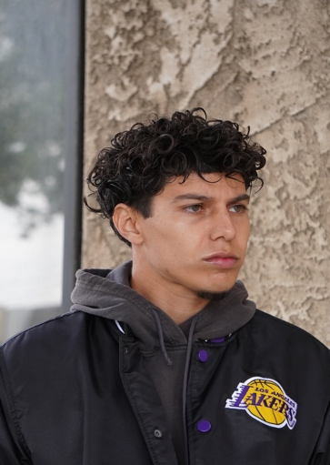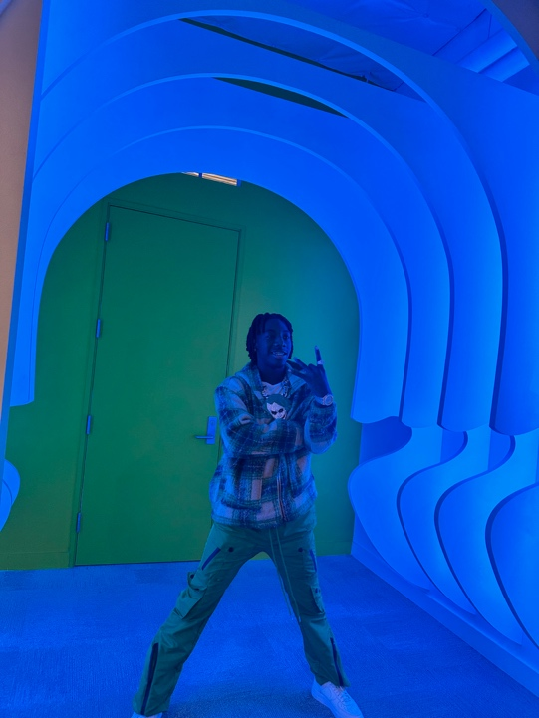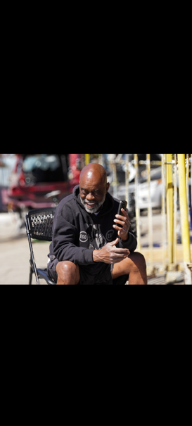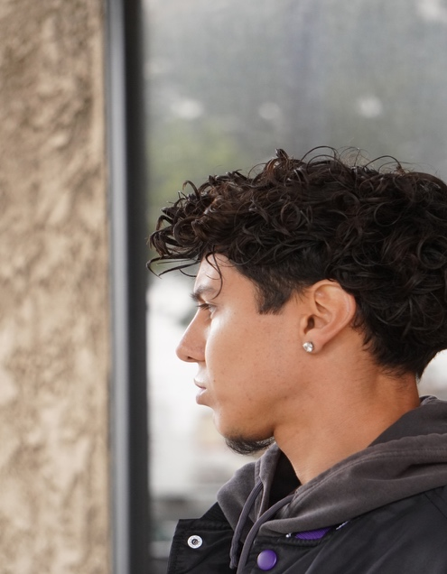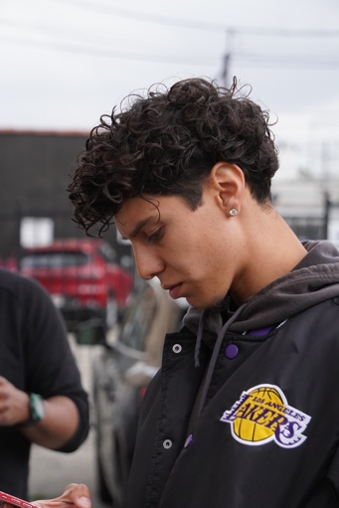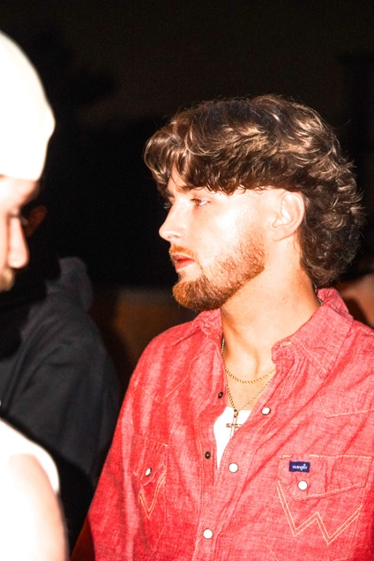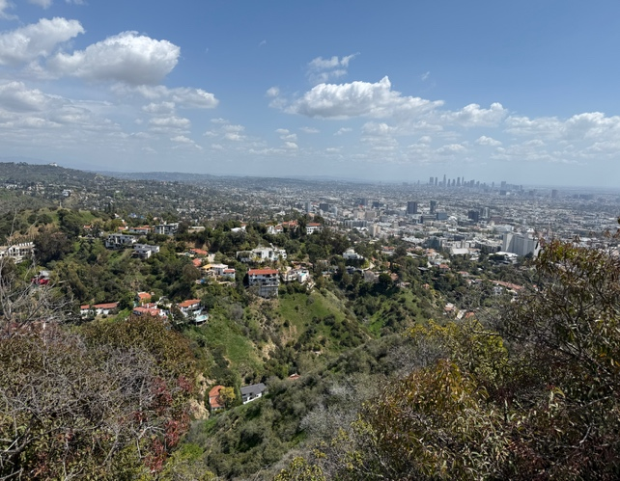My job is to capture the moments we live for and turn them into a masterpiece.

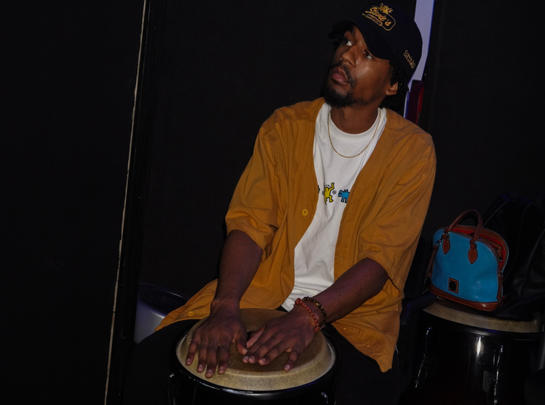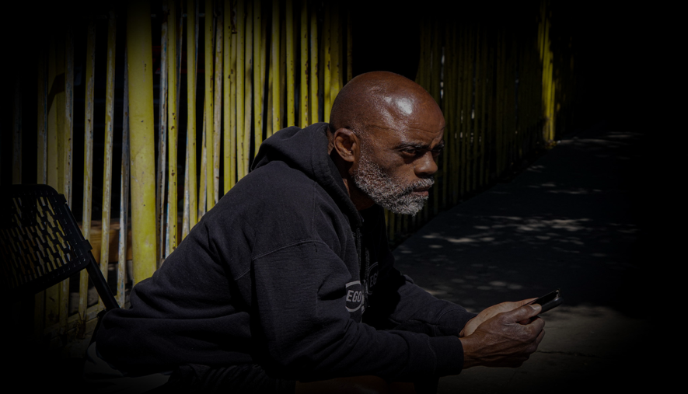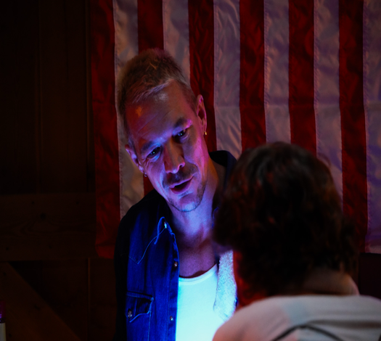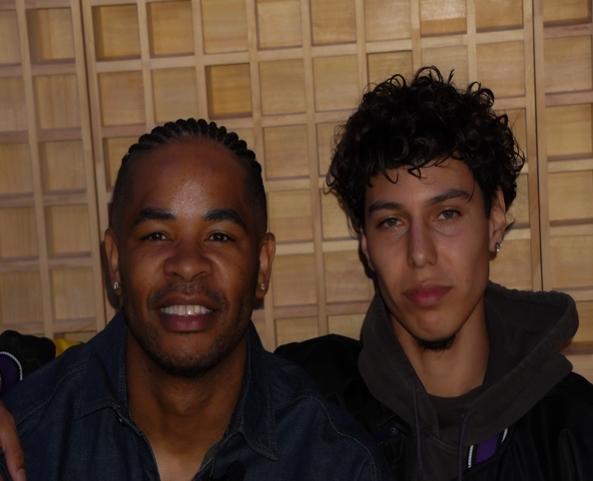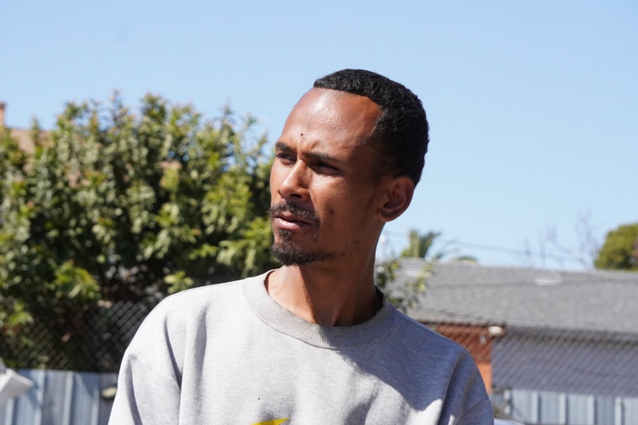

Sky Armory

Event Staff, Syracuse, NY

March 2019 -2021

Assist with event setup and breakdown

Provide exceptional customer service to clients and guests

Ensure the smooth execution of events

Walmart

Sales Associate, Oneida, NY

May 2021 - August 2022

Assisted customers with their shopping needs

Maintained cleanliness and organization of the sales floor

Processed customer transactions using a cash register

Dollar General

Sales Associate, Upstate NY

June 2019 - August 2020

Stocked shelves and maintained store organization

Assisted customers with their shopping needs

Processed customer transactions using a cash register

Car Detailing Companies

Detailer, Los Angeles CA

June 2016 - August 2016

Cleaned and detailed cars to a high standard

Assisted with scheduling appointments and answering phone calls

Maintained cleanliness and organization of the detailing area

Skills:

Active listening skills

Communication skills

Computer skills

Customer service skills