***Carys Stannard resume***

***Socials***.

***Number- +44 07368243459***

***Instagram-carys_stannard***

***About me***

* *14yrs old (march 26th 2011)*
* *In high school (Sir John leman high school,Beccles)*
* *I can sing and dance*
* *I live in Carlton Colville , England*
* *I am 5 ft 1 and I weigh 7st*
* *I have a dirty blonde colour hair , and bluey greeny eye colour*

***Facebook-Carys_stannard.***

***Skills-***

* *I have great communication skills*
* *Will listen to / Do anything*
* *Can do a display of emotions*

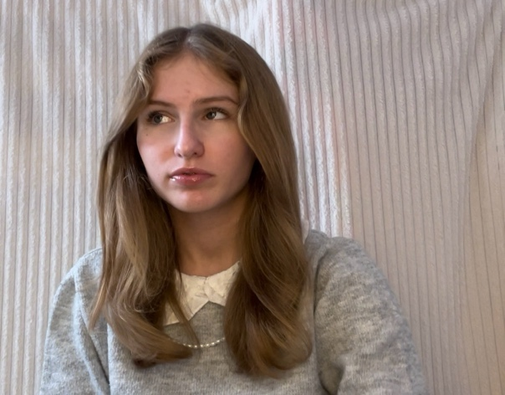***Objective***

***To be able to work well with others that accept others for who they are. And to be able to perform in feature films or normal films perfectly. I also will change anything that needs to be changed like my hair colour , accent e.t.c.***

***Education***

***I used to do dancing for about 2 years but had to quit due to Covid and lockdowns. I did pick up on lots of things about the expressing of the body and how your body can help you express and show the feelings more powerfully.***

***At school in drama I learn a lot about the movement and how the movements can show you the language for instance mime you use your body to express what your saying but not speaking but using your body.***

***In my own time I learnt how to sing and I can now effectively sing smoothly without any problems.***