**CASHMEER BURKS**

Screenplay Writer

Phone: 661-492-5081 | Email: cashcomets@gmail.com

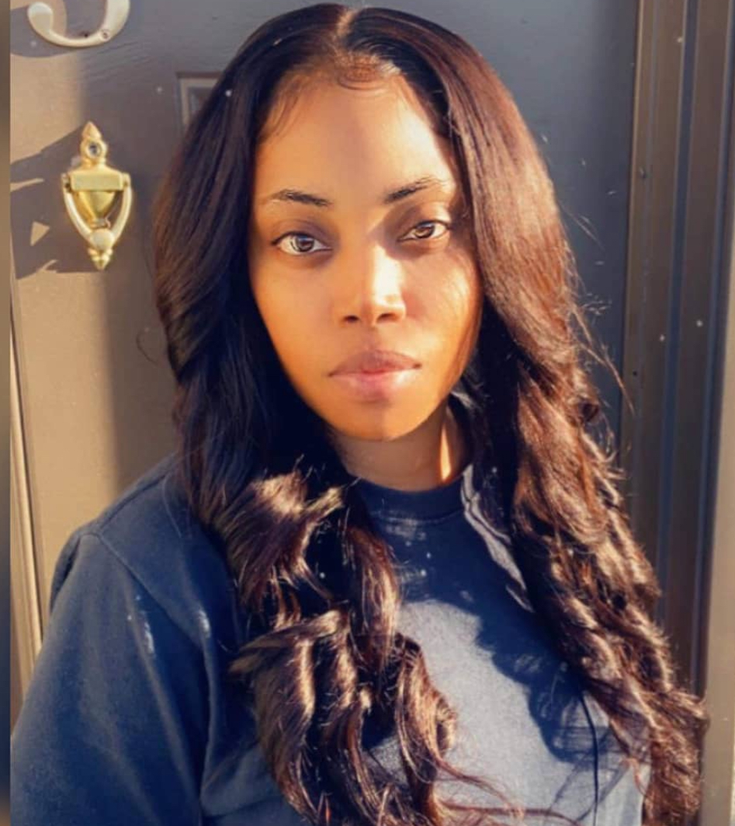

**Professional Summary**

Imaginative and passionate Screenwriter with over 15 years of experience crafting powerful, character-driven stories across genres. Adept in screenwriting for both live-action and animation, with scripts that explore the complexities of human ambition, love, and transformation. Proficient in Final Draft, with a strong grasp of visual storytelling and cinematic structure. Always seeking to collaborate on meaningful projects that leave an impact.

**Selected Screenplays**

* For the Love of Money – Feature Screenplay

A gritty, character-driven drama exploring the fine line between ambition and morality in the underworld of fast cash.

* Fly on the Wall – Animated Screenplay

A surreal animated tale told from the point of view of a street-smart fly navigating a chaotic household with dark humor and vivid visuals.

**Key Skills**

* Creative Writing & Screenwriting
* Voice Acting & Narration
* Content Creation for Social Media & YouTube
* Storyboarding & Character Development
* Research & Concept Development
* Microsoft Office, Google Docs, Final Draft
* Media Production Knowledge
* Goal-Oriented & Deadline-Driven

**Professional Experience**

* Freelance Writer | 2007 – Present

- Created content for social media platforms and YouTube  
- Wrote over six animated film scripts  
- Conducted research to support story authenticity

* Author – A Child’s Mind, LLC | 2007 – Present

- Self-published novel “Behind 2 Hearts”  
- Managed the entire publishing and promotion process

* Wesley Health Centers – RDA/Sterilization Tech | Mar 2016 – Present

- Maintains sterilization protocols and supports patient care  
- Works in fast-paced, collaborative healthcare environment

**Education**

* B.S. in Writing for Film and Television – Los Angeles Film School (Graduated 06/2024)

GPA: 4.0 (Summa Cum Laude)

* Licensed Registered Dental Assistant – Charter College (Graduated 10/2011)

GPA: 4.0

**Hobbies & Interests**

Creative writing, reading fiction, fitness, watching films for cinematic inspiration