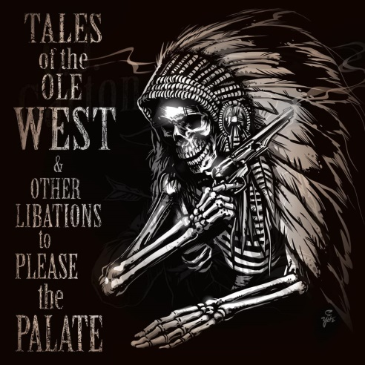CJ Garton is a 6th generation rancher living on a cattle farm that was founded by his family during the land run in the 1800’s just outside of Bristow, Oklahoma. He’s a consummate cowboy in well-worn boots, schooled in the kind of life that rises with the sun and is sustained by the land. A life like this inevitably shapes a man into a natural story teller which just so happens to be the very foundation Red Dirt music is built on. CJ Garton is a proud decedent of that Oklahoma soil and the unprocessed music that grows out of it. His songs are, by definition, working man’s music; all heart with an honest story.

CJ is a country music singer who writes country music songs, plain and simple. It was never a path he chose to take; it’s just the way he was born. For years he has split his time between his home in Oklahoma and the one in Nashville where his songwriting savvy has been embraced by artists like Tonya Tucker, David Alan Coe, Struggle and Whey Jennings, Daryl Singletary and Brooks & Dunn. In 2019, he left his label in Nashville with a desire to start his own, but with pop country having a tight grip on the reins, he questioned how many folks still preferred that true country music sound. So, he decided to go and find out…the old school way. CJ and his 13 year old son got on their horses and rode from Tennessee to Oklahoma, and asked people. The journey took them 31 days to complete, and not only gave father and son an invaluable piece of time together, but also provided them an opportunity to experience the graciousness and goodwill of humanity. “*The generosity that people gave us along the way was overwhelming and we saw inspiration on their faces. Everywhere we went people told us how much they loved the old school country music sound and wanted to hear more of that on the radio. Getting that feedback gave me what I needed to take the risk*.”

CJ created G-Bar Records and Cowboy Carnival Publishing soon after that remarkable pilgrimage, and he will release his 7th studio album “**Tales Of The Ole West And Other Libations To Please The Palate**" on September 16th. This double album is what some might call a “concept album.” It’s a long story that only one album could not possibly tell. Songs about travelers and heroes, freedom and imprisonment, lovers and family; a memoir more or less cultivated from CJ’s heritage and grounded by a root system that spans his past and present. The album is produced by CJ himself along with partner Joe Spivey who is known for his mastery of the fiddle and his studio work with some of country music’s biggest names. Vinyl copies of this double fisted anthology will be available in limited supply and those who are able to grab a copy will be one of a very select few to gain access to the visual side of these tales. Each song is accompanied by its own individual music video, but when strung together, plays out like a feature film. It’s back to the Ole West in 2021 both sonically and visually, but CJ ain’t gonna stop there. With the help of the Mayor’s office in Bristow, Oklahoma, CJ plans to reconstitute country music festivals in small towns along Route 66 that were bypassed with the instillation of interstates. The first 3-day event will kick off in August 2021 in his hometown of Bristow.

[www.cjgarton.com](http://www.cjgarton.com) [www.facebook.com/CJGarton1](http://www.facebook.com/CJGarton1) [www.twitter.com/cjgarton](http://www.twitter.com/cjgarton)