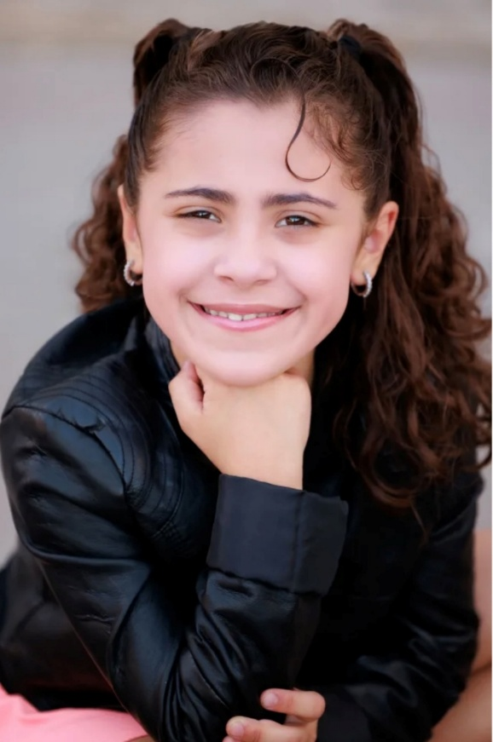

**AMARA V. LANGDON**

**Eye Color:** Brown

**Height:** 4’ 5”, **Weight:** 73 lbs

**Hair Color:** Brown

**Contact details**

**Representatives**

Alana and James Langdon

**Email**

alanaandjames@gmail.com

**Phone**

602-309-3784

**Experience**

Theatre Role Location

“Moana” Student #1 Chandler Center for the Arts

“All The Things You Can Think But, Shouldn’t” Wickersham #2 Chandler Center for the Arts

“Seussical The Musical” Sour Kangaroo Chandler Youth Theatre

Young Kangaroo

Jungle Citizen #5

“Wicked” TBD Chandler Youth Theatre

“The Addams Family” TBD Chandler Youth Theatre

**Training**

Triple Threat Class (July 2025-December 2025) Chandler Youth Theatre, Chandler, AZ

**Special Skills**

Singing/Voice, Horseback Riding, Swimming, Self-Defense, Background in Jazz and Ballet Dance, Public Speaking