**Acting CV**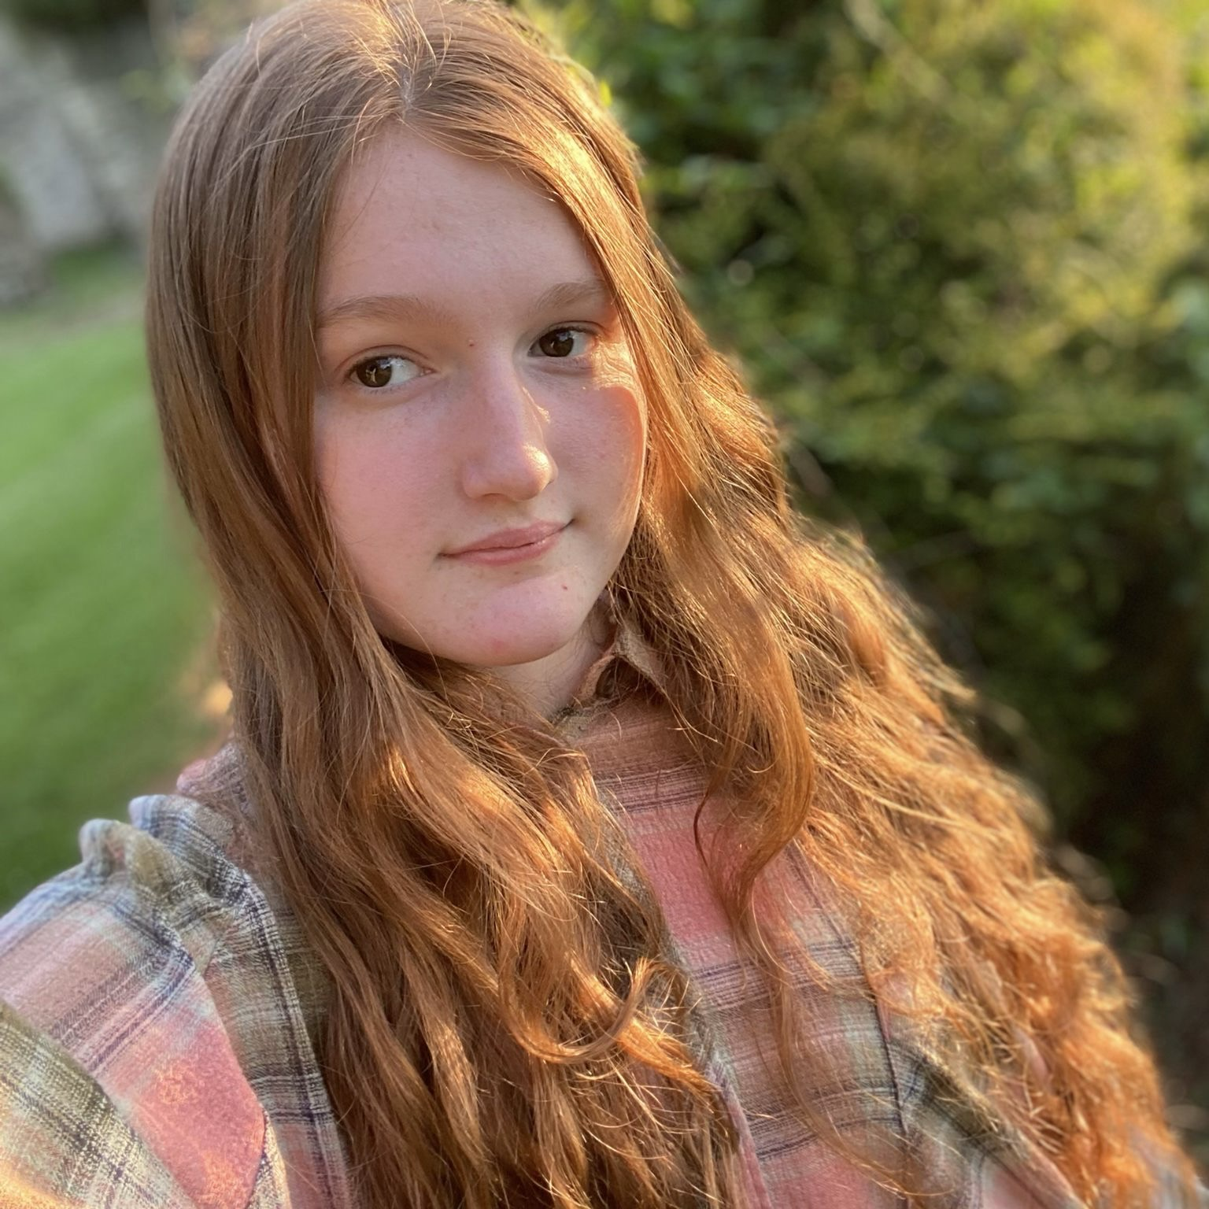

Email: [hollygill06071976@icloud.com](mailto:hollygill06071976@icloud.com)

Phone: 07462404971

Age: 18

Location: Wiltshire, U.K

Playing age: 14-20

Height: 5’4

Hair: Ginger

Eyes: Brown

Gender: Female

Nationality: British

**Credits**

**Short Films**

**Title Role Company**

“72 Amy BU Film Production

Across The Pond Angela Monachopsis Films

**Theatre**

**Production Role Venue**

The Wolves Of Aunt/Mother Studio Theatre

Willoughby Chase

Beauty And The Ensemble/ Queen Mary's Hall

Beast Understudy Cogsworth

High School Kelsi/Martha Queen Mary's Hall

Musical

Caucasian Chalk Grusha Central Studio

Circle

Titus Andronicus Marcus/Lavinia Queen Marys Hall

Hairspray Velma Queen Mary's Hall

Grease Ensemble/ Queen Mary’s hall

Understudy Roger

**Social Media**

Micro.wav - Promoting songs with notable names ( Ed Sheeran, The Rolling Stones, Dua Lipa, Baby Queen, Lana Del Rey, Alessi Rose, Coldplay )

Kalp.app - Advertisement for app

Katkin - Advertisement for cat food

Severance - Advertisement for Soundtrack

Sol De Janeiro - Advertisement for Perfume

Bubble Skin Care - Advertisement for moisturiser

TikTok Shop - Product Advertisement ( multiple ads, wide range of products )

**Training**

Louise Vincent's School Of Ballet - Ballet Training

Show Off Dance - Musical Theatre Training

Studio Theatre Youth Theatre - Acting Training

Panthera Dance Company - Musical Theatre Dance Training

Queen Marys College - Musical Theatre training

Ashley Kate Hughes - Vocal Training

**Workshops**

Musical Theatre Audition workshop - Bristol Hippodrome

Creative Arts Careers workshop - Salisbury Playhouse

Ocean At The End Of The Lane workshop - Bristol Hippodrome

Hamilton Cast Musical Theatre workshop - New York City Centre

Stage Combat Workshop - New York City Centre

**Skills**

Accents: British, American ( california, basic ), Australian, Northern Irish

Singing: Alto

Dance: Jazz, Ballet ( basic )

Other: Swimming, Badminton, Trampolining, Basic Gymnastics, Basic Contortion, Cycling,