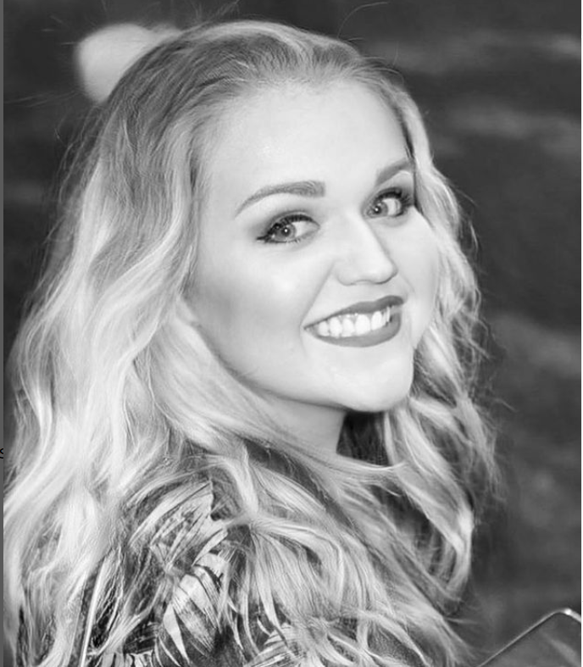
GRACE HOBIN
Contact: 61 Salisbury Avenue
Lytham St Annes, Lancashire.
Phone: 07539252800
Location: Lytham St Annes, Lancashire

Height: 5ft 6 Build: medium Hair: mid-length blonde Eyes: green/blue.
Native accent: UK North West, specializes in Northern accents.
Other Accents: UK Southern, Cockney, RP English, Neutral American, Standard Irish
Role Playing Ages: 28-40
Skills and Training:
9 years of dance training, ballet and Tap at Jenness Barker’s School of Dance, Preston.
Vocalist (Popular and Musical Theatre.)
Whitakers Dance and Drama School – Acting lessons.
Eleven Years of swimming training, member of Kirkham and Wesham Swimming club, competing at national level.
LAMDA - to Gold medallion standard.
University of Central Lancashire – completed first year of BAHons Acting degree. (2006-2007)
Painter – Commissioned artist, specializes in Acrylic on canvas.
Creative Internship - Planetshakers City Church, Melbourne Australia. 2009-2010.
Act Up North – Actors Training, 2024 (ongoing)
Credits: Lawyer – ‘To Be Or Not To Be’ -Student film (2005)
Alice – ‘Daisy Pulls It Off’ – Anonymous Players (2005)
‘A Story For When We’re Granddads ‘- Random Productions (2006)
Trish - 'X-Generation' - BlackBladeProductions (2007)
Performer - Choir, and Actress - 'Beautiful Woman 2009' and 'Planetshakers Conference 2010' with Planetshakers City Church, Hisense Arena, Melbourne Australia (2009/10) Aired on GODtv internationally.
Assistant Cruise Director and Entertainment officer - (Presenter, Host, Singer, Cast Member) – Carnival UK, P&O Fleet MV Oriana, MV Aurora, MV Ventura, MV Arcadia, MV Azura, MV Britannia (2014-2019)
‘Nell Gwynn’ – Nell Gwynn, Cre8ive Little Theatre Thornton-Cleveleys, Director Stephanie Heney (Nov, 2024)
Recordings: EP: ‘Mountains with Many Caves’ –Kids Trippin(g) (2007)

