

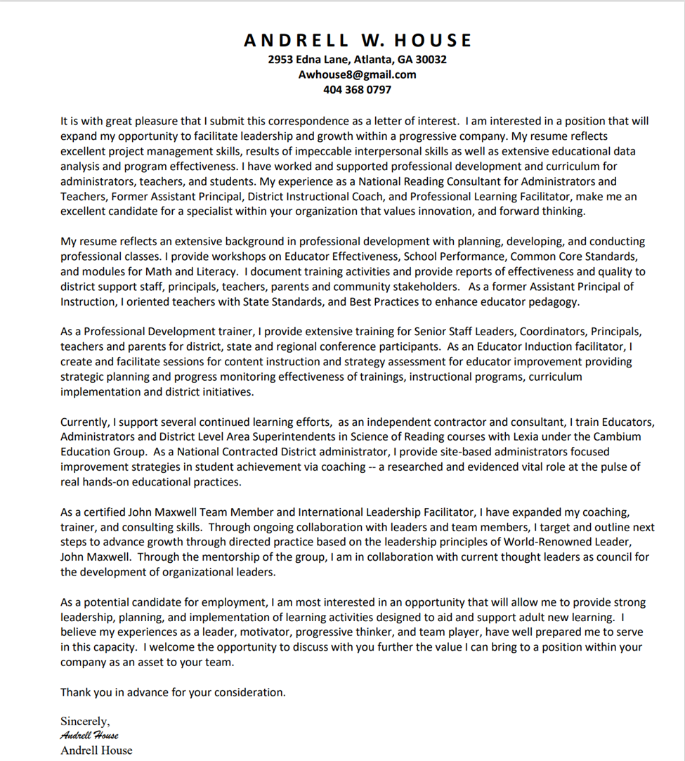

## Narrow horizontalAndrell House

**Mission:** To increase personal achievement by supporting teams with professional learning opportunities that strengthen learning through the use of best practices and leadership development

**Contracting Employment History:**

**Senior Executive - Torch**

Coaches and trains C-Suite members of various agencies. Supports agencies to improve strategic visioning to meet goals and improve leadership capacity

**Educational Consultant - Lexia Learning**

Conducts district coordinators, teacher and administrator Reading and Leadership training

services for schools and across the country who use LETRS (Language Essentials for Teachers of Reading and Spelling)

**Independent Contractor** – National Trainer and Consultant of Professional learning Services -PEAK

Pinnacle Empowerment, Advancement of Knowledge

Training professional with extensive experience in staff devilment, process and productivity improvements, performance management and curriculum design. Team-oriented Training and Development Coordinator competent in developing training processes and procedures for teams

* Facilitates training - across cultures and time zones - for participants on human skills such as leadership, team effectiveness, DE&I, feedback, career development, communication, personal development etc.;
* Creates training programs, plans and schedules by designing and developing training materials for the entire business.
* Owns and drives a diversity of projects/programs that enhance the skills, knowledge and capabilities on a specific topic.
* Builds relationships and consults with key stakeholders to conduct needs analysis to identify the best learning solutions for the business with global scale in mind
* Optimizes current training portfolio and ensures trainings stay relevant, interactive, refreshing and impactful.
* Chooses appropriate training methods per case (virtual, simulated, mentoring, on the job training, andprofessional development classes
* Develops and provides train-the-trainer sessions to drive scale.
* Designs new/blended training programs based on business needs.

**Certifications:**

J. Kouzes & B. Posner Certified Coach Leadership Challenge Coach

John Maxell International Leadership Certification International

TKES: Teacher Keys of Effectiveness System State of Georgia

TSS: Teacher Support Specialist State of Georgia

**Coursework Training**

J***. Kouzes & B. Posner Paradigm 360 training***

* The Leadership Challenge Five Practices of Exemplary Leadership
* Team Leadership

***John C. Maxwell***

Developing the Leader Within You 2.0, Leadership Gold, Becoming a Person of Influence,

15 Invaluable Laws of Growth, Everyone Communicates Few Connect,

Intentional Living, Sometimes You Win, Sometimes You Learn

Global Youth Initiative

***Georgia Department of Education,***

* Teachers as Leaders- Instructional Coaching for School Improvement-

***Mentor Academy – New Teacher Academy***

* Santa Cruse, CA –Leadership Training

***SREB – Southern Regional Education Board***

* Creating High Performance Learning Cultures
* Thinking Maps – A Language for Learning

**Conference Presenter**

**National** Leading with Your Eyes Closed -Developing your Leadership skills through self-discipline and

Mindfulness – OLC Online Learning Consortium / Merlot

**Regional** District ESOL **–** English to Speakers of Other Languages- Learning Text Structure

**State**  GATESOL - Georgia Teachers of English to Speakers of Other Languages- Writing

**District**  SLC - Summer Leadership Title I Conference –Differentiated Instruction

**Curriculum Developer**

Discovery Learning Academy – Primary Science Curriculum

Miller Soaring Eagle Tutorial – Reading / Math Curriculum

GACE – Georgia Assessment for the Certification of Teachers – Reading & Writing Test Taking Support Workshop 2013-2017

**Experience:**

**DeKalb County School System Mountain Industrial Stone Mtn, GA 30088**

**Assistant Principal of Instruction**

### **District Award: 2016-2017 Educational Support Person of the Year Level II**

As an Assistant Principal, I provided support to the instructional process with specific responsibility of directing assigned programs and services, building capacity by providing training for curriculum and standards, serving as a resource to others; supervising assigned staff; coordinating school activities, problem solving issues, de-escalating incidents and problems that arise on campus with enrolled students, parents and faculty

* Implemented and designs policies, procedures and/or processes providing direction and compliance with mandated requirements for professional development and modeling of best practice that align with College and Career Readiness.
* Created and maintains master schedule for over 75 teachers and 750 students, created and implemented innovative student instructional safety net schedule that maximized gaps in teacher availability by providing additional one-on-one student support. Responsible for organization of additional 90 minutes of instructional time which allowed increase in foundational skills mastery and decrease in student learning gaps for over 20% of K-5th grade students
* Provided Standardized state testing schedule, coordinates testing and administration of online and paper assessment for state testing of curriculum and instruction. Implements and develops standards based researched best practices and monitors use of Professional Development through online Learning Management System and Teacher Effectiveness System
* Managed a variety of school administrative functions such as student disciplinary policy, scheduling, selection and assignment of personnel, selection of school resources, equipment, and budgeting for enforcing school, district and state policy while maintaining safety and efficiency of school operations
* Collaborated with staff, co-authors Schoolwide Improvement plan (SIP) ensuring efficient and effective functioning of school, prepared a wide variety of materials (e.g. quantity reports, faculty evaluations, observations, student activities, correspondence, Federal Title I, II audits) for documenting activities, providing written reference, and conveying information

Coursework /Research in Brain Based Learning-

**Learning and the Brain** - Conference attendee of collaborations of disciplines such as neuroscience, education and psychology geared at investigating and understanding the Science of Learning and exploration of disorders and practical interactions and classroom learning application

* **Neuroscape** – University of California San Francisco, participant of mini conference coursework on bridging the Gap between neuroscience, technology and gaming. As a participant, active engagement in studies of attention, perception, memory, brain stimulation, neuroplasticity and cognitive development were investigated and studied.

Self-Research Affiliations: **Dana Foundation-** Left Brain, Right Brain-

The Healthy Skeptic: Brain Training and Games

**Coursea-** Learning and the Brain - Barbara Oakley, Oakland, University

Visual Perception and the Brain, Dale Purves

**Podcast**- The Price of Distraction – Adam Gazzaley

**AARP / United Way Reading Tutorial Site Coordinator**

As a charter Metro-Atlanta facilitator, I program coordinate and supervise the AARP Foundation Experience Corps Reading Volunteers.   In collaboration with United Way and AARP, volunteers work one-on-one with students for thirty minutes twice weekly with a goal of increasing Reading fluency.  The program at Miller has continued to expand and is the largest thriving program in the metropolitan Atlanta area with over thirteen volunteers serving forty-one students each week equaling a massive two-thousand four hundred and sixty additional minutes of direct instruction for students.

**Academic Data Coach**

As a site-based coach provided job embedded training, disaggregated, and analyzed standardized test data and developed multimedia presentations to provide comprehensive needs summaries for curriculum development, and guidance for staff

* Monitored, assessed and implementation of Common Core Standards, Learning Management System for Teacher Keys Effectiveness System (TKES) and district instructional goals and objectives
* Monitors district and site-based program effectiveness for Content and Technology initiatives and implementation for PreK – 5th Grade, creator of annual Math Mania Day, Literacy Initiative and Read-In
* Responsible for planning, writing, and implementing coordination of the

School-Wide Improvement Plan and management of $200,000+ Title I Budget

**Administrative Team member** – I am responsible for developing capacity as a catalyst for change for improvement through on-going problem solving, and decision-making review, while handling day to day circumstantial occurrences. I support interviewing personnel applicants, creating master schedules, state GA Milestone Assessment testing and monitoring procedures. Responsible for creating a School Wide Safety Drill Evacuation Protocol and action plan that improved student safety and created teacher accountability for potential crisis situations

**Coordinator of After School & Extended Learning Tutorial Program**

As the Coordinator of the tutoring project, I successfully appoint and manage staff, develop curriculum, and serve as the program director for the yearlong program. I maintain detailed paperwork and federal documents, including student data and program analysis, and academic goals. For two consecutive years, the program received accolades and student achievement increased with 90% of third graders passing the state standardized test.

* Creator of Federal Budgeting Proposal – Title 1, Weekly Payroll
* Development of Math & Reading Curriculum, conducts program evaluations, review of curriculum, performance program standards
* Coordinates continuous improvement for Student Discipline, Attendance, Transportation monitoring
* School Council member - Presentations for school data analysis

**Facilitator for PRIDE - Program of Induction or new DeKalb Educators**

As a facilitator, I created monthly interactive presentations for small groups of primary teachers with zero to three years’ experience, and large group induction sessions for over 300 new Pre-K-5th grade educators

* Coordinated continuous content improvement with progress monitoring
* Mentored new instructors to enhance program effectiveness, and teacher to leader development
* Developed and assessed Reading and Math content workshops for pedagogy and theory

**Facilitator for GACE – Georgia Assessments for the Certification of Educators**

As a facilitator for GACE, I provided coursework for certification by developing and assuring knowledge and skills of prospective educators aligned with state and national standards for the P-12 curriculum. I oversee the implementation of teacher leader development and build capacity for educators.

**Student Support for Behavioral Interventions**

As a member of the building-wide student support team, I mediated and provided conflict resolution for students who have discipline concerns. As a tutorial lead, I implemented a behavior plan/procedure that combined an instructional graphic organizer with a cause/effect story map for conflict resolution. Use of this plan allowed students to practice peer-mediation and develop positive replacement behaviors. Behavior referrals dropped by 43% within the first semester of implementation.

**School Improvement Team**

As a member of the School Improvement Team, I supported district and local school initiatives for continuous school improvement. As a member of the team, I monitored teacher effectiveness, coordinated and facilitated district initiatives analyzed and monitored improvement in CCRPI (College and Career Readiness Performance Indicators) and provided local assessment and plan of action

**Community Involvement**

As an active member for building community partnerships, I facilitate community sponsors for school support, and act as a voice for building bridges between community and schools for all stakeholders grounded in creating a culture of collaboration through productive networks and shared interest of high expectations and commitment for increase in student performance.

**TEF- Teacher Effectiveness Facilitator**

As a district & local school liaison for school improvement, I planned, directed and evaluated district initiatives for effectiveness and efficiency of curriculum and provided staff development for administration, teachers and specialists. I demonstrated how to effectively use statistical data to increase student achievement and monitor application of principles and techniques as well as familiarity with current district educational training.

**District Instructional Coach Office of School Improvement**

As a district coach I supported standards-based instruction for schools with over 300 teachers weekly. District collaboration meetings were held quarterly with the Superintendent & Area Superintendents, monthly with Coordinators of Instruction and weekly with school Principals and school leadership to assess system wide program effectiveness

* Conducted individual school needs assessment, guided in analyzing and interpreting scientific data, created reports, and provided follow-up assistance in setting goals for school improvement, teacher instructional development, which increased student achievement and developed building staff capacity
* Collaborated with the Department of Elementary Instruction, Office of School Improvement, Department of Assessment & Accountability, and Professional Learning for program needs and instructional initiative recommendations and provided core content and online platforms to meet systemic SMART goals.
* Title I Conference presenter for principles/district staff and coordinators two consecutive years for Differentiated Instruction. Assessed and designed modules for capacity building, establishing benchmarks and next action steps to help educators increase application for continuous student improvement
* Developed systemic district plan for implementation of district instructional framework for Marzano's High Yield Strategies, Depth of Knowledge (DOK) and Thinking Maps
* Monitored quality of curriculum, programs and developed performance reports for SACS district accreditation compliance and made recommendations for change in practice based on data analysis
* Redelivered district-wide initiatives, represented district at various meetings and state-wide educational conferences
* Implementation of continual business intelligence to transform school state assessment data into informative, action-oriented change of practice using root cause analysis
* Disaggregated district College & Career Ready Performance data for analysis and continuous improvement planning.

**March Mindfulness**

Facilitator of Mindful Yoga Classes for help with student focus. Through techniques of deep breathing, exercise, and relaxation students learned how to de-stress and relieve muscle tension. Students learned tools that enhanced focus, attention and eased anxiety, with improvement of student confidence, self-esteem and increased academic performance.

**Facilitator for PRIDE - Program of Induction for DeKalb Educators**

As a facilitator, I created monthly interactive presentations for groups of teachers with under three years’ experience and large group induction sessions for over 300 new PreK-5th Grade educators

* Coordinated continuous content improvement with progress monitoring
* Mentored collaborative planning with new instructors to enhance program effectiveness and leadership capacity building
* Conducted RTI, Response to Intervention, resource classes for student support teams for monitoring of Interrelated, Medical 504 and special education students

**Math Instruction Book Study Facilitator**

As a Math facilitator, I supported teachers in Math initiatives by providing study groups that help teachers understand what it means to teach in a student centered, scientific researched, problem-based manner. Analysis of class content allowed focus on standards, using authentic assessments and evaluating student work to develop classroom practice and instruction.

Teaching Student Centered Mathematics K-3 –John Van De Walle

Algebra and the Elementary Classroom – Transforming Thinking – Maria Blanton

Vertical Acceleration & Other Research Based strategies for K-12 Mathematics – Mehesh Sharma

Response to Intervention in Math – Paul Riccomini

Standards for Mathematical Practice – Common Core Georgia Performance Standards

**Shadow Rock Elementary Primary Educator**

* First Grade Teacher – 80% Passing rate CRCT Teacher of Year Nominee
* Kindergarten Teacher - 90% readers by the end of year Grade Level Chairperson
* Pre-K Teacher – Initial cadre member of district program Two Year Looping

**Education:**

**Fielding Graduate University** Santa Barbara, CA Initial Doctoral Coursework - Leadership & Change

**Cambridge College** Boston, Massachusetts M. Ed Educational Leadership

**Brenau University** Gainesville, Georgia B.S. Early Childhood Education

**University of West Georgia** Carrollton, Georgia Marketing

**___________________________________________________________________________________**

**Leadership Roles:**

**School District Level Trainer**

* DeKalb County Pro-Corps - Leadership Training and Professional Development Facilitator over 300 new teachers
* District Level Literacy and Math Trainer
* PRIDE New Teacher Orientation

**Train the Trainer Course Development**

* Development and design of training modules that support educational research for school district in school leadership, professional learning communities, and teaching / learning

**PTA Vice- President**

* Collaboration with school administration, staff, parents and community leaders to plan fundraisers. Created and scheduled programs, 64% increase in membership, oversaw finance and budgeting of school’s $ 150,000 program operation

**Teacher Forum Representative**

* Member of select few of over 6,000 educators selected to liaison/ represent and express facility concerns during cluster meetings to superintendent and upper administrative staff

**Staff Development Liaison /Relations Advisor**

* Served on restructuring committee to develop plan of action for ongoing effective professional learning
* Planned, budgeted, and scheduled building level staff development.

**School Council Member**

* Served as a parent representative to address instructional concerns from a parental perspective, evaluated programs effectiveness
* Created, distributed, analyzed and reported stakeholder’s involvement survey to assess parental and community school involvement

**School SACS / AdVancED Committee**

* Acceded with committee to create school mission statement, and beliefs
* Collaborated with school counselors to create school motto

**Grade Level Chairperson**

* Inspired, motivated and guided team members toward innovative teaching concepts
* Monitored programs and implemented instructional strategies

**GA Milestones- Performance based Assessments**

* Nominee for the District review team **FIP Formative Instructional Practices**

for the State of Georgia Milestone Assessment Modeled and implemented formative

System. Participants researched, evaluated, Instructional Professional Development,

field-test items for content, bias, depth Supported web-based modules that aided

of knowledge, and alignment to content in teacher refinement of learning processes

standards based on research. Followed statistical trends

scientific evaluations

**TRAINING AND LEADERSHIP**

**Andragogy - Adult Learning Theory Self – Efficacy in the Workplace**

**Cognitive Coaching Mentoring the Adult Learner**

**Professional Development Courses / Workshops Created & Facilitated**

* Looking at Teacher Grading Practices – Connecting student standards to Classwork
* Matching Primary Books to Readers – What’s the Point? Foundational Reading Pre-K-3rd
* Differentiated Instruction – Managing the Classroom, DI – Routines and Procedures
* Getting to the Core - Exploring Common Core Curriculum Standards from coast to coast
* Math is All Around Us – Exploration of Arrays in Everyday Environments
* Best Practices – Working Smarter, Not Harder
* Tightening Your Formative Assessment Tool belt
* Assessment Uses – Identifying and Enhancing Student Learning to Improve Instruction
* Assessment Strategies – Encouraging Student Self-Assessment via Thinking & Reasoning
* PLC’s- Professional Learning Communities in Action
* Transporting Our Students into Excellence with Aligned Instructional Systems
* Building a Balanced Literacy Program – Literature Circles in Action & Guided Reading
* Write Now! Exploring the Craft of Text Structure
* Winning Instructional Strategies
* Teach to Win! – Mastering Classroom Instruction and Behavior Management
* Get Plugged into Powerful Presentations
* Creating Habits, Cues, Routines, Reward – Based on the Power of Habit – Charles Duhigg
* The Power of Habit Exploration – Procrastination Elimination: Redefining Goals
* 4 C’s of Effective Teamwork -Exploring Communication, Collaboration, Community, Culture,
* Georgia Performance Standards & Differentiation - Stitching the Pieces Together
* Guiding Parents, Supporting Students, through Common Core Curriculum Standards

**Co-Developer/Facilitator**

Got Books? - Integrating Math and Reading

ABC’s of Phonics – eCourse

Let’s Talk About Text- eCourse



**PROFESSIONAL DEVELOPMENT CERTIFIED TRAINER**

* John Maxwell Leadership Development
* Coaching with Confidence
* Common Assessments for Math
* Team Building / Ethics in the Workplace
* Pro Corps New Teacher Training
* Cultural Diversity
* Higher Order Thinking
* Brain Based Learning – Eric Jensen
* Impact Teaching – Dr. Rich Allen
* I Can Do It - Classroom Management
* Thinking Maps
* Block Scheduling for Middle and High School
* Brain Based Compatible Strategies
* Gender Based Education
* TESA - Teaching Expectations /Student Achievement
* CHAMPS – Classroom Management –

Dr. Randy Spricks

* GET SET Co-teaching / High School &

Special Education Collaboration

* Rubrics & Checklist – Kay Burke
* Understanding Lexiles – Metro RESA
  + Differentiated Instruction
* High Yield Research Based Strategies- Marzano
* Coaching Mentoring Academy – Santa Cruz
* Southern Regional Education Board –Creating High Performance Learning Cultures
* Depth of Knowledge – Norman Webb
* Best Practices – Metro RESA
* FISH Improving Employee Morale

**Additional LEADERSHIP ROLES**

* Kiwanis Charter Member Stone Mountain, Treasurer
* GATESOL Professional Learning Community Member
* BrenauUniversity – Student Teacher Mentor/ Advisor
* District Level Literacy/Math Trainer
* Annual Teacher Job Fair Interview Team
* Miller Elementary Interviewing Panel
* Teacher Effectiveness Facilitator
* Pro-Corps - Leadership Training and Professional Development Presenter
* Instructor for New Instructional Coaches 0-3-year experience

**PROFESSIONAL AFFILIATIONS**

* GAE - Georgia Association of Educators
* ASCD member - Association of Supervision and Curriculum Development
* NCTM member - National Council Teachers of Math